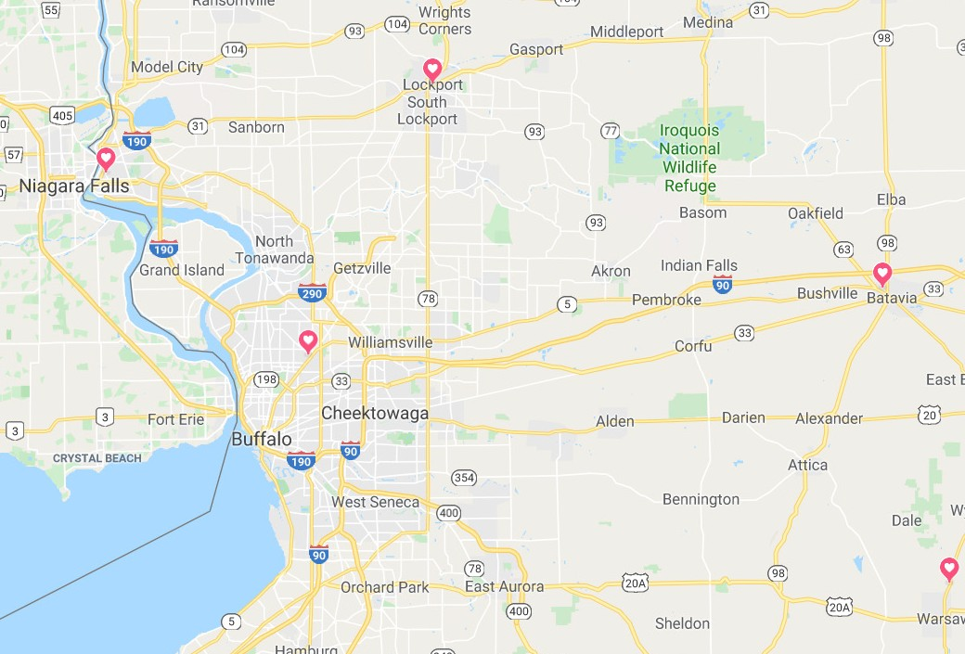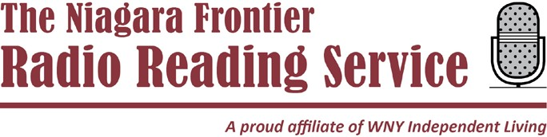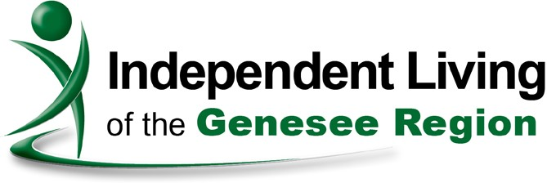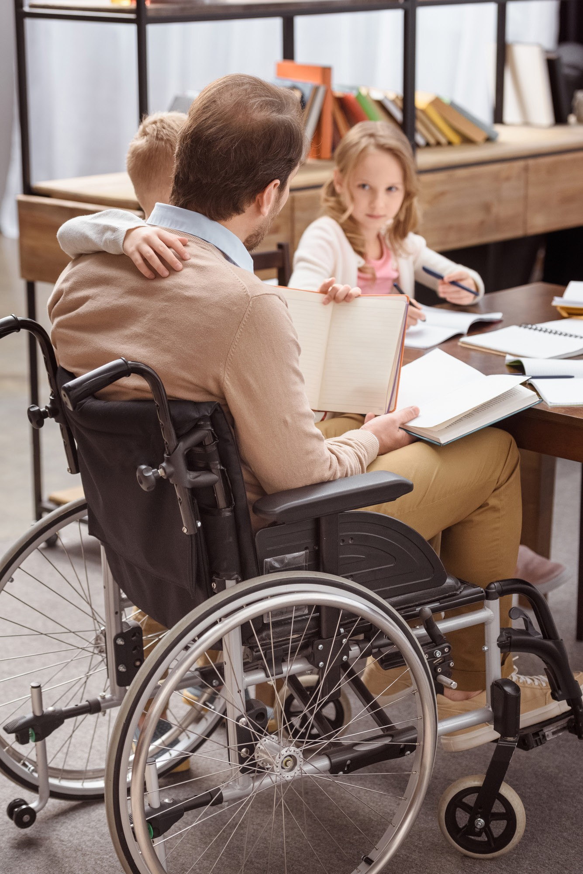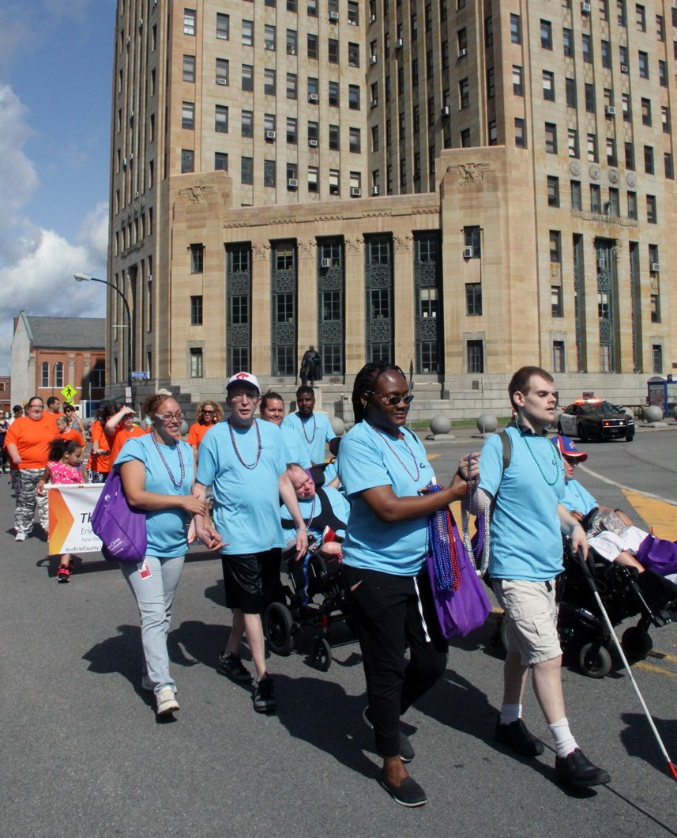

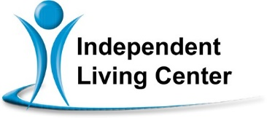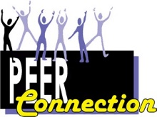

**Western New York Independent LIVING**

The WNY Independent Living, Inc. Family of Agencies provides an array of programs and services throughout

the region...

**Mental Health PEER Connection**

3108 Main Street

Buffalo, NY 14214

(716) 836-0822

**Independent Living**

**of Niagara County (ILNC)**

746 Portage Rd., Niagara Falls, NY 14301 140 Genesee St., Lockport, NY 14094

(716) 284-4131

★

★

★

★

★

319 West Main St., Batavia, NY 14020 2407 N Main St., Warsaw NY 14569 (585) 815-8501

**Western New York’s largest disability- run service**

**and advocacy organization...**

**Follow Us on Social Media**

...that fosters the ability of all people

of any disability and any age to...

For more information on our programs and services go to [www.wnyil.org](http://www.wnyil.org/)

Independent Living Centers are 501(c)3, non-profit organizations.

1199 Harlem Road

Buffalo, NY 14227

(716) 821-5555

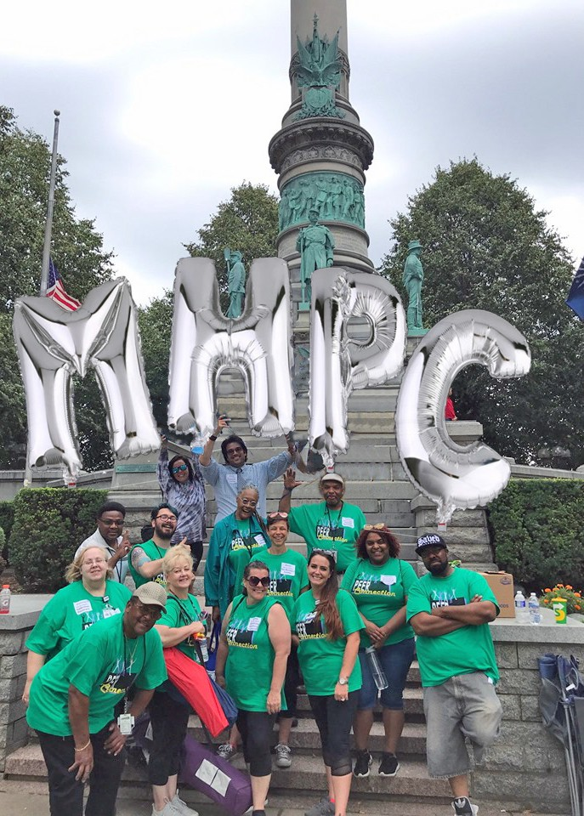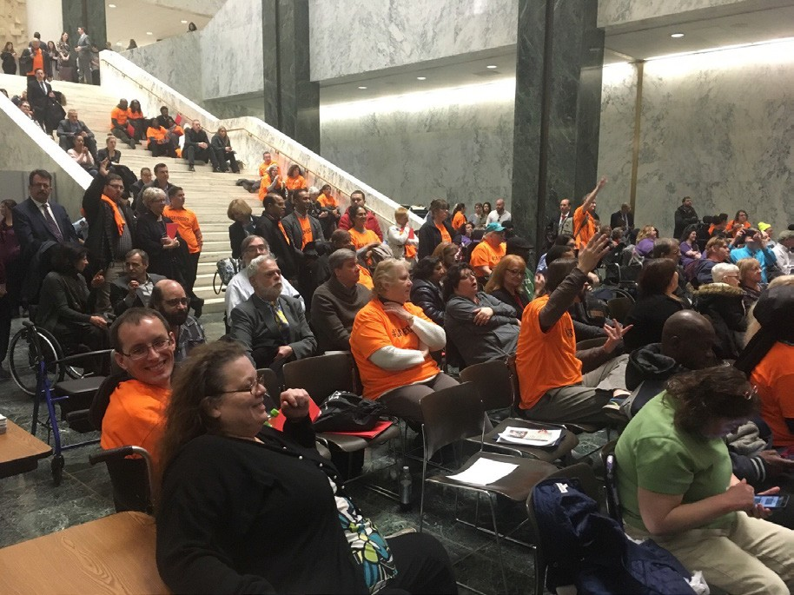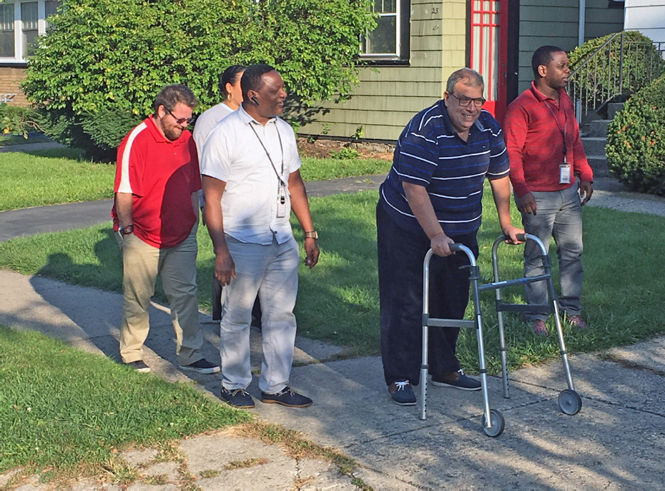

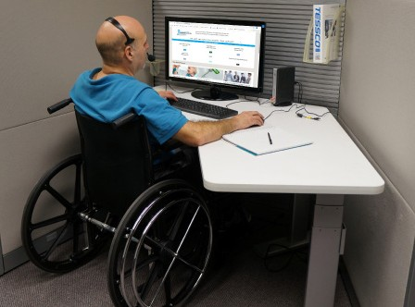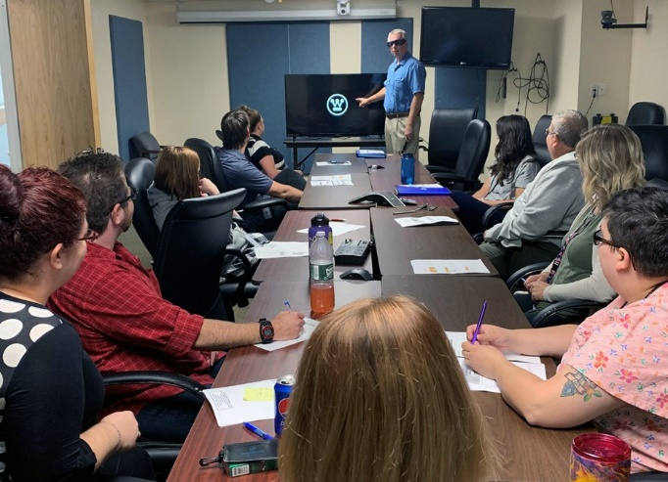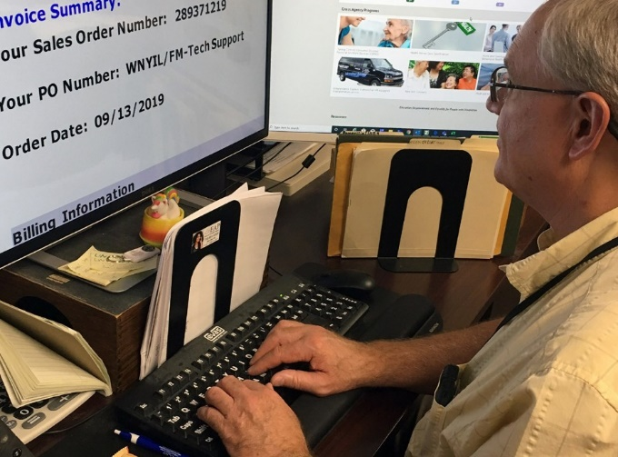

Engage

**in our society**

Live

**in our neighborhoods**

Work

**in our communities**

The Western New York Independent Living, Inc. Family of Agencies has six convenient, accessible locations which can support you to remain independently living,

working and engaged in the

community of your choice.

**...by providing support through**

* Independent Living Skills
* Peer Counseling
* Consumer-Directed Personal Assistant Services
* Transition Services
* Health Care Coordination
* Support Groups
* Assistive Equipment

**...by assisting with**

* Work force Readiness Training

**...by taking control of the choices and options available to you through...**

* Learning your Rights as a Person with a Disability
* Removal of Communication, Physical and Attitudinal Barriers
* Access to News and Information
* Equal Opportunity and Participation in your Community
* Job Seeking Skills
* Job Placement Assistance
* Transportation
* Information & Referral
* Benefits Advisement