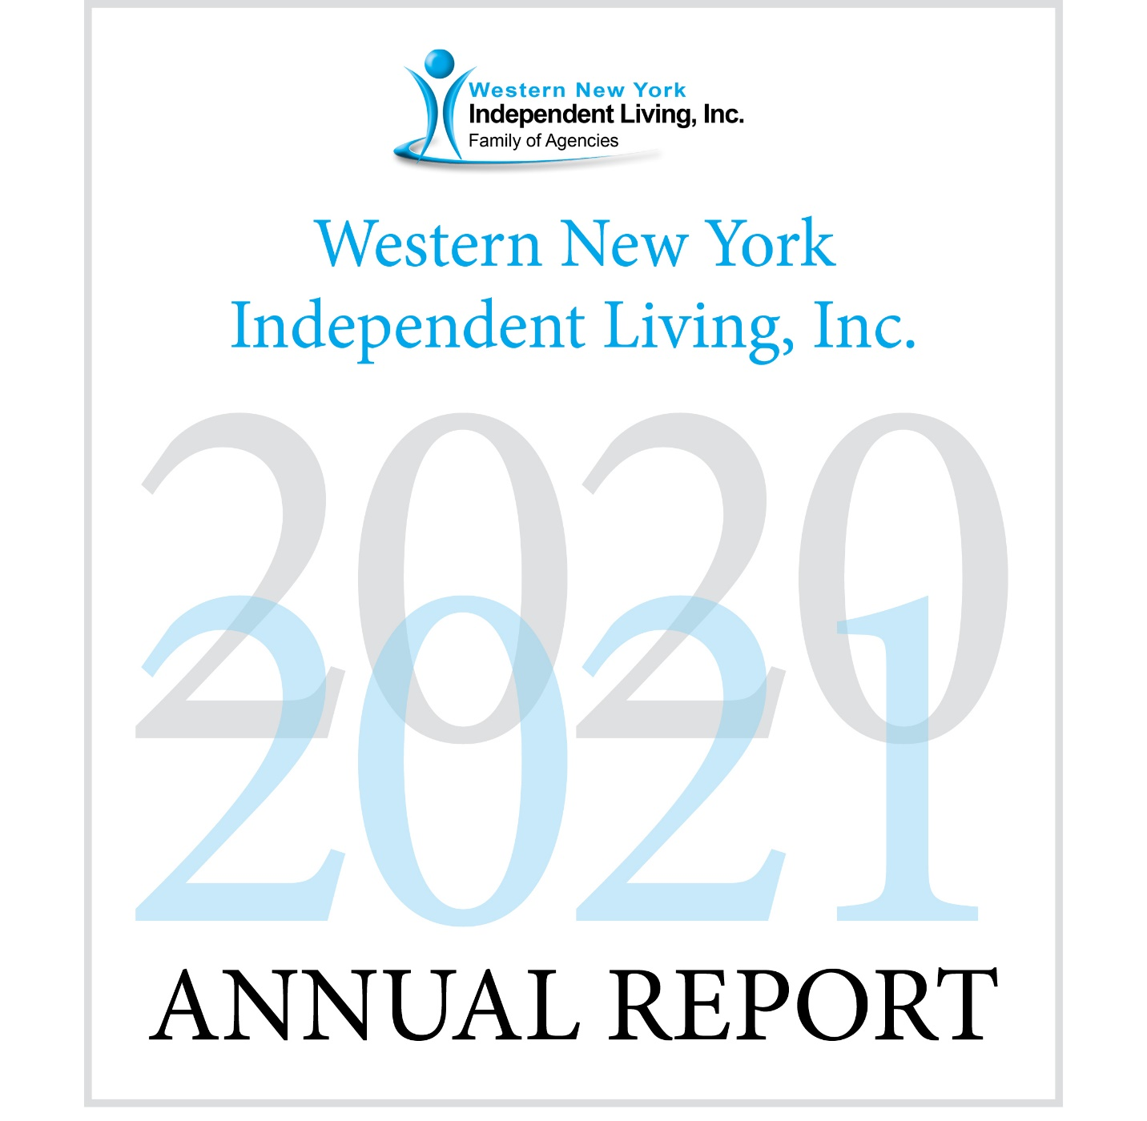

Western New York Independent Living, Inc.
2020-2021 Annual Report
Table of Contents
Western New York Independent Living, Inc. (WNYIL)
Vision, Mission, History 1
Agencies 2
Board and Councils 4
President’s Report 5
Chief Executive Officer’s Report 8
WNYIL’s Work, Systemic Goal Accomplishments 11
WNYIL Statistical Report 12
ILC Vignettes 15
Statement of Financial Position 17
Statement of Activities 18

Mental Health Peer Connection (MHPC)
Director’s Report 19
Vignettes 20
Statistical Report 23

Independent Living of Niagara County (ILNC)
Director’s Report 25
Statistical Report 26

Independent Living of the Genesee Region (ILGR)
Director’s Report 29
Vignettes 31
Statistical Report 34

Niagara Frontier Radio Reading Service (NFRRS) 37

Independence Express
Director’s Report 38
Health Homes Care Coordination 39

Young Leader’s and Advocates Network (YLAN) 42

Vision Statement
Western New York Independent Living, Inc. family of agencies is a catalyst for systems and individual change, enhancing the quality of life for persons with disabilities, while respecting diversity, and promoting choices for independent living in our societies.

Mission Statement
Western New York Independent Living, Inc. (WNYIL, Inc.) Family of Agencies is an intercultural, civil rights organization that advances the quality of life for all people of any age and disability through community change activities, empowerment programs, independent living services, community-based programs, fiscal intermediary services, and family supports. WNYIL, Inc. is directed, led, and staffed by a majority of people with disabilities who run a professional and efficient organization, dedicated to cultivating a hospitable environment that actively seeks out community partnerships to eliminate barriers, facilitate transportation and promote employment.

The WNYIL Family of Agencies includes the Independent Living Center (ILC), Mental Health Peer Connection (MHPC), Independent Living of Niagara County (ILNC), Independent Living of the Genesee Region (ILGR), Young Leaders and Advocates Network (YLAN), and Niagara Frontier Radio Reading Service, Inc. (NFRRS).

History
Born during the nationwide independent living and civil rights movement, college students with disabilities who were fed up with discrimination and the lack of access for people with disabilities, decided to make their own opportunities and assist their peers to do the same. In 1979 “The Independents,” a group of students with disabilities at the State University of New York at Buffalo, investigated the independent living movement and began operating what was then known as Western New York Independent Living Project (WNYILP). The agency was awarded a Federal Title VII grant in 1980 and opened its own facility early in 1981.

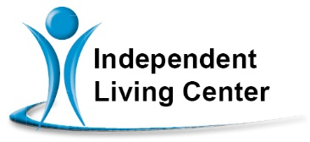
The Independent Living Center of Erie County (ILC)
Provides Independent Living’s 5 Core Services: Peer Services, Advocacy, Information and Referral, Independent Living Skills and Transition Services. ILC also provides Educational Navigation, Student Services, NY Connects Information and Referral, Housing Subsidies, and Benefits Application Assistance to individuals in Erie County.

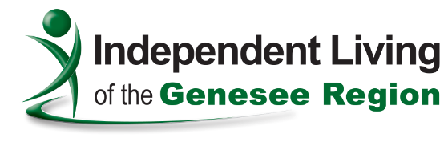
Independent Living of Genesee County (ILGR)
A community pathway for an empowered life for people with disabilities by providing Independent Living Skills, Advocacy, Information and Referral, Peer Counseling, Transition Services and Financial Advisement in Genesee, Orleans and Wyoming Counties.

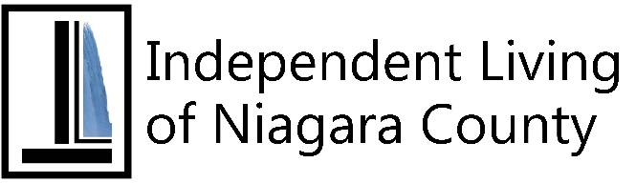
Independent Living of Niagara County (ILNC)
An independent living center that provides the five core services of Peer Counseling, Independent Living Skills, Advocacy, Transition Services and Information and Referral which empower people with disabilities on both the individual and community level.

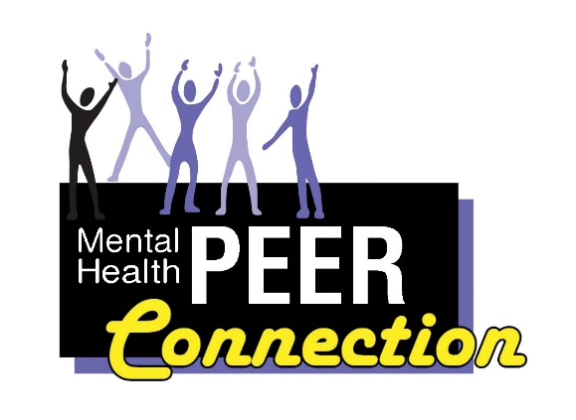
Mental Health PEER Connection (MHPC)
A peer-driven advocacy organization dedicated to facilitating self-directed growth, wellness and choice through genuine peer mentoring. Provides institutional, community and vocational-based services assisting consumers in their recovery process.

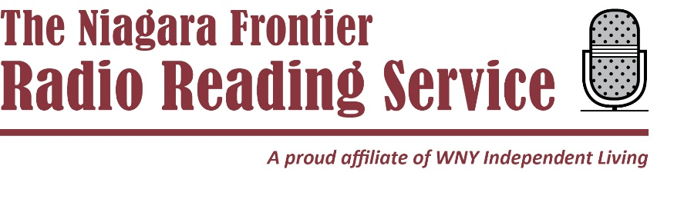
Niagara Frontier Radio Reading Service (NFRRS)
Your Niagara Frontier Radio Reading Service gives thousands of people throughout Western New York and Southern Ontario who are blind or have a print disability daily access to a variety of print publications.

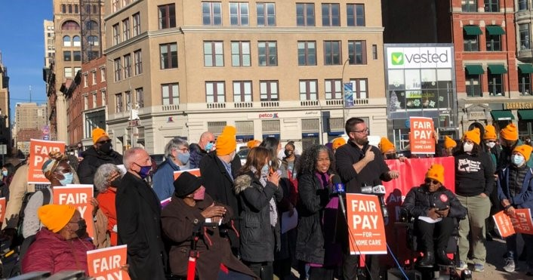
The following volunteer representatives were in place
during all or part of the 2020-21 fiscal year.

Western New York Independent Living
Board of Directors
Paul D. Beakman, Sr. (President); Richard Dread, (Vice President); Richard Koch, CPA (Treasurer, 10/20 – 3/21); Ann Scherff (Treasurer, 4/21 – 9/21); Sue Ann Sehl (Secretary); Blaise Bryant; Matt Carlucci; Syreeta Dean; Barbara Gaetano; Melanie Hecker; Erycka Lea Kosinski; Ellen Lawson; Donald Le Ber; Michael May; Bobbie Jo Meyer; Kaitlyn O’Dell; Juan Santiago; Miguel Santos; John Schappacher; Ann Scherff.

Independent Living of the Genesee Region Council
Ann Scherff (Chair); Kelly March (Vice Chair); Ida Caldwell (Treasurer); Erycka Kosinski (Secretary); Katie Cotter; Jonathan Doherty, Lorrie Gilbraith; Linda Makson; Christi Waldron.

Mental Health PEER Connection Council
Donald LeBer (Chair); Benjamin Woodrow (Vice Chair); Nafisa Ahmad (Secretary / Treasurer); Judy Capan; Bobby Jo R. Meyer; Noel Young.

Independent Living of Niagara County Council
Paul Beakman (Chair); John Schappacher (Vice Chair); Barbara Gaetano (Secretary / Treasurer); Gracie Chambers; Darlene Cutonilli; Brigid Dillman; Lana Redell; Darren Sneed.

Niagara Frontier Radio Reading Service
Board of Directors
Paul Beakman (President), Richard Dread (Vice President), Sue Ann Sehl (Secretary); Richard Koch, CPA (Treasurer, 10/20 – 3/21); Ann Scherff (Treasurer, 4/21 – 9/21); Patricia LaMont; Peg Mergenhagen; Lori Heidenburg Morrell; Miguel Santos.

Message from the President of the Board of Directors

Unfortunately, this year I have the sad duty to announce the loss of two very dedicated staff, whose combined years of service to WNYIL exceeded 60 years. This loss of Michael Phillips, Chief Fiscal Officer, and Richard Nawrocki, our Number One and longtime van driver, gave our staff and Board a stunning emotional blow.

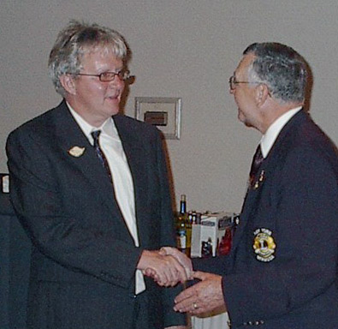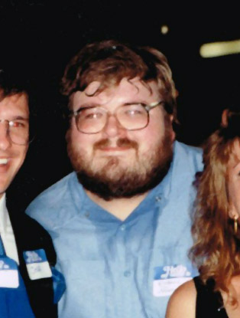
Both individuals did whatever needed to be done, in order for WNYIL to provide its programs and services to the people we serve. Mike was hired as an Accountant back in 1985, but more than keeping books, he was filling in driving vans, moving furniture, cooking at staff picnics, and organizing WNYIL’s softball teams. Mike went from overseeing $250,000 to supervising a staff of 14 and managing successfully over $50 million in his years of service.

Richie, came to the Center as a Van driver when we had only two vans and began his pleasant, courteous, and friendly service to people with disabilities throughout Western New York. One can honestly say that, over his 25 years of service, Richie got people where they needed to go through rain, ice, and snow, not to mention the warm and sunny days of Buffalo. He has given rides to literally thousands of people on every day of the week, including holidays, weekends, and late evenings. If a ride was needed, and if Richie wasn’t booked, he would be the first to volunteer to do the job that no one wanted. Richie didn’t stop at just driving, he filled in (sometimes weeks at a time) to run the office when its director was out. Richie always greeted everybody with a friendly gesture, made you smile, and believe he was happy not only to see you, but to provide you the service.

Our Family of Agencies has lost two wonderful people this past year, and our hearts and prayers go to their families for the loss of two very special people.

Even with the sad news of losing two valuable pieces of WNYIL, our efforts of being a catalyst for individual and community change continue. During this past year, our Family of Agencies has provided programs and services to almost 7,000 people with disabilities and their families and provided a variety of services to area businesses and organizations in Western New York

This past year has seen continuous growth not only in programming but physically as well.

Independent Living of the Genesee Region added another 2,000 square feet to accommodate their growing staff and provide more room for the community to continue using their digs as a location to meet

Independent Living of Niagara County added a whole new section of which their newest State Opioid Response (SOR) program will be working out of along with the expansion of their Medical Loan Closet.

Niagara Frontier Radio Reading Service (NFRRS) started their renovations of the second floor, that when done will provide them a revenue stream from the lease income.

Mental Health PEER Connection (MHPC), in partnership with Recovery Options Made Easy and Spectrum Behavioral Health, have embarked on an innovative tri-partnership, creating a diversion program for people in need to seek peer support, respite, and clinical assistance, when and if needed, The Renewal Center.

We have acquired a new van and will be moving into Medicaid-reimbursable transportation.

Not to mention that Taking Control Consumer-Directed Personal Assistance Services (TC-CDPAS), Health Home Care Coordination, Independent Living Services, NY Connects, and our Medicaid Application Assistance (MAAP) programs continue to grow, as the needs for their community supports are increasing.

During the past several months of loss, pandemic, and need for appropriate wages for all our staff, The WNYIL “Family of Agencies” continues to stand up and jump into the fray. Supporting the person with a disability to have the right to live in their home, work in our communities, and engage equally in society.

Paul Beakman
President of the Board of Directors
of Western New York Independent Living, Inc.

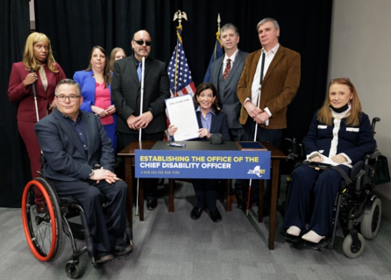

Report of the Chief Executive Officer

“Gone but not forgotten.”

I will begin by expressing my extreme sorrow for the lost of two valuable members of “the Family of Agencies”. Mike Phillips (Chief Financial Officer) and Richard (Richie) Nawrocki (Best Van Driver Ever). Both individuals were responsible for bringing life, humor, color, and comradery to the agency. There was never a day that I wasn’t pleased for the chance to see or work with either gentleman. They were always ready to pitch in without complaint, do what needed to be done, and always advance the rights of people with disabilities, regardless of what their job description said. I will forever miss them both, and each day when I think of them, I feel their loss, but maintain a smile for how they not only enriched my life, and, for that matter, how their work enriched the lives of thousands of Western New Yorkers with disabilities.

So, it is with sadness I say, “Good-bye my friends and colleagues; I will miss you.”

In memory of our fallen colleagues, we can honor their work by advancing the lives of our fellow citizens with disabilities to take control of their own lives.

Many of you know how the pandemic has shrouded our lives with a depressing blanket these past two years. While recognizing this, I am proud to say that WNYIL continues to prosper and persists in challenging the systems, empowering people, and opening up our communities.

Our Vision to facilitate change continues, as we bring the message of people with disabilities to our leaders who have the power to make change in our society. We were fortunate to have Zoom-casts of both a primary and election day faceoff for the seat of the Mayor of Buffalo, wherein all the candidates were participants, and dozens of people with disabilities and their advocates were able to hear from the candidates and ask questions.

The members of our Family of Agencies’ staff continue to be in the trenches, working from home, in the office, and out in the communities, making sure that people with disabilities are connected to the programs and services that they need.

Did you know that WNYIL provides…

- Peer Counseling for all people with any disability of any age?
- That we are part of NY Connects, and offer aid and information on hundreds of programs and services (not just ours)?
- We can provide you, free of charge, assistance in obtaining Medicaid or Medicare?
- We have mobile peers that can assist the person who has decided to stop abusing substances to find the right kind of supports and services to make this happen?
- That if you have a disability of any kind, we can assist you in preparing and seeking employment?
- That if you have a behavioral health disability, AIDS, or chronic health conditions, that you can find assistance of a care coordinator to assist you in coordinating your health care and navigating all that paperwork and confusion?
- That if you want to get out of institutional care, to live in the community, we have teams that can assist you in doing that?
- If you want a ride and have a developmental disability, if eligible, you can get it from one of our vans or at an affordable fee, and not just stick to the bus lines?
- That if you need in-home care and would prefer to decide who takes care of you and be in charge of the people who clean your home, cook your food, and coordinate their hours, we can assist you to do that as well?
- If you need help in making the simple things that are now no longer simple become easier, you can give us a call? We can assist in identifying housing modifications, assistive technologies, and alternative methods to make those things simple again,
- That if you are a family member of a person lost in the world of substance abuse, and need assistance in knowing what you can do, and where you can go, you can give us a call?
- You are on the verge of an emotional crisis, but you do not believe that you need hospitalization or emergency care, you can contact our Renewal Center, where help is a call or a short drive away?
- If you need assistive equipment to get through a short-term disability or want to try a device out, you can call one of our Loan Closets?
- That, if you can’t read, you can either turn on the radio, or ask Alexa, or go to your favorite podcast app.?
- That, if you want to talk about your disabilities, feelings, or concerns to others with disabilities, you can contact the Center nearest you?

Finally…

As you can see, the list is exhausting! Our staff work with people: one-on-one, in groups, interacting with families, advocating in the community, in schools, with other agencies, and the list goes on and on and on. We do what it takes to make sure that you can get all that you have a right to get. Our staff is dedicated to ensuring that everyone who wants to has the right to live in their home if they wish, work in our community, earn a competitive wage, and engage equally in society in electing our leaders, participating in our community activities, and connect as a full and contributing citizen.

Douglas J. Usiak
Chief Executive Officer

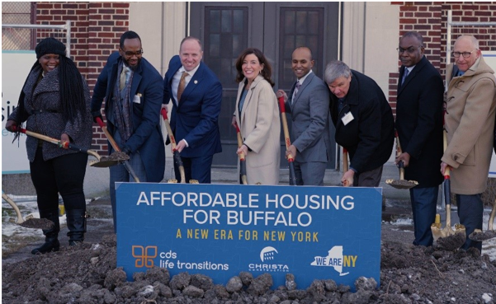
WNYIL’s Work is Good for Consumers AND Good for New York State

$750,000,000
That is how much money in Medicaid payments the WNYIL Family of Agencies saved New York State taxpayers since 2008 by helping people stay in their homes instead of being admitted to nursing homes, group homes, and other institutionalized settings.

A Sampling of WNYIL’s Systemic Goal Accomplishments

- WNYIL worked with other statewide partners to assure full accessibility to Governor Cuomo’s pandemic press briefings.

- WNYIL worked with 12 New York counties to deliver masks and other Personal Protective Equipment to persons with disabilities.

- WNYIL partnered with Housing Opportunities Made Equal to create opportunities for housing modifications so people could live more comfortably in their own homes.

- Advocates in Niagara County removed physical barriers to access from Restaurants and Public buildings in Newfane and Lockport.

- Advocates in the Genesee Region got our concerns for housing added to their Resident Opportunities and Self Sufficiency (ROSS) Program.

Annual Report 2020-2021 WNYIL Statistics

Total Number of Consumers Served: 2111

Number of Consumers by Age
Under 5 years old: 12
Ages 5 – 19: 73
Ages 20 – 24: 76
Ages 25 – 59: 886
Age 60 and older: 954
Age unavailable: 110

Number of Consumers by Race and Ethnicity
American Indian or Alaska Native: 90
Asian: 68
Black or African American: 552
Hawaiian or Other Pacific Islander: 3
White: 1132
Hispanic or Latino: 113
Race / Ethnicity unavailable: 153

Number of Consumers by Disability*
Cognitive: 607
Mental / Emotional: 1031
Physical: 2344
Sensory (hearing, vision, etc.): 586
Multiple disabilities: 404
*Some consumers may have indicated more than 1 disability category.

Number of Consumers by County of Residence
Albany: 3 Monroe: 15
Allegany: 3 Niagara: 195
Bronx: 1 Orleans: 8
Cattaraugus: 64 Saratoga: 1
Chautauqua: 31 Suffolk: 1
Erie: 3950 Ulster: 1
Genesee: 77 Wyoming: 4
Jefferson: 1
*County numbers include consumers with disabilities as well as
casual contacts and information and referral for people with and without disabilities

Number of Consumers by Veteran Status
Veteran (served in US military): 65
Non-veteran (never served in US military): 1714
Status unavailable: 332
Number of Consumers by Services Received*
Advocacy / legal services: 166
Architectural barrier services: 3
Assistive devices / equipment: 18
Children’s services: 6
Communication services: 152
Counseling services: 121
Family services: 6
Housing and shelter services: 447
Information and referral: 2383
Independent living skills development and life skills services: 208
Mobility training: 26
Peer counseling: 1289
Personal assistance services: 915
Recreational services: 47
Transportation services: 220
Youth services: 5
Vocational services: 173
Plan for the Achievement of Self Support: 7
Business / Industry / Agency services: 3
Benefits Advisement: 457
Voter Registration: 2
Other: 7
*Some consumers may have received more than 1 service.

Number of Businesses / Agencies Served: 80

ILC 2021 Vignettes

“Lynn” – Live Independently

“Lynn” is a 64-year-old woman who has mental health and anxiety issues, and a Spinal Cord injury which left her partially paralyzed from the waist down. A resident in a long-term care facility, she wanted to live on her own.

An Independent Living Center (ILC) counselor helped her enroll in a pooled trust, to set aside excess funds to enable her to apply for assistance; instructed her on how to complete disbursement forms and helped her to locate a studio apartment to which she moved. Our staff enrolled her in a Managed Long-Term Care program; and secured personal care aide services for her. Additionally, they transported some donated furniture to her new apartment using their own vehicles; enabled her to obtain household items and clothing through a voucher; and helped her select items in the store that would meet her needs.

She is now living successfully in her new apartment. Lynn stated that she couldn’t have done this without our help and is very grateful for the ILC.

Man who needs power wheelchair

A gentleman who sought to obtain a power wheelchair through our Medical Equipment Loan Closet to assist in living independently was aided by a New York Connects counselor at the Independent Living Center (ILC). This individual suffered from a disability in which he would randomly have stroke-like symptoms, so he could not easily move or speak. Due to these challenges, it was very difficult for him to leave his home and carry out necessary tasks, for fear of being unable to leave another location, should one of these episodes occur.

Our staff was able to locate a power wheelchair that had been donated to our Medical Loan Closet which would accommodate him. We then obtained the batteries to operate it using funds from the Maria Love Foundation. He is now able to navigate independently outside of his home, safely and comfortably, without fear of being unable to return, or of being harmed.

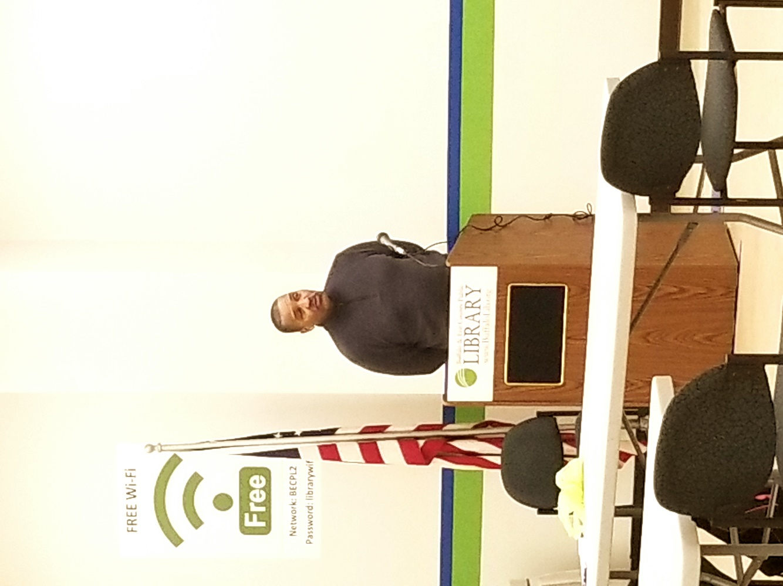

Western New York Independent Living, Inc. and Affiliates
Statements of Financial Position September 30, 2021 and 2020

Assets 2021 2020
Current assets:
Cash and equivalents $ 14,003,755 $ 14,476,549
Investments 5,078,533 10,231
Contracts and fees receivable, net 8,758,755 10,726,988
Prepaid insurance and expenses 139,152 233,078
Total current assets 27,980,195 25,446,846
Loan receivable Note 67,902 130,000

Property and equipment, at cost:
Leasehold improvements 2,594,288 2,483,991
Office equipment 439,344 491,130
Vans and related equipment 394,008 384,171
Computers and related equipment 306,527 583,931
Construction in progress 91,927 0
3,826,094 3,943,223
Less accumulated depreciation (2,827,765) (2,962,703)
Net property and equipment 998,329 980,520
Other assets 12,295 12,564
$ 29,058,721 $ 26,569,661
Liabilities and Net Assets
Current liabilities:
Accounts payable 608,525 697,544
Deferred revenue 4,531,876 3,412,005
Accrued salaries 1,694,915 2,048,289
Accrued expenses 366,963 374,426
Promissory note - payroll protection program 0 23,700
Total current liabilities 7,202,279 6,555,964
Net assets:
Net assets without donor restrictions 21,837,818 18,982,509
Net assets with donor restrictions 18,624 1,031,188
Total net assets 21,856,442 20,013,697

Total liabilities and net assets $ 29,058,721 $ 26,569,661
Western New York Independent Living, Inc. and Affiliates
Statements of Activities Years ended September 30, 2021 and 2020

2021 2020
Revenue:
Contracts and grants $ 6,382,704 $ 6,268,396
Consumer directed personal assistant services 39,792,680 44,014,048
Fees for services 648,518 728,419
Contributions and Membership 6,660 2,645
Fundraising 18,091 20,800
Grant income - paycheck protection program 23,700 0
Investment income, net of investment fees of
$13,142 in 2021 and $30 in 2020 91,356 112,864
Other revenue 14,679 12,108
Total revenue 46,978,388 51,159,280
Net assets released from donor restrictions 1,039,422 48,389
Total revenue and other support 48,017,810 51,207,669
Expenses:
Program services 42,329,915 43,038,651
Management and general 2,832,586 2,410,899
Total expenses 45,162,501 45,449,550
Change in net assets without donor restrictions 2,855,309 5,758,119
Change in net assets without donor restrictions:
Revenue - contracts and support 26,858 1,079,577
Net assets released from donor restrictions (1,039,422) (48,389)
Change in net assets without donor restrictions 1,012,564 1,031,188
Change in net assets 1,842,745 6,789,307
Net assets at beginning of year 20,013,697 13,224,390
Net assets at end of year $ 21,856,442 $ 20,013,697

Mental Health PEER Connection Director’s Report

As a member of the Western New York Independent Living Inc. Family of Agencies, Mental Health PEER Connection (MHPC) managed to work through an ongoing Coronavirus pandemic, despite being short-staffed, and delays from the process of hiring both a new Director and Assistant Director. I cannot put into words my heartfelt gratitude towards our hardworking, dedicated staff during these difficult times. While I cannot speak for all the people MHPC touched, I am certain they too appreciate all your efforts and assistance.

Our staff did not let everything going on around them stop them from providing needed services. Whether it was the Renewal Center, Erie County Medical Center’s Behavioral Health units, Erie County Medical Center’s Emergency Room, Erie County Medical Center’s outpatient clinics, Home and Community Based Services, Life Coaching, Benefits Advisement, Work Support, virtual / and or in person support groups, they tried to help everyone who needed it. One of the stand-out in-person groups was the one for our brothers and sisters lucky enough to receive day pass outings from Buffalo Psychiatric Center. That and a host of other community-based, person-centered services and support surely improved the lives of many.

Kevin Smith
Director of Mental Health PEER Connection

MHPC 2021 Vignettes

Mother needs employment

A young woman with a three-year-old son came to Mental Health PEER Connection’s Job Club seeking assistance in finding employment, to help her find a place to live.

MHPC staff were able to help in secure a position in the nursing field. We also helped her to find a Day Care that she can use while she is at work and connected her with a support group for women.

In order to get her own place, she also wanted help getting financial assistance with the first month’s rent and security deposit, so our staff linked her with an appropriate program. Additionally, she has now received a bus pass to go to work from Western New York Independent Living Erie County Department of Mental Health-Work Support Job Club for three months. She will be coming in once or twice per month to keep our staff updated on her progress.

We consider hers to be a success story because she did not think that she could find a job, as well as someone to watch her child. We are gratified to see her working, moving into her own place, and maintaining her independence.

Man with TBI seeks work and to relocate

A young man came to the Job Club for assistance with job support and updating his résumé, in order to help him find a part-time job, and he also wanted to move from the room where he lived.

Our Vocational Peer Support Specialist aided him in securing a part time job while he continued to receive his Social Security Disability Income and Supplemental Security Income, which is vital to him, as he has a Traumatic Brain Injury. At this report, he has been working for over 120 days and has found a new rooming house where he rents an apartment.

He has been coming to the Job Club to keep our staff updated with his progress: since his employment and relocation, he is greatly improved. In additional support, he even got a donation of living room furniture to help him with his living arrangements. Our counselor helped him get a bus pass to get to work and move around the neighborhood, because he would generally walk to all his appointments.

With the new job and living arrangements he has achieved independence, so MHPC considers his story an unqualified success.

Homeless man seeks work and housing

A homeless 57-year-old Black man came to MHPC’s Job Club for our Erie County Department of Mental Health-Work Support (ECDMH-WS) services.

He shared that he and his son were staying in a shelter, and he had been coming to the Enhancement Program while his Social Security Disability application was pending. He requested ECDMH – WS Program services to attempt to return to work part-time so he could set up housing. When his Social Security case was denied, our counselor linked him with our Benefits Advisement Support Program, and with a pro-bona lawyer to assist with appealing the Social Security decision.

He attended Job Club regularly and maintained frequent biweekly appointments with his therapist. After some time, he won his case with the Judge awarding him a favorable judgment. Thereafter, he could focus on his goal to obtain part-time employment. Thanks to information from the ECDMH Benefits Advisement support program, he knew he could work minimal hours and still maintain his benefits.

He asked his counselor to write him a supporting letter of reference to help him get into an apartment which was reviewed by the supervisor. Four months since he first sought services, he and his son moved into an apartment and still are living there now.
Due to his disability, he was unable to obtain employment; however, the connections made by our staff resulted in his son -- who also has a disability -- being hired by Russell’s Steaks and Chops Restaurant. Our counselor encouraged the father to explore educational options, so that he could obtain employment regardless of his disability. He is now attending Erie Community College full-time.

We assisted the man to help himself to find his independence and keep it, and his son’s life was enhanced also, so we count this as a great success story.

56-year-old man with TBI seeking work

A 56-year-old African American man came to the MHPC’s Job Club to set up goals in our Erie County Department of Mental Health-Work Support program. He sought help with obtaining and maintaining employment.

Even before this effort to secure work began, he felt he needed to move out of an unhealthy living environment, a process that required six months to complete.

With our assistance, he secured a part-time job at Family Dollar, but continued to receive government benefits and acquired a bus pass.

While both his ECDMH Work Support goals have been met, due to his having a Traumatic Brain Injury, he still meets with our counselor in the Job Club to provide updates about his progress.

We feel he is doing much better since he gained his independence, as he has started working and has moved to his new place, so we count this a real Success Story.

Annual Report 2020-2021 MHPC Statistics

Addict to Addict Peer and Family Support Program*
Total number of interactions with individuals presenting with substance use issues: 983
Total number of individual follow ups completed: 233
Total number of individual calls responded to within 2 hours: 204
Total number of interactions with families and caregivers of individuals who have substance use issues: 106
Total number of continued supports for families and caregivers: 88
Total number of family or caregiver calls responded to within 2 hours: 55
Total number of family and A2A support groups: 263
Total number of community presentations regarding family members in relationships with people who have substance use issues: 208
*Reflects data from January - December 2021

ECDMH Benefits Advisement, Life Coaching,
and Work Support Programs

Total number of individuals who received benefits advisement services: 173
Total numbers of individuals served whose qualifying benefits were identified: 95
Total number of individuals who were certified or re-certified for benefits: 34
Total number of individuals who received life coaching services: 412
Total number of individuals who had an improved quality of life: 29
Total number of individuals whose basic needs (housing, financial, mental, physical, wellness) were met: 282
Total number of individuals who completed a Wellness Recovery Action Plan (WRAP): 94
Total number of individuals who received work support services: 86
*Reflects January-December 2021 Data

Renewal Center
Total number of individual crisis diversions: 269
Total number of individuals linked to community-based treatment: 48
Independent Living of Niagara County Director’s Report

With many restrictions in New York State due to the COVID-19 Coronavirus pandemic, Independent Living of Niagara County (ILNC) had to postpone some traditional activities, such as the Small Mouth Bass Fishing Derby, during 2020-2021. Similar to the prior year, the staff of ILNC worked to communicate with consumers and continue to provide services in ways that used to be considered non-traditional, becoming remote workers and providing services from outside of the office. By working together, ILNC was able to overcome the many challenges and continue to provide support by reaching out to our consumers.

The ILNC Team participated in community education forums, coalitions and outreach initiatives in order to continue educating residents in Niagara County about the Independent Living Philosophy as well as the many programs that ILNC offers

Some of the activities and events that helped engage ILNC constituents and supporters included the annual Meet the Candidates Forums, the Calling for Home Care promotion to increase wages for home care workers, a Virtual Legislative Week with the NYS Association for Independent Living to speak with local, state, and federal elected officials about issues important to people with disabilities, our Virtual Walk, Run and Roll fundraiser, the 5th Annual Lockport Overdoes Awareness Day Rally, and the Rise Above the Occasion campaign to urge addicts to seek wellness and recovery.

ILNC provides:
- Health Home Care Coordination
- Advocacy
- Open Doors Transition Services
- Independent Living Skills
- Taking Control - Consumer Directed Personal Attendant Services (CDPAS)
- Information and Assistance through NY Connects
- Certified Peer Recovery and Advocacy through Addict 2 Addict Niagara

Stephanie Orlando
Interim Director of ILNC

Annual Report 2020-2021 ILNC Statistics

Total Number of Consumers Served: 648

Number of Consumers by Age
Under 5 years old: 3
Ages 5 – 19: 8
Ages 20 – 24: 15
Ages 25 – 59: 225
Age 60 and older: 294
Age unavailable: 103

Number of Consumers by Race and Ethnicity
American Indian or Alaska Native: 21
Asian: 2
Black or African American: 119
White: 453
Hispanic or Latino: 8
Race / Ethnicity unavailable: 44

Number of Consumers by Disability*
Cognitive: 190
Mental / emotional: 260
Physical: 805
Sensory (hearing, vision, etc.): 166
Multiple disabilities: 133
*Some consumers may have indicated more than 1 disability category.

Number of Consumers by County of Residence
Allegany: 1 Monroe: 1
Cattaraugus: 4 Niagara: 1005
Chautauqua: 1 Orleans: 2
Erie: 64 Wyoming: 2
Genesee: 12
*County numbers include consumers with disabilities as well as
casual contacts and information and referral for people with and without disabilities

Number of Consumers by Veteran Status
Veteran (served in US military): 36
Non-veteran (never served in US military): 477
Status unavailable: 135
Number of Consumers by Services Received*
Advocacy / legal services: 24
Architectural barrier services: 1
Assistive devices / equipment: 4
Communication services: 10
Family services: 2
Housing and shelter services: 122
Information and referral: 437
Independent living skills development and life skills services: 37
Mobility training: 1
Peer counseling: 218
Personal assistance services: 314
Transportation services: 30
Vocational services: 15
Business / Industry / Agency services: 58
Benefits Advisement: 77
Voter Registration: 2
Other: 16
*Some consumers may have received more than 1 service.

Number of Businesses / Agencies Served: 122
Independent Living of the Genesee Region
Director’s Report

The COVID-19 Coronavirus pandemic changed many things about the way we provided services, but, overall, Independent Living of the Genesee Region (ILGR) continued to grow in our programs and partnerships for the Fiscal Year October 2020 through September 2021.

ILGR received Emergency Solutions Grants under the CARES (Coronavirus Aid, Relief, and Economic Security) Act for our tri-county (Genesee, Orleans, Wyoming) area to provide Eviction Prevention and Rapid Rehousing services. This included emergency shelter, rent and security deposits for unhoused people. New York State opened a statewide portal to help tenants and landlords with back rent, and we assisted with the application process. Three new Housing Specialists positions were created to facilitate these services.

Growing our presence in Genesee County became a priority and investment dollars were used to expand with the creation of an additional seven offices, a new conference room and storage space at our current Main Street location in Batavia, NY.

Our agency partnerships have increased our presence in the community. Rae Frank, ILGR Director, has been appointed to the GLOW WIOA (Genesee, Livingston, Orleans, Wyoming - Workforce Innovation and Opportunities Act) Board of Directors, assisting in developing policies regarding employment for people with disabilities. ILGR is also piloting a new “Healthy Ideas” project with Western New York Integrated Care Collaborative which aims to reduce social isolation for people experiencing depression due to the pandemic. The Monroe Plan for Medical Care has invited us to a seat at the table during their community meetings, seeking input from service providers.

Due to the pandemic, we learned how to fund-raise virtually and launched our first ever Virtual 5K Walk, Run, Roll event. From sponsorships alone, we received over $2,000 in donations. Throughout the year, we continued to provide personal protective equipment (PPE) in the community, distributing gift bags, gift cards, and household items.

And finally, the mission close to our hearts, our Consumer-Directed Personal Assistance Services Home Care Aide Program grew from 185 to 201 individuals receiving services to stay living independently, in their homes.

Rae Frank
Director of Independent Living of the Genesee Region
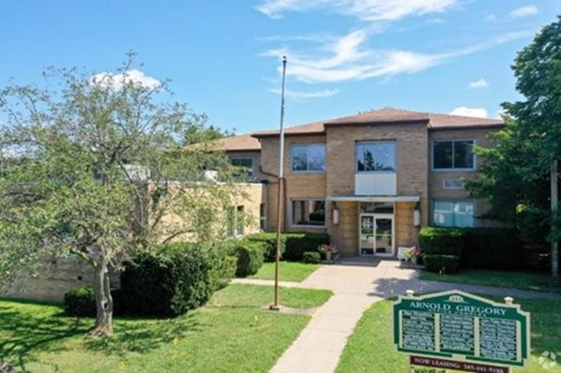
ILGR 2021 Vignettes

Helping a woman with Medicaid denials

One woman needed both Medicaid Facilitated Enrollment and Independent Living Services. Despite our staff working tirelessly at gathering documentation, her many Medicaid applications were denied each time due to failing to turn in all the needed documents. Eventually she grew tired of the process, but one counsellor kept encouraging her to strive toward a successful ending, even across a change of departments.

In the new position, the counsellor helped her apply for Supplemental Nutritional Assistance Program (SNAP) benefits. As she expected, the first attempt ended in a denial for not submitting enough documentation with the application; however, encouraged to re-apply, she did. A few weeks later, she called to tell us, “Thank you so much. Even though I gave up on myself you never did; and even though everything was not approved, I got approved for the first time on something!”

Woman needed equipment to return home

The daughter of a hospitalized woman came to borrow items from the ILGR Medical Loan Closet for her mother. She could not be released without certain equipment being available in the home. Knowing her mother was worried about remaining in the hospital because of COVID-19 concerns and thinking she was going to have to buy this equipment, the daughter was a bit overwhelmed. The hospital had mentioned that ILGR had a Loan Closet and sent her to us to borrow the needed items. We had everything that was needed, and the mom was released from the hospital.

Concerns of potential Personal Assistant

A woman who was thinking of a job as a home care Personal Assistant (PA) called to learn whether we were hiring, among other questions. Our staff explained the Consumer-Directed Personal Assistance Services program to her. She had just had a baby and was worried about going back to work, which she has not since before the COVID-19 pandemic restrictions. We told her that we could start the process and at any time she wanted to stop, she could. Ultimately, she attended PA orientation and was linked to a Consumer that fit her schedule. She loves her new job, and her Consumer is now like part of her family.

Woman assisted with Medicaid qualification

A female with a back issue came to ILGR as she needed both home care and transportation to her medical appointments. However, after her Medicaid was approved, she needed to lower her monthly income by $500 to be eligible for support, a loss that would make her acquiring Medicaid useless. Our counselor helped her to open a pooled trust, which designated her monthly rent payments as irrevocable parts of the trust that did not count against her eligibility. Now, she is able to get the care she needs and to utilize Medicaid transportation.

Impoverished consumer faced eviction

A family with trust issues called ILGR and was very hesitant to talk to us at first. After we spoke and got to know the family, they “came out of their shell” and told us about their needs. They had no food, no money and were about to be evicted from their property. Our counselor connected them with the vital services they needed; brought them some food from the food pantry to hold them over while they waited for Supplemental Nutritional Assistance Program (SNAP) benefits to be authorized; and also connected them with County Social Services. Ultimately, they felt better about having come to us and are always happy to talk to us on the phone. This has brightened their mood and has made their austere life a little bit easier.

Complications enrolling consumer in ILGR’s CDPAS program

A woman in Orleans County, who has multiple sclerosis and uses a wheelchair, switched to Taking Control home care at ILGR from another Consumer-Directed Personal Assistance Services (CDPAS) program. Our staff had some challenges getting her existing Personal Assistants (PAs) signed up with ILGR, so she ended up having to pay them out-of-her-own-pocket to keep them working with her until they could start officially. Her sister had to step in and help her, as well. Our Taking Control staff referred her to an ILGR Independent Living Specialist (ILS), who was able to help get a PA for Sundays.

Consumer wished to avoid nursing home

This man started working with ILGR’s Medicaid Application Assistance Program (MAAP) in 2019. He has a disability and lives with his son and daughter-in-law but wanted to avoid having to go to a Nursing Home and the family hoped for the same. He wanted to remain in the family home for as long as possible. The son left his job to care for him, so it had become a major stressor on the family. The son wanted to go back to work and provide more income in the home.

He heard about our agency and started working with MAAP; however, we quickly found that he would have a very large savings spend-down if approved. Once Medicaid was in place, he was required to get a local disability determination because the consumer was not disabled prior to age 65. There was some back and forth with the Managed Long-Term Care organization that the family chose, and our Independent Living Specialist (ILS) worked for months with the family to get everything straightened out. The ILS helped him through getting the local disability determination, setting up the pooled trust for fixed expenses to protect some funds from the spend-down, securing the evaluation with his long term health care provider.

The son and daughter-in-law were able to both return to work full-time, and the son can still spend time with his dad as one of his personal care aides. The man is able to continue living in his home through the assistance of our Taking Control Consumer-Directed Personal Assistance Services (CDPAS) program.

Annual Report 2020-2021 ILGR Statistics

Total Number of Consumers Served: 876

Number of Consumers by Age
Under 5: 4
5 – 19: 12
20 – 24: 29
25 – 59: 383
60 and older: 296
Age unavailable: 152

Number of Consumers by Race and Ethnicity
American Indian or Alaska Native: 9
Black or African American: 89
White: 685
Hispanic or Latino: 13
Race / Ethnicity Unavailable: 79
Number of Consumers by Disability*
Cognitive: 119
Mental / Emotional: 253
Physical: 749
Sensory (hearing, vision, etc.): 90
Multiple Disabilities: 81
*Some consumers may have indicated more than 1 disability category.

Number of Consumers by County of Residence
Albany: 1 Livingston: 9
Cattaraugus: 8 Monroe: 4
Chautauqua: 1 Niagara: 1
Erie: 23 Orleans: 93
Genesee: 1142 Wyoming: 55
*County numbers include consumers with disabilities as well as
casual contacts and information and referral for people with and without disabilities.

Number of Consumers by Veteran Status
Veteran (served in US military): 31
Non-veteran (never served in US military): 590
Status unavailable: 255
Number of Consumers by Services Received*
Advocacy / legal services: 88
Assistive devices / equipment: 2
Communication services: 45
Counseling services: 14
Housing and shelter services: 373
Information and referral: 666
Independent living skills development and life skills services: 292
Peer counseling: 54
Personal assistance services: 305
Recreational services: 1
Transportation services: 15
Youth services: 3
Vocational services: 23
Plan for the Achievement of Self Support: 8
Business / Industry / Agency services: 1
Benefits Advisement: 228
Other: 177
*Some consumers may have received more than 1 service.

Number of Businesses / Agencies Served: 21

Niagara Frontier Radio Reading Service
Executive Director’s Report
Between October 2020 and September 2021, your Niagara Frontier Radio Reading Service reached more Listeners, with a greater variety of programs than possibly at any time in our history.

How did we realize this remarkable accomplishment? Two reasons. When we added the Internet to our broadcast platform, we made our programs accessible to anyone with an Internet connection. Listeners can live-stream our broadcast or download podcasts of their favorite publications when they want, where they want, and however they want. And we were no longer bound by the range of our radio signal or its ability to penetrate the walls of assisted living centers, apartment buildings, or nursing homes. More than 5,000 Listeners tuned in on-air or on-line over the last 12 months.

While we improved our ability to reach more people, we also wanted to ensure we delivered news and publications relevant to a more diverse listening audience. Publications like the Buffalo Challenger and the Buffalo Criterion and other weekly newspapers are now standard to our schedule, and plans call for more diversity around language, culture, ethnic background, and geography.

What hasn’t changed is the loyal support of the more than 120 volunteers who read every day, every week, and every month. They are the bedrock of our organization. Not only did our volunteer ranks increase this past year, it did so in the light of a pandemic that made everything we do that much more challenging. Steps were taken to make operations in our studios safer, including cleaning and sanitizing each studio between readers, wearing masks, and faithfully following all the best practices to reduce the chance of transmission. We also learned how volunteers could record from home rather than coming into a studio. Remarkably, but for the acoustics of the room, listeners were hard pressed to identify if a magazine was read in a kitchen, living room, or our professional studios. Many of our regular volunteers have now opted to continue reading from home, which freed up studio space for even more readers.

Over the next year, look for your Niagara Frontier Radio Reading Service to quantity and variety of things we read, or the number and diversity of our volunteers. Because we know what we do is important for so many. Thank you!
Michael Benzin
Executive Director, Niagara Frontier Radio Reading Service
Independence Express Director’s Report

WNYIL has been providing transportation for people with disabilities for 40 years. Starting with one wheelchair van shared by three drivers, Independence Express now has a growing fleet of six wheelchair accessible vans and one minivan to serve people with disabilities in WNY.

IE is currently available to transport people with disabilities in Erie, Niagara, Genesee, Orleans, and Wyoming counties to go wherever they need to in our service area.

We manage two programs that provide bus passes for individuals who use public transportation in Erie and Niagara Counties and we offer rides at a cost of $15 each way, plus $0.50 per mile traveled, where travel is not covered by insurance or other sources.

As always, people receiving services at one of our agencies, attending functions of, and attending groups that are sponsored by, WNYIL may receive transportation at no cost when available. For the first time we provided transportation to polling places for voting at no cost to people in Erie County on Election Day. During the 2020-2021 fiscal year IE made nearly 4,400 trips!

In addition to providing transportation, IE also delivered Personal Protective Equipment (PPE), COVID test kits, sanitizer, and groceries more than 1,000 people in our area.

COVID-19 still has had a very big impact on how we offer our services; however, we did not stop providing van rides during the pandemic. We drive and provide bus passes to people who are essential workers and will continue to do so. Also, we have taken many people to doctor’s appointments and grocery shopping. As the number of cases of COVID-19 decreased and programs opened, we began transporting people to some safe social activities.

These have been difficult times for many of us and it is our goal to keep people connected to their community as much as possible. We will continue to provide safe, affordable, dependable transportation in Western New York.

Cathy Colicchia
Director of Independence Express
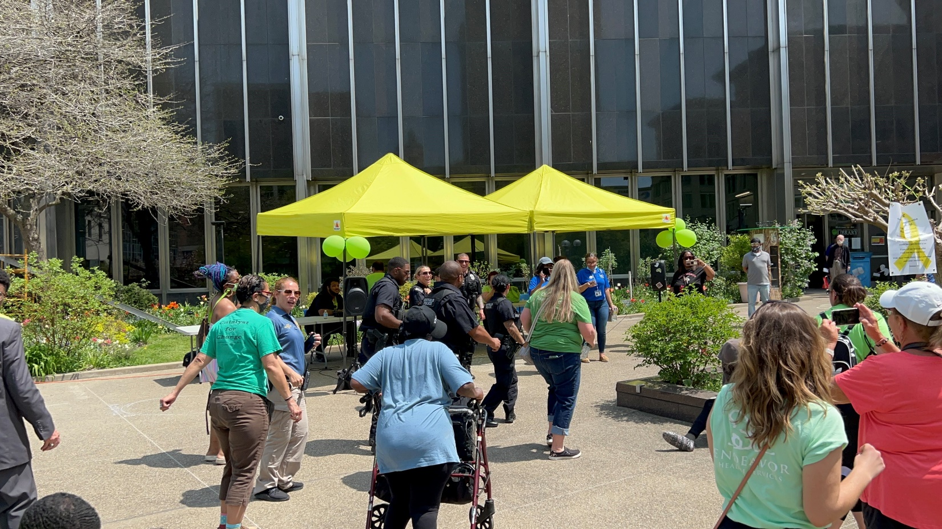
Health Homes Care Coordination Director’s Report

Vision:
Western New York Independent Living Health Homes Care Coordination Department is WNYIL’s Care Coordination service that assists, facilitates, and advocates for its members to realize better health and social outcomes through developing and implementing individual care plans that improves one’s quality of life.

Summary:
WNYIL currently contracts with three Lead Health Homes in the Western New York/Genesee, Orleans, Wyoming County (GOW) region.
1. Greater Buffalo United Accountable Health Network (GBUAHN) operating in Erie and Niagara Counties.
2. Health Homes of Upstate New York Best Self operating in Erie and Niagara counties and
3. Health Homes of Upstate New York Huther-Doyle operating in Genesee & Orleans Counties.
This provides choice to the individuals we serve here at WNYIL.

What does the Health Home Coordination do and for whom? The WNYIL Health Homes Care Coordination Department provides Care Coordination services to ensure all those involved in an individual’s care are working together and sharing the necessary information in supporting a person’s recovery. A Health Home Care Coordinator is expected to help coordinate not just medical, mental health and substance abuse services, but the social service needs of the individual as well.

We:
- Coordinate care through effective communication with other providers,
- Advocate for individuals so they receive the care they deserve,
- Navigate the complex healthcare systems,
- Link people to resources for finding affordable housing, food, clothing, childcare and transportation,
- Assist people learn more about meaningful activities to improve their health and keep them healthy and
- Assist people identify goals and ensure everyone involved in their care understands their care plan, to best help them reach those goals.

Eligible individuals will have one or a combination of the following diagnosis: a significant mental illness, substance use disorder or suffer from chronic health conditions, i.e., asthma, diabetes, heart disease.

WNYIL Health Home Services are provided to people in a convenient location of their choice. This can be in our office, another provider’s office, in the community or right in the people’s home.

Many Medicaid beneficiaries suffer from multiple or severe chronic conditions and benefit from organized coordination and management of the health and long-term services they receive. WNYIL, through Health Home Care Coordination Program’s extensive work in applying transformation research and implementation initiatives, has been at the forefront of adopting a person-centered, recovery-focused delivery service model for its consumers, ultimately, making sure its consumers get the care and services they need. This may mean fewer trips to the emergency room or less time spent in the hospitals, getting regular care and services from doctors and providers, finding a safe place to live, and finding a way to get to medical appointments.

The WNYIL Health Home Care Coordination Department has, within this past year, continued to struggle with staffing continuity. Also, one of our contracted lead health homes underwent a redesignation from the New York State Department of Health and it was determined that the lead health home was not operating above the State’s minimum standards and has lost their designation as a lead health home. We maintained the enrolled consumers that we served through this contract and transferred these consumers to another service.

The hard work of the Health Home staff has improved the lives of countless people. 2021 continued to prove difficult with the challenges brought on by the COVID virus and its different variants. Staff succeeded by providing ongoing comprehensive care coordination remotely and face-to-face when county restrictions deemed viable. The other significant threat that plagues operations is maintaining our workforce as the candidate pool is significantly smaller. As the Director, I continue to work with and provide voice as it relates to mandated education/experience and reimbursement of service to maintain viability.

Hans Schiffert
Director of Health Homes Care Coordination

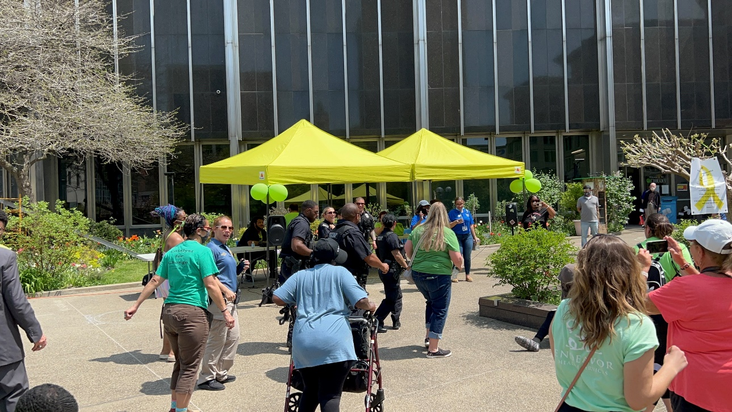
Young Leader’s and Advocates Network (YLAN)
Director’s Report

The Young Leaders and Advocates Network (YLAN) is the newest member of the Western New York Independent Living, Inc.’s Family of Agencies (WNYIL). As a statewide network run for, and by, young people with disabilities, YLAN is dedicated to uniting and empowering young people across the state. We ensure young people are authentically and meaningfully involved in all decisions that affect us. Together, we change systems so young people get the support they need with the respect and dignity they deserve.

Throughout the year, YLAN has worked to lay the foundation of the network. The YLAN team has developed relationship with partners statewide and nationally, participated in various committees and coalitions, and provided training and technical assistance to organizations across the state.

YLAN has provided support to the community by serving on the following committees:
• New York State Behavioral Health Services Advisory Council
• New York City Suicide Prevention Council
• New York Association on Independent Living Conference Committee
• May Mental Health Awareness Month Planning Committee
• WNYIL Disability Pride Parade Committee
• Integrated Block Grant Committee
Statewide Advisory Council for the Integration of the New York State Office of Mental Health (OMH) and New York State Office of Addiction Services and Supports (OASAS)

Systems Advocacy efforts this past year included:
- Provided input on the proposed integration of the Office of Mental Health and the Office of Addiction Services and Supports
- Partnered with the New York State Developmental Disabilities Planning Council (DDPC) to ensure young people provided input into the development of their State Plan
- Participated in a Virtual Rally and meetings with legislators for New York Association on Independent Living (NYAIL) and the Consumer-Directed Personal Assistance Association of New York State (CDPAANYS) advocacy week

YLAN has created blogs, videos, and participated in podcasts bringing forward the voices of young people on topics including:
• National Mentoring Month
• Jewish Disability Awareness and Inclusion Month
• National Kidney Month
• Autism Acceptance
• COVID-19 Vaccination in New York State

Brianna Gower
Director
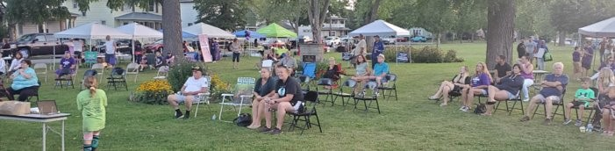
Western New York Independent Living, Inc.
Independent Living Center (ILC)
Mental Health Peer Connection (MHPC)
3108 Main Street, Buffalo, N.Y. 14214
716-836-0822
800-348-8399 (Toll Free)
716-835-3967 (Fax)
Independent Living of Niagara County
746 Portage Road, Niagara Falls, N.Y. 14301
716-284-4131
716-284-3230 (Fax)
855-366-1042 (Toll Free)

Independent Living of the Genesee Region
319 West Main Street, Batavia, N.Y. 14020
243 South Main Street, Albion, N.Y. 14411
585-815-8501
585-815-8502 (Fax)

Niagara Frontier Radio Reading Service
1199 Harlem Road, Buffalo, N.Y. 14227
716-821-5555

