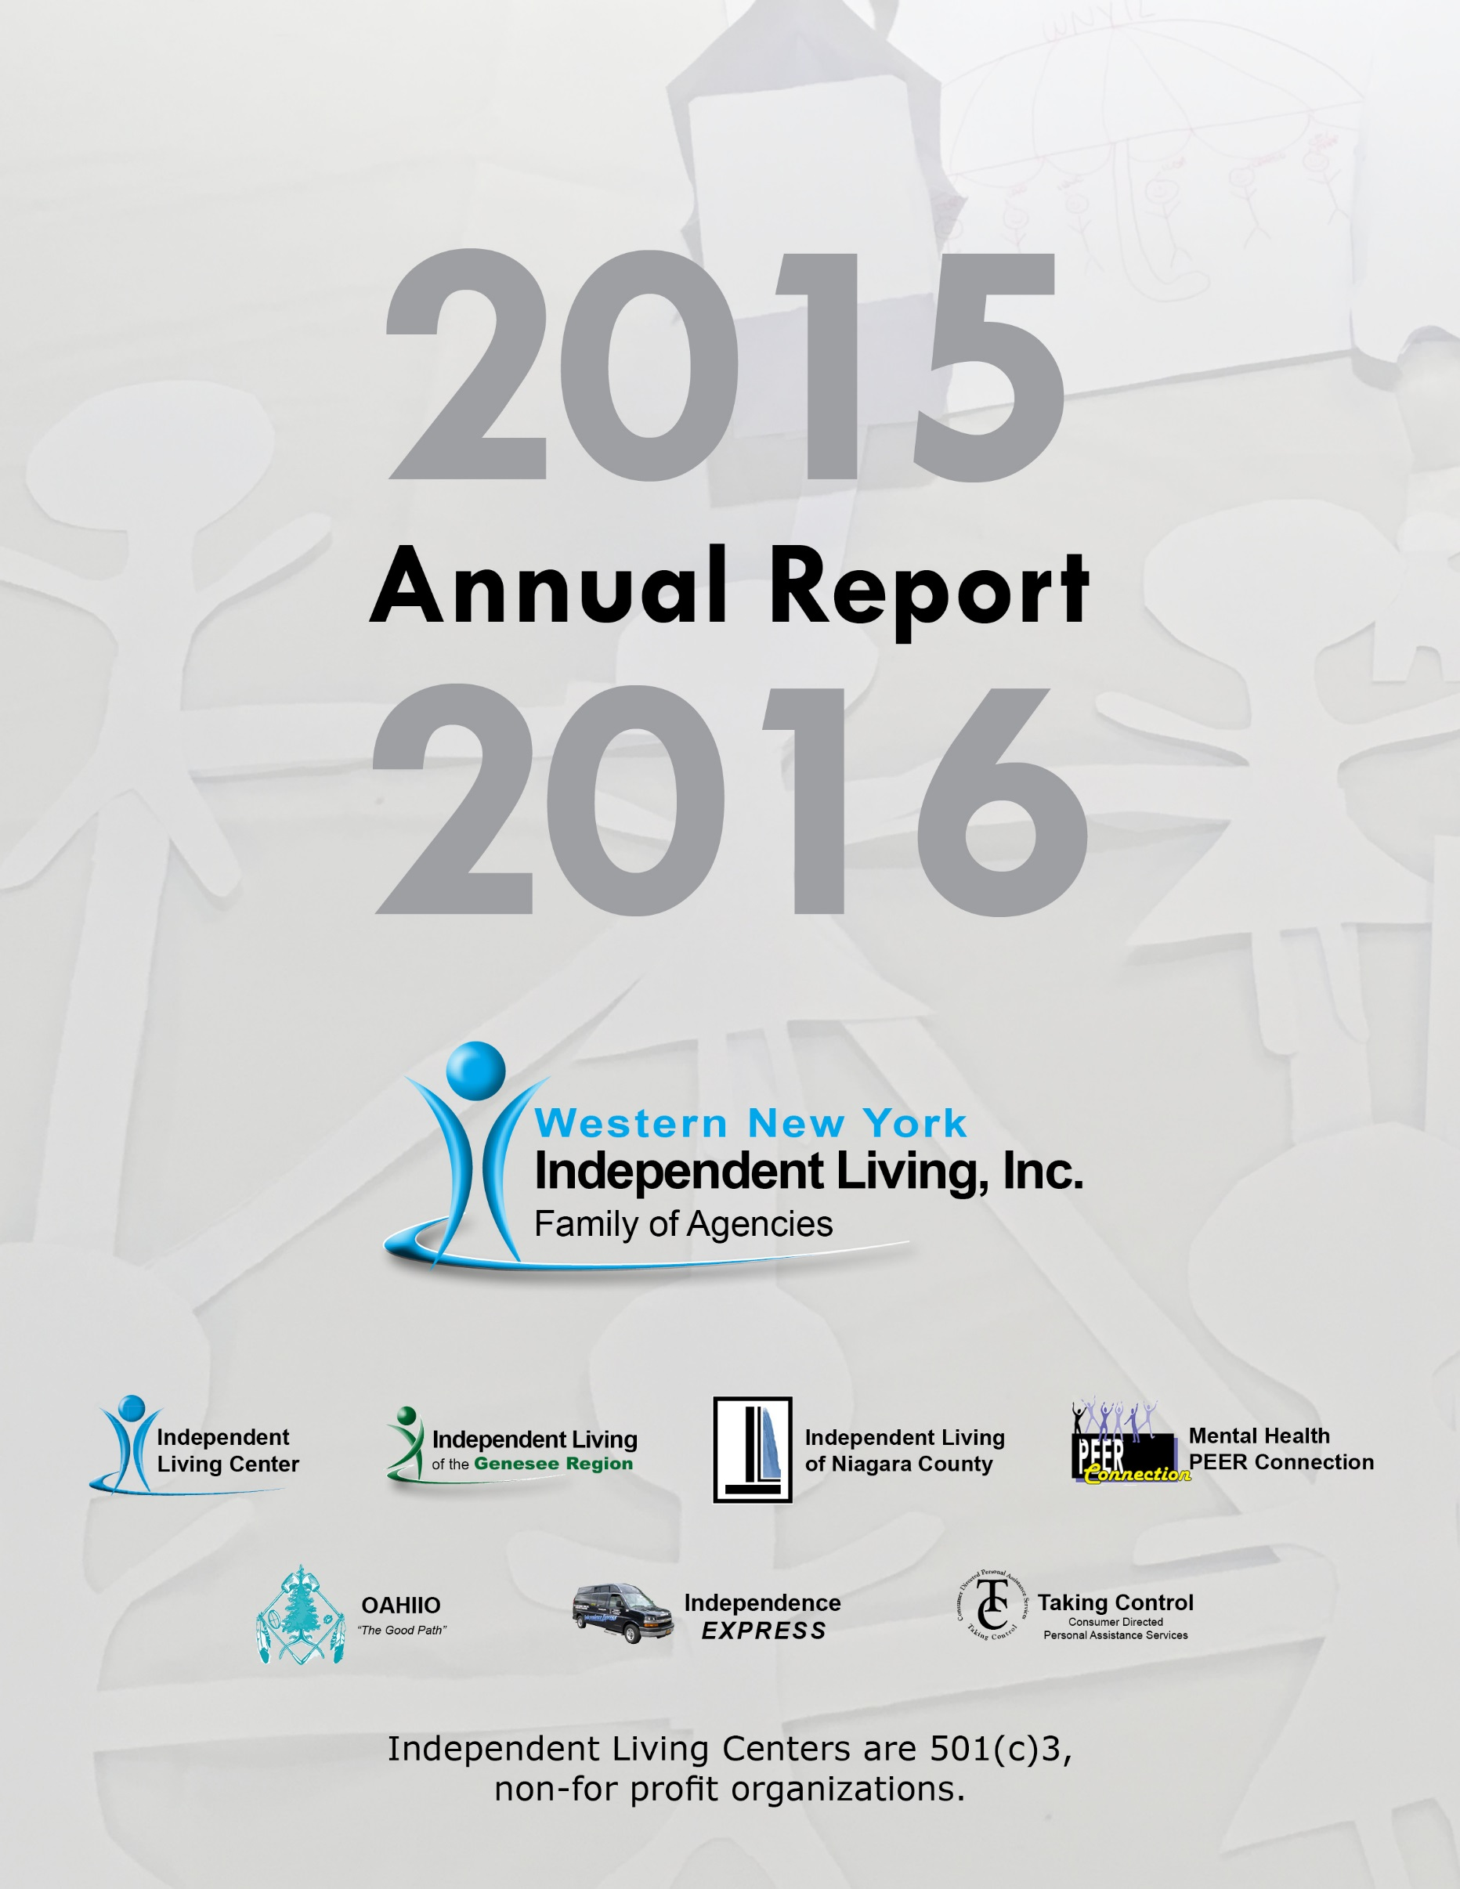
Western New York Independent Living, Inc.
Annual Report
Table of Contents

Western New York Independent Living, Inc. (WNYIL)
Vision, Services 3
History, Mission, WNYIL Board of Directors 4
ILGR, MHPC, OAHIIO, ILNC Councils 5
President’s Report 6
Executive Director’s Report 8
Vignettes 2015-2016 10
WNYIL Statistical Report 14
Statement of Financial Position 17
Statement of Activities 18
Mental Health Peer Connection (MHPC)
Director’s Report 20
Statistical Report 23
OAHIIO “The Good Path”
Director’s Report 26
Vignettes 2015-2016 29
Statistical Report 30
Independent Living of Niagara County (ILNC)
Director’s Report 33
Vignettes 2015-2016 35
Statistical Report 38
Independent Living of the Genesee Region (ILGR)
Director’s Report 42
Vignettes 2015-2016 44
Statistical Report 46
Independence Express Transportation Department
Director’s Report 49

Vision Statement WNYIL Inc. family of agencies is a catalyst for systems and individual change, enhancing the quality of life for people with disabilities while respecting diversity and promoting choice and alternatives for independent living in our societies.

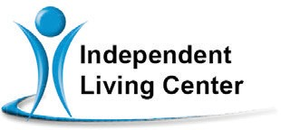

Independent Living of Niagara County

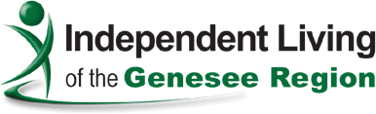

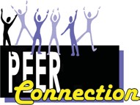
Mental Health PEER Connection

OAHIIO
“The Good Path”

CT
Taking Control
Consumer Directed Personal Assistance Program

Independence
EXPRESS

Independent Living Center provides transition services, Medicaid Service Coordination, care coordination, developmental disability and family reimbursement programs.

Independent Living of Niagara County (ILNC) provides independent living skills, educational advocacy, consumer- directed personal assistance services, and work incentives benefits advisement in Niagara County.

Independent Living of Genesee County (ILGR) provides independent living skills, educational advocacy, information & referral, peer counseling and financial advisement in Genesee, Orleans and Wyoming Counties.

Mental Health PEER Connection (MHPC) provides institutional, community and vocational-based services assisting consumers in their recovery process. Our program assists individuals in their recovery process.

OAHIIO is a “walls free” program that provides independent living services to all Native Americans with disabilities, on and off the reservations in WNY. Programs consist of educational advocacy, independent living skills, family support and life skills coaching.

Taking Control - Consumer Directed Personal Assistance
Services (CDPAS). Medicaid consumers may be eligible for
in-home personal assistance. The consumer hires, trains, and evaluates their own personal care attendant.

Independence Express WNYIL operates fee-based and funded transportation services for employment, family and recreational activities.

History Born in the nationwide independent living and civil rights movement, college students with disabilities who were fed up with discrimination and the lack of access for people with disabilities, decided to make their own opportunities and assist their peers to do the same.
In 1979 “The Independents,” a group of students with disabilities at the State University of New York at Buffalo, investigated the independent living movement and began operating the Western New York Independent Living Project (ILP). The agency was awarded a Federal Title VII grant in 1980 and opened its own facility early in 1981.

Mission Statement Western New York Independent Living, Inc. is a multi-cultural, grassroots, peer directed, civil rights organization that
provides a full range of assistance, programs, and services to enhance the
quality of life for all individuals with disabilities.

Western New York Independent Living, Inc.
Board of Directors

Dennis M. Kessel - President
Sean Quinn - 1st Vice President Richard Dread - 2nd Vice President Paul D. Beakman Sr. - Treasurer Sue Ann Sehl - Secretary Kimmarie Brown
Lisa Maria Cruz Barbara Gaetano Richard Koch Ellen Lawson Donald Le Ber Samuel Mattle Michael May
John Schappacher Ann Scherff

Independent Living of the Genesee Region Council
Ann Scherff - Chair
Kelly March - Vice Chair Barbara Hoffman - Treasurer Nathan Moffett - Secretary Ida Caldwell
Linda Makson

Mental Health PEER Connection Council
Donald Le Ber - Chair Joseph Macchia - Vice Chair
John Rooney – Treasurer/Secretary Ellen Lawson
Bobbie Jo R. Meyer Lawrence Nowell Noel Young

OAHIIO Council Kimmarie Brown - Chair James Hill
Miguel Santos Lucille Sherlick

Independent Living of Niagara County Council
Paul Beakman - Chair John Schappacher - Vice Chair
Barbara Gaetano – Treasurer/Secretary Gracie Chambers
Darlene Cutonilli Megan Diamond Brigid Dillman Lana Redell Darren Sneed

Report from the President of Western New York Independent Living, Inc.
Welcome to the 36th version of Western New York Independent Living (WNYIL)’s Annual Report. Our first Annual Report was just four pages; and, if you read this entire document, you would have enjoyed 49 pages telling you what we have done, where we have done it, and why we do it. Our work in the Counties and communities of WNY continues to expand, and, in this past year, our “Family of Agencies” has touched the lives of over 7,000 people who are, who live with, or who are working with, people with disabilities.

So, let’s take a walk down Memory Lane for 2015 to 2016, and see what are
the highlights of this past Fiscal Year.

Mental Health PEER Connection (MHPC) has been approved to provide peer services for Medicaid-eligible persons, such as Home and Community-
Based Services (HCBS), funded through the New York State Office of Mental Health (OMH), and is eligible to be a Health and Recovery Plan (HARP) provider as well. This is a milestone to be noted, as, for the first-time,
it brings Medicaid-funded peer services to our brothers and sisters with
mental health disabilities in Western New York.

Other brag-worthy accomplishments:

  - MHPC has been awarded a contract to assist, link, and connect resources to individuals who have experienced a heroin, opioid, or other drug overdose, or who otherwise want to deal with their substance abuse. This effort, “Addict 2 Addict; Family 2 Family”, is not only to assist the individual to find recovery, but will also give the family support through this difficult time.
  - Independent Living of Niagara County (ILNC) has expanded by hiring two Medicaid Service Coordinators (MSCs), to bring Independent Living (IL) philosophy and support to folks with Developmental Disabilities and their families, in Niagara County.
  - The home base of WNYIL, the Independent Living Center of Western New York, has expanded its capacity by offering Certified Benefits Advisement; and, through the New York State Office of People With Developmental Disabilities (OPWDD)’s Balancing Incentive Program (BIP), has found jobs and housing for individuals with developmental disabilities who wanted to seek the Independent Living path, but could not previously make the connection.

  - OAHIIO has entered into a contract with the Seneca Nation of Indians, and will be coordinating Consumer-Directed Personal Assistance Services (CDPAS) for the Native American elderly. Our “walls-free program” has also been awarded a Native American outreach contract by the Federal Administration on Community Living (ACL), to work at establishing stronger relationships with the three Western New York Native American nations.
  - WNYIL has established a Health Home (HH) Department, working with three of our region’s HH providers, coordinating health care plans for hundreds of people with behavioral health disabilities and/or two or more chronic conditions, so they may live healthier lives.
  - Our Consumer Directed Personal Assistance Service, “Taking Control”, has grown by over 45% in the past year, serving over 1,000 consumers in six Counties, and managing over 1,300 attendants.
  - Independence Express has brought three new vans into our fleet, replacing two high-mileage vehicles, and expanding by one. Our thanks to all who supported the “Night for Independence Gala”, where all profits went to the purchase of vans.
  - Independent Living of the Genesee Region (ILGR) has been able to secure a contract with the New York State Delivery System Reform Incentive Payment (DSRIP) Performing Provider System for our area, introducing the importance of person-centered planning, and bringing IL philosophy into this region’s health care systems.

I could go on and on and on. But, in conclusion, I will share with you the following words that were inscribed in a plaque that was presented this past September 15th to Western New York Independent Living by the New York Association of Psychiatric Rehabilitation Services (NYAPRS):

The NYAPRS Board of Directors is pleased to present the Marty Smith Memorial Award to Western New York Independent Living, in recognition of your groundbreaking advancement of best practices in service to New Yorkers with psychiatric disabilities.
Need I say any more?... Dennis M. Kessel
President

Report from the Executive Director of Western New York Independent Living, Inc.
Every year, I present to you my thoughts and concerns, along with trumpeting our victories, in these Annual Report reflections, and this year will be no different. Wherever I look back, I see growth, strength, and a world made a better place by our embracing our brothers and sisters with disabilities. Also, I see that many people with disabilities have become an active part of our society, and have, in turn, contributed for the betterment of all.

However, as I look forward, I cannot help but feel great concern. I see a road ahead of us that may be considerably harder than the one that we are already traversing. I reflect that, four decades or so ago, our efforts were focused on gaining the rights that the able-bodied majority enjoyed: to be able to navigate through our communities without barriers to our progress; to apply for a job without disability-based prejudice; and to have the right to participate in all facets of life, regardless of the mental, physical, sensory, or intellectual limitations that challenged us.

Our efforts brought change, as we saw laws and regulations enacted: Rehabilitation Act, Section 504 (the non-discrimination act for federally- funded programs); the Air Carriers Act (providing equal access for people with disabilities who want to fly); the Fair Housing Act (permitting equal housing rights for people with disabilities); and the Americans with Disabilities Act (ADA, a law that provides opportunities to eliminate barriers for people with disabilities in many aspects of our society).

Yet, even now, I see increasing, constant attacks on those rights that give people with disabilities the right to work, live, and play in our communities. I see assaults on our right to have equal access to services that can mean the difference in being able to participate.

“It couldn’t happen; we’ve come too far!” you say? I will share with you a conversation that included me. I will not state who said it, nor will I identify the service to which it referred…but, what I will do is pull out one statement that exemplifies what I mean.

In a conversation among professionals, a person said, “People who use wheelchairs are the smallest percentage of people with disabilities, and that if we allow [expletive] to happen, it really won’t affect that many.”

First, let me say that this may not be a word-for-word exact quote, since
I am working from memory, but it does make the same point; so let me share with you my concern. To purposely exclude any group or segment of our community from participation in, or the benefits from, any aspect of life is just wrong. This attitude, that any part of the disabled public is so small that it can easily be sacrificed, could shatter the hard-won belief in our concept of an America for all its citizens, and reveal the “melting pot of our nation” to be a myth! We cannot, as true Americans, allow the rights that our brothers and sisters have fought for to be altered at a whim. We cannot tolerate some individuals to go without, or not benefit from, the advantages of others, just because they are a small group, or “different”. I believe that we, as people with disabilities, could convince our elected leaders to include us into all aspects of our society through legislation, because it has become a principal tenet of America that all are equal, and that all have a right to participate.

As we face these new efforts to chip away at our rights, as we see proposals that are being drafted with the presumption that things will be better if we go back to the past ways of doing things; I ask you to stop and think for a minute.

Was it better when we who were considered “different” were forced into warehouses to live? Was it a better place when those of us who were unique were left in basements and attics? Was it a better place when, once we no longer fit into “the norm”, we could not work?

Please ask yourself the question: what makes your life better? Is it the potential different experiences you could find; that each day you can encounter new and exciting people, places, and things? Is it that those of us who want more out of life are able to stimulate growth in technology, leisure, and employment?

If you believe like I do, that American is great because of its differences, then join me and work with me -- and Independent Living -- in assuring that all the people have the right to Education that will Empower us to be an Equal player in our society.

Douglas J. Usiak
Executive Director

WNYIL Vignettes 2015-2016

- Long before he became disabled, a 28-year-old consumer was having run-ins with the law. By 14 years of age, he already had multiple arrests for using and dealing drugs, and carrying illegal weapons. Then, at 18 years, his dice game was interrupted by police sirens, causing him and his friends to flee. Before he could toss away the gun he was running with, five Buffalo Police officers converged on him, ultimately shooting him in the back. Fearing that he would not survive, he asked the policeman bending over him to tell his son that he loved him. Following back surgery, he did live, but was a quadriplegic, requiring a wheelchair for the rest of his life. Convicted on various charges, he was sentenced to ten years in prison, an even more dangerous place for a prisoner who lacked mobility.

Upon his release, knowing that the ex-offender would need all the services he could obtain, his Parole Officer made a referral to Western New York Independent Living Inc. (WNYIL). Of the several goals that he established, the most important – and difficult -- was housing, as he required an apartment that is wheelchair-accessible; so he stayed in a
motel for months of housing searches. He could have spent years moving from place to place, or possibly living on the streets, if not for a referral that was made by WNYIL to Neighborhood Legal Services, Inc. WNYIL staff assisted the consumer in filling out an application through Buffalo Municipal Housing Association (BMHA), which moved him up the waiting list, due to his diagnosis and the fact he was living in a motel. Regardless, it still took a lot of advocacy from WNYIL to get BMHA to finally place him in an apartment, so he has a roof over his head. For instance, WNYIL made referrals for him to get assistance with his security deposit, and linked him with sources for furniture and other household items.

At present, WNYIL is helping him to develop an important set of abilities that will serve him for the rest of his life: independent living skills. He has shared with staff that, during his ten years of imprisonment, the times have changed, as has the technology most people routinely use.
He can no longer make “easy money/fast money” on the street, but now must budget his funds, follow through with doctor visits, etc.; and he has learned to make his own appointments, reach them using
public transportation, and keep his apartment clean. He still needs some guidance, but he’s definitely come a long way. He has asked WNYIL to enroll him with New York State’s ACCES-VR (Adult Career and Continuing Educational Services – Vocational Rehabilitation), a program that will assist him in obtaining employment. The progress he has made, due to

WNYIL’s advocacy and his own compliance, prompted him to remark, “I’m very thankful for the services I have received through WNYIL, and how understanding and compassionate the staff has proved to be”.

- A man called Western New York Independent Living (WNYIL) concerning his daughter, who lost some of her fingers in a fire when she was very young, and was having difficulty obtaining her driver’s license. She was a Senior in college and wanted a license in order be able to apply for jobs, attend interviews, and just enjoy her life. Her father believed that the driving school where she was taking lessons was giving her a raw deal. A WNYIL staff Independent Living Specialist (ILS) working with the consumer and her father went to the Department of Motor Vehicles
(DMV) to explain the accommodations she needed and the obstacles she was facing. A DMV employee gave the ILS the name of a new driving school to investigate, and invited the woman to come down and talk with her. All agreed that the woman should have the same opportunities as everyone else does to take her road test to obtain her driver’s license. While completing her driving classes at the new school, the consumer became an intern at WNYIL, to gain experience in her major
(Psychology), and she did a fabulous job. Finally the consumer graduated from college, and, despite her father’s pessimism, obtained her driver’s license. She is now working at an agency where she is can employ her experience from her internship through WNYIL, and is able to use her major, Psychology at her job as well.

- A senior citizen sought the ILC’s help in transitioning from a nursing home to the community; but she no longer had a home to which she could return. ILC staff recommended some apartments which seemed safe and within her means, and assisted with applications, but, in the process, 62 additional possibilities were discovered. She moved out of the nursing home in April, and is now living happily in a senior apartment she selected, which is lovely, modern, safe and affordable. She is still dealing with challenges, such as health risks; she has had to go to the hospital for two surgeries, due to complications from, and the progression of,
her disabilities. Staff admires her independent spirit, her desire to live on her own, and real courage in confronting these barriers every day. They are glad to have met her, and gratified to have been a source of encouragement to her in achieving her goals.

- A consumer, “Jay”, came to the ILC for assistance to transition from a nursing home facility into his own apartment in the community. As staff got to know him and his dreams for a better future, she gradually learned what had brought him to this point: a long history of personal hardships

culminating with institutionalization.

He was in his early 50’s when he came to the Agency, but Jay had enjoyed a good life long ago, with a wife, a young son, and the start of a promising construction business. All that was shattered with the tragic violent death of his seven-year-old son, who was abducted, sexually assaulted and murdered right in their own neighborhood by a violent criminal pedophile. Not only did his marriage fall apart, but his wife subsequently committed suicide. This terrible tragedy started him on the long path of living in rooming houses, shelters, and sometimes on the streets for many years, due to long-term substance abuse. Although he had also been in and out of treatment programs, he told the staff, “My abuse of drugs destroyed my family, my business, my health, and my life”. A severe knee injury due to an assault while living in a rooming
house lead to surgery, and the placement for physical rehabilitation in the
nursing facility.

In spite of all he had been through, Jay remained articulate and intelligent. During his long hospitalization and rehabilitation, he had taken a serious look back on his life and determined to never go back to his old habits. Jay told staff that he viewed this as a second chance, and had a newfound determination to start over.

He knew that an essential part of his continued recovery was a secure and safe apartment that he could call home. As he worked with staff to prepare for his discharge, he took necessary steps to improve his condition. Jay followed through any tasks required, consistently and effectively, in order to apply for Social Security Disability Insurance
(SSDI), food stamps, and Department of Social Services (DSS) benefits. At the same time, he acted as an advocate for some of the other residents.

Eventually, staff was able to locate a nice wheelchair-accessible one- bedroom apartment, and secured funding, partially with a community grant, for his security deposit and first month’s rent. All this had to be done within a 48-hour time frame, with staff employing strong advocacy and dialogue with the landlord, as the landlord had other people in line also ready to take the apartment. ILC was also able to find donated household items to let him begin setting up his new home.

Today, not only is Jay enjoying his independence in his new home, but is participating in a recovery group! His new goal is to become a peer advocate, eventually, to support other people with disabilities in their

own recovery.

- “Joe”, a 30-year-old male who suffered a Traumatic Brain Injury at the age 18, had been living in a 24-hour certified group home in the community for two years. With the assistance of his WNYIL Medicaid Service Coordinator (MSC), he moved into his own apartment in June 2015. She was able to obtain funds for his initial rent and security deposit, as well as enabling him to purchase items for his new home.

Joe’s main goal for 2016 was to remain out of the group home and to continue to live in his own apartment. With the assistance of his MSC, Joe has obtained Consumer-Directed Personal Assistance Services, which allowed him to hire the Personal Attendant of his choice.

He also wanted to obtain a job in the community, but had to defer this goal due to health issues. While he seeks to resolve this situation, Joe will be learning more independent living skills, which will allow him to be more self-sufficient.

While Joe is very close to his family, he would like to participate in WNYIL programs that will teach him to become more self-reliant. His MSC enrolled Joe in Community Services for the Developmentally Disabled’s “Project COACH”, an evening and weekend hotline service. This provides Joe an alternative to calling his family when he needs help outside Agency business hours.

- An ILC Medicaid Service Coordinator (MSC) assisted “Joe Smith” in completing a New York State ACCES-VR (Adult Career and Continuing Educational Services – Vocational Rehabilitation) application prior to his Graduation and Transitioning into the work world. Working closely with ACCES-VR, his Individual Residential Alternative (IRA) group home staff, and assigned job coach, the MSC gathered the necessary and accurate information that would allow Joe to make a smooth transition into the work environment and be successful. Joe now has employment, is happy with his position, and continuing to grow in his independence.

Annual Report 2015-2016 Statistics WNYIL

Total Number of Consumers Served: 3113

Number of Consumers by Age:
Under 5 years old: 39
Ages 5-19: 720
Ages 20-24: 223
Ages 25-59: 1390
Age 60 and older: 727
Age unavailable: 14

Number of Consumers by Gender:
Female: 1624
Male: 1486
Gender unavailable: 3

Number of Consumers by Race and Ethnicity:
American Indian or Alaska Native: 53 Asian: 65
Black or African American: 832 Hawaiian or Other Pacific Islander: 2 White: 1481
Hispanic or Latino: 144 Two or More Races: 33
Race/Ethnicity unavailable: 503

Number of Consumers by Disability*:
Cognitive: 1587
Mental/Emotional: 1687
Physical: 2156
Sensory (hearing, vision, etc.): 546
Multiple Disabilities: 1661
*Some consumers may have indicated more than 1 disability category.

Number of Consumers by County of Residence:
Albany: 2
Allegany: 22
Cattaraugus: 69
Cayuga: 1
Chautauqua: 110
Clinton: 5
Duchess: 1
Erie: 4601
Essex: 1
Franklin: 14
Genesee: 61
Herkimer: 1
Jefferson: 11
Lewis: 2
Livingston: 2
Niagara: 329
Onondaga: 1
Orange: 2
Orleans: 34
St. Lawrence: 14
Sullivan: 2
Wayne: 1
Wyoming: 8 Outside of NY: 4
*County numbers include consumers with disabilities as well as casual contacts and information and referral for people with and without disabilities.

Number of Consumers by Veteran Status:
Veteran (served in US military): 62
Non-veteran (never served in US military): 2432 Status unavailable: 619

Number of Consumers by Services Received*:
Advocacy/legal services: 442 Architectural barrier services: 10 Assistive devices/equipment: 56
Children’s services: 112
Communication services: 42
Counseling services: 81
Family services: 828
Housing and shelter services: 492 Information and referral services: 3902
IL skill development and life skills services: 406 Mobility training services: 17
Peer counseling services: 898 Personal assistance services: 594 Recreational services: 211
Transportation services: 330
Youth services: 79
Vocational services: 350
Plan for the achievement of self support services: 1
Benefits advisement services: 698 Voter registration services: 12 Other services: 366
*Some consumers may have received more than 1 service.

Number of Businesses/Agencies Served: 64

Western New York Independent Living, Inc.

Statement of Financial Position September 30, 2016 and 2015

ASSETS
 | 2016 |  | 2015
Current assets:
Cash and equivalents | $ 359,722 |  | 457,582
Contracts and fees receivable | 5,127,062 |  | 3,493,293
Prepaid insurance and expenses | 20,404 |  | 57,081
Investments - non marketable securities | 9,962 |  | 9,962
Total current assets | 5,517,150 |  | 4,017,918
Property and equipment, at cost:
Leasehold improvements | 1,347,279 |  | 1,327,564
Office equipment | 330,185 |  | 316,634
Vans and related equipment | 252,599 |  | 239,285
Computers and related equipment | 355,070 |  | 342,658
 | 2,285,133 |  | 2,226,141
Less accumulated depreciation | (1,699,566) |  | (1,598,229)
Net property and equipment | 585,567 |  | 627,912
Other assets - security deposits | 2,500 |  | 2,500
 | $ 6,105,217 |  | $4,648,330
LIABILITIES AND NET ASSETS
Current liabilities:
Accounts payable |  | 379,454 |  | 309,533
Deferred revenue |  | 827,644 |  | 508,472
Accrued salaries |  | 680,881 |  | 828,458
Accrued expenses |  | 202,213 |  | 171,086
Total current liabilities |  | 2,090,192 |  | 1,817,549
Unrestricted net assets |  | 4,015,025 |  | 2,830,781
Total liabilities and net assets |  | $ 6,105,217 |  | 4,648,3306

Western New York Independent Living, Inc.

Statement of Activities Years ended September 30, 2016 and 2015

 | 2016 | 2015
Unrestricted revenue:
Contracts and grants | $ 4,935,887 | 4,080,942
Consumer directed personal assistant services | 19,416,860 | 12,491,588
Fees for services | 562,859 | 292,396
Contributions and membership | 2,263 | 4,660
Fund raising | 63,679 | 55,016
Investment income | 5,640 | 3,242
Other revenues | 16,164 | 20,651
Total unrestricted revenue | $25,003,352 | $16,948,495
Unrestricted expenses:
Program services | 22,213,534 | 15,047,448
Management and general | 1,605,574 | 1,329,047
Total unrestricted expenses | 23,819,108 | 16,376,495
Increase in unrestricted net assets | 1,184,244 | 572,000
Unrestricted net assets at beginning of year | 2,830,781 | 2,258,781
Unrestricted net assets at end of year | $ 4,015,025 | 2,830,781

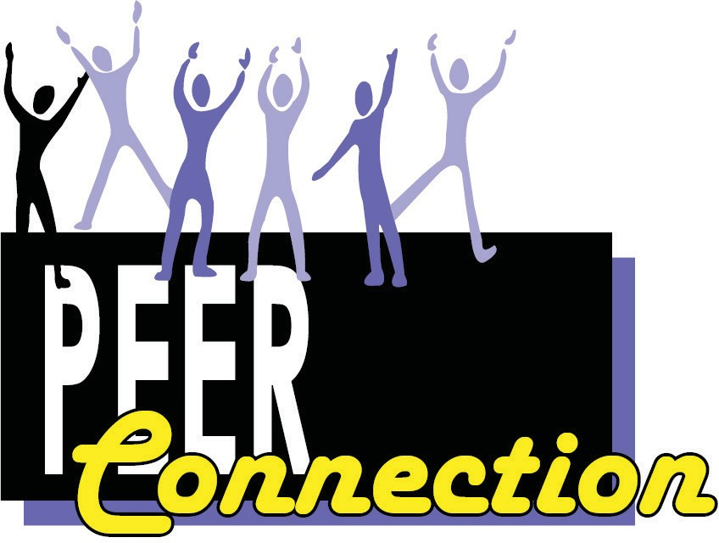

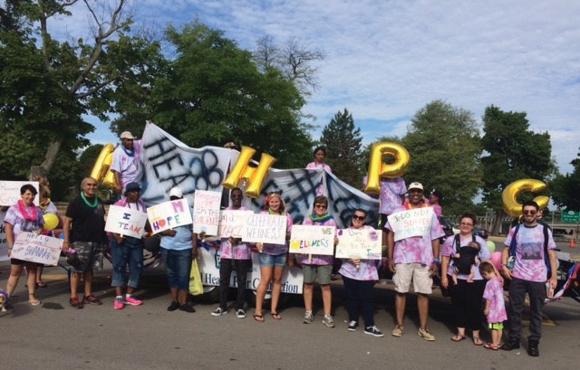

Report of the Director of Mental Health PEER Connection
“Meeting the Changes, Making them Effective”
As I sit down and reflect on the 2016 Mental Health PEER Connection (MHPC) Annual Report, I think of the 20-plus-year history of Mental Health Peer Services being provided at the WNYIL, and I marvel at the continued growth of MHPC and its ability to anticipate, adjust, and adapt to the ever-changing needs, roles, and importance of our Services in Erie County, New York.

During this year, MHPC, once again touched thousands of lives through education, advocacy, peer counseling, information and referrals, independent living skills, and transitions from institutions. As funding dollars become tighter, we have managed to grow and adapt to different funding streams and needed qualifications to receive funds.

For the first time ever, in 2016, MHPC staff who have been working longer than a year with our agency all became what is called “New York State Certified Peers.” Yes, we are now “Certified as Peers.” Along with having been diagnosed with a behavioral health issue to be a Peer, we are now educated, trained, tested, and approved by the New York Peer Certification Board to earn that designation. I am proud to be a Peer, because it has opened up my life to total recovery; but, as my staff and myself have been acknowledged by the Certification Board, this indicates that we have obtained and mastered core fundamental values, ethics, knowledge and skills that enable us to better serve our fellow brothers and sisters. Also,
obtaining this certification for over 20 of our MHPC Staff means that we are now “qualified” to bill Medicaid through Managed Care Organizations for some of the services we provide. Yes, just as doctors and other health care providers can charge insurance providers, so can we. That is how much this Peer movement has changed over the years. WE once were considered an afterthought, having secret self-help support meetings in the middle of the night while we were patients on psych wards, and then, in the community, after we got out. Now we are present in almost every module of service for those with mental health issues.

As I have indicated in past Annual Reports, we are almost everywhere that you can find someone with a behavioral health issue in Erie County: hospitals, clinics, jails, prisons, nursing homes, community residences, Crisis Services, police departments, residential communities, apartments in the community, churches, community centers, Mental Health and Family
Courts, homeless shelters, soup kitchens, and on the streets, literally, often,
24 hours per day.

WE initially started being underwritten in 1994 by New York State Office of Mental Health Reinvestment Funds. Today, we are funded by many sources and can even bill for our services. This has just started. But we have spent most of 2016 getting prepared and ready to take on this huge endeavor. Not only has MHPC needed to change our agency process of delivering service, but, more than ever, we have had to rely on the infrastructure of the entire Western New York Independent Living (WNYIL) Family of Agencies to implement needed changes. We must comply with: Contract Coordination requirements, the Health Insurance Portability and Accountability Act (HIPAA), Corporate Compliance, Human Services Billing Department, new Technology and Community Outreach and Engagement. Without these core and necessary services built-in to the whole infrastructure of the WNYIL,
we would literally be up a creek without a paddle. The capacity of the entire WNYIL has made MHPC a viable, competitive, and successful “product” to sell to the “buyers” and ultimately to the people whom we serve in their efforts to recover from behavioral health issues.

Our success is measured in our Outcomes:

We started a new Substance Use Disorder program for those addicted to chemicals and their families, in July, called “Addict 2 Addict; Family 2 Family”. It’s a 24-hour call-in service at 716-836-2726 for addicts and
family members to reach out and take that step “when they are ready” to stop and embrace recovery from addiction. For the first six months, we had over 200 calls. We responded to every call within two hours. But that’s not all: every caller who asked for us to help out -- that’s 100% -- followed through with “being ready” and got into the treatment that was best suited for them. Yes, 100%!

The Crisis Services Mobile Transition Team, who serve individuals currently in the psychiatric hospitals after numerous hospitalizations for life-threatening issues, prevented 78% of those individuals from being re-admitted to a psychiatric hospital within the first 90 days of hospital
discharge. This period is considered the most difficult time of transition for those who have been released, and the most likely time of re-admission.

Our Peer Support specialist, stationed at Erie County Medical Center (ECMC), provided almost 300 support groups to patients in the behavioral health units in 2016. Our peers gave hope, inspiration, and motivation
to those who were hospitalized – those who, until then, had no hope. This “Peer” staff also educated the hospital staff on our IL Philosophy and Recovery from mental illness, even giving the ECMC staff, itself, hope, and an expectation that everyone can live a productive life, despite being

labeled with a serious mental illness.

Our Enhancement Program, which served over 300 parents with children, who wished to be self-sufficient and independent of government hand-outs by becoming employed and contributing members of our community, met their goals for 2016. The parents being served learned about responsibility, accountability, and dependability.

These are just some of the “numbers” we obtained in 2016. But numbers alone to not give justice to each individual life that was impacted by our services … every person that received services from MHPC Peers and decided to have hope, set a goal, give it another try, and succeed! This type of success would not have occurred without our Peers working their own Recovery and applying their own skills and knowledge toward those they serve. I must also strongly recognize that our success is largely due to the countless hours, days, and weeks of work and endeavors of our behind-the- scenes departments that improve the lives of consumers who were labeled with a mental illness.

Yes, we have had growing pains. If we didn’t, we would not still be standing. Change is hard. Every person with a disability knows that. But just like our IL Philosophy teaches us, we will adapt, we will overcome, we will not only survive these changes in the health care system, we will thrive!

Maura Kelley
Director

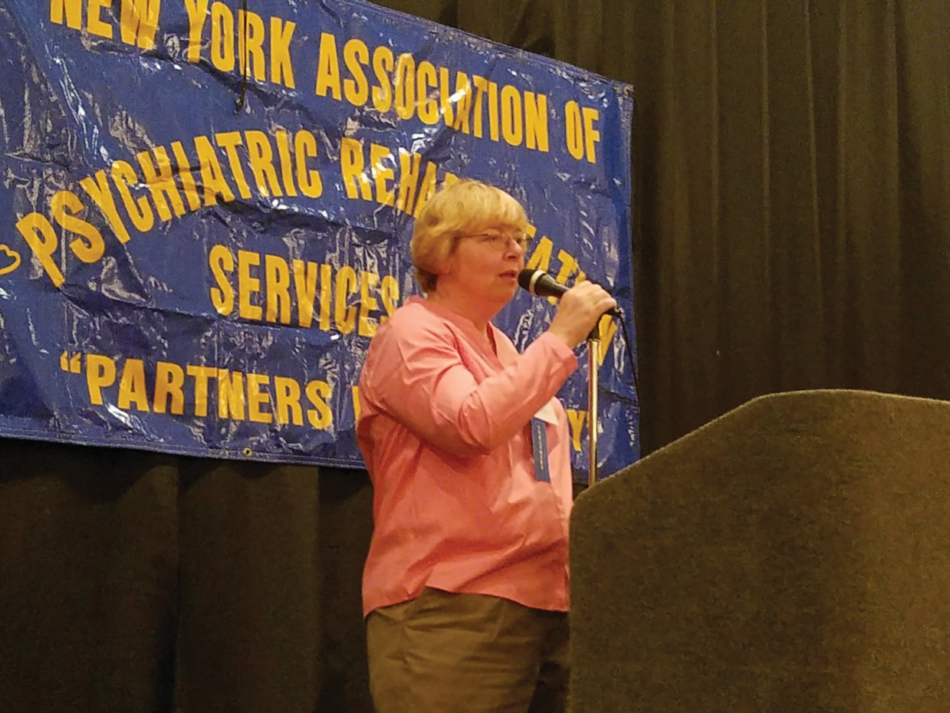

Annual Report 2015-2016 Statistics MHPC
ECMC Peer Support Program: Total individuals served: 1,502 Total visits: 2,600
Total groups: 480
Total treatment team meetings: 170
Total individual referrals for peer services: 40
Total individual referrals to community services/programs: 60

Crisis Services Mobile Transition Team Program:
Total individuals enrolled: 111
Percentage of individuals successfully avoided hospitalization for 90 days
post discharge: 78%

Addict to Addict Peer and Family Support Program*:
Total number of calls taken from individuals: 103 Total number of individual face to face meetings: 89 Total number of individual follow ups completed: 93 Total number of successful individual linkages: 103 Total number of calls taken from family: 60
Total number of family face to face meetings: 46 Total number of family follow ups completed: 49 Total number of successful family linkages: 60
Percentage of calls responded to within 2 hours: 100%
*Reflects August-December 2016 Data. Program began in August 2016.

ECDMH Benefits Advisement, Life Coaching, and Work Support
Programs*:
Total number of individuals who received benefits advisement services:
283
Total number of individuals served whose qualifying benefits were identified: 237
Total number of individuals who were certified or re certified for benefits:
75
Percentage of eligible employed individuals who maintained work
transition benefits: 89%
Total number of individuals who received life coaching services: 489 Total number of individuals who had an improved quality of life: 190 Total number of individuals whose basic needs (housing, financial,
mental, physical, wellness) were met: 52
Total number of individuals who completed a Wellness Recovery Action Plan (WRAP): 305
Total number of individuals who received work support services: 615
*Reflects January-December 2016 Data.

Enhancement Program:
Percentage of individuals who obtained employment through the program: 24%

OAHIIO The Good Path

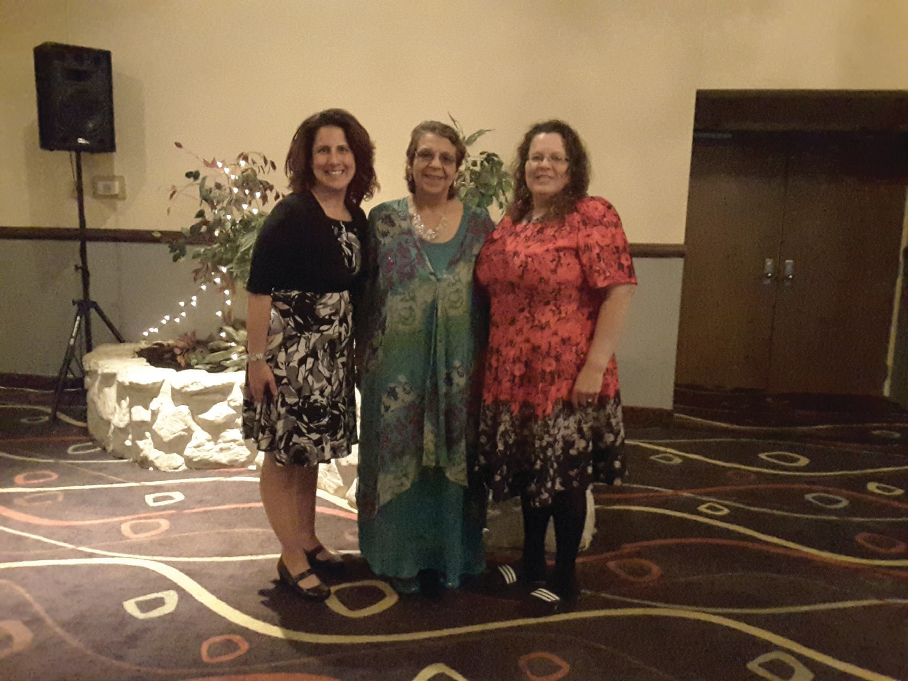

OAHIIO - ‘The Good Path’

OAHIIO - ‘The Good Path’ is a non-profit Independent Living Center that is staffed and governed by Native Americans with disabilities. We are a part of Western New York Independent Living, Inc.

Formerly known as NAILS, Native American Independent Living Services,
this center has been in existence since 1995.

Designed with a “walls-free” structure, OAHIIO allows advocates and specialists to work on-site with Native American Indians on the Tuscarora, Seneca Tonawanda, and Seneca Nation of Indians Territories, in addition to Native American Indians residing throughout Western New York.

We operate a consumer focused, person centered, culturally based organization, creating opportunities for choice, independence and community participation by advocating for the elimination of physical, cultural and attitudinal barriers that restrict individual access to entitlements and support services.

OAHIIO furnishes direct services to American Indians with disabilities in a culturally sensitive manner consisting of the five core services: Independent Living Skills: coaching consumers to improve daily living skills such as personal care, coping skills, financial management, and information about availability of relevant assistive technologies.

Information and Referral: provision of guidance to consumers by identifying available resources, providing answers to their concerns, and linking them to culturally sensitive service providers.

Advocacy: use of foundational knowledge of area agencies and community entities to aid consumers in obtaining their rights and entitlements. There are two types of advocacy offered at the Independent Living Centers of WNY Independent Living: Individual and Systems.

Peer Counseling: Native Americans with disabilities-peers- assist other
Native Americans with disabilities by sharing practical experiences.

Transition: defined in two ways 1). from youth to adulthood, learning the skills needed to “transition” into living independently. 2). People with disabilities transitioning from an institutional setting back into the community.

A couple of notable happening for this past year:

- October 19, 2015. As a result of Information and Referral and the advocacy of OAHIIO with the Seneca Nation of Indians, the Seneca Nation of Indians approached the agency with a Consumer Directed Personal Assistant Program for their seniors. This correlation is the first contract ever with an American Indian Nation in the twenty-year history of OAHIIO.

- September 30, 2016. OAHIIO received notification of being a recipient of the Native American Independent Living Demonstration Project to assist in the increase of Native American Indians being educated about, and receiving Independent Living services.

OAHIIO Services: Independent Living Specialist
Provides assistance and instruction to Native American Indians with
disabilities and requesting to learn daily living skills. These include managing family activities, household maintenance, work and education assignments through the use of tools, techniques and assistive technology.

Engagement and Referral Specialist
Funded by The Administration for Community Living (ACL), the Native American Independent Living Demonstration Project helps educate individuals with disabilities, living on Native Indian Territories or Native Indian communities, about Independent Living services.

This program was created to ensure an increased understanding of service
needs of Native Indians with disabilities and improve cultural competence.

No Wrong Door (NWD) Independent Living Specialist
Funded by the New York State Office For the Aging, the Balancing Incentive Program (BIP), along with New York Connects.
This program was created as a partnership to expand and enhance NY Connects program funding for opportunity for Independent Living Centers and/ or Community-Based organizations to provide Information and Assistance (I & A) and Options Counseling/Person-Centered Counseling (OC/PCC) for older adults with disabilities so that people can live independently and remain in their home and community.

Benefits Advisement
Provide information and assistance about work Social Security Administrative incentives to Social Security Disability (SSD) and Supplemental Security Income (SSI) beneficiaries by explaining how work activity and other income will impact his or her cash benefits and/or health insurance.

Cultural Competency and Sensitivity Training
Instructing people that deal with our constituency the ways Native consumers differ from European-based American culture and practices, thus broadening more traditional service providers’ understanding of Native American Indians.

Cynthia Printup-Harms Director

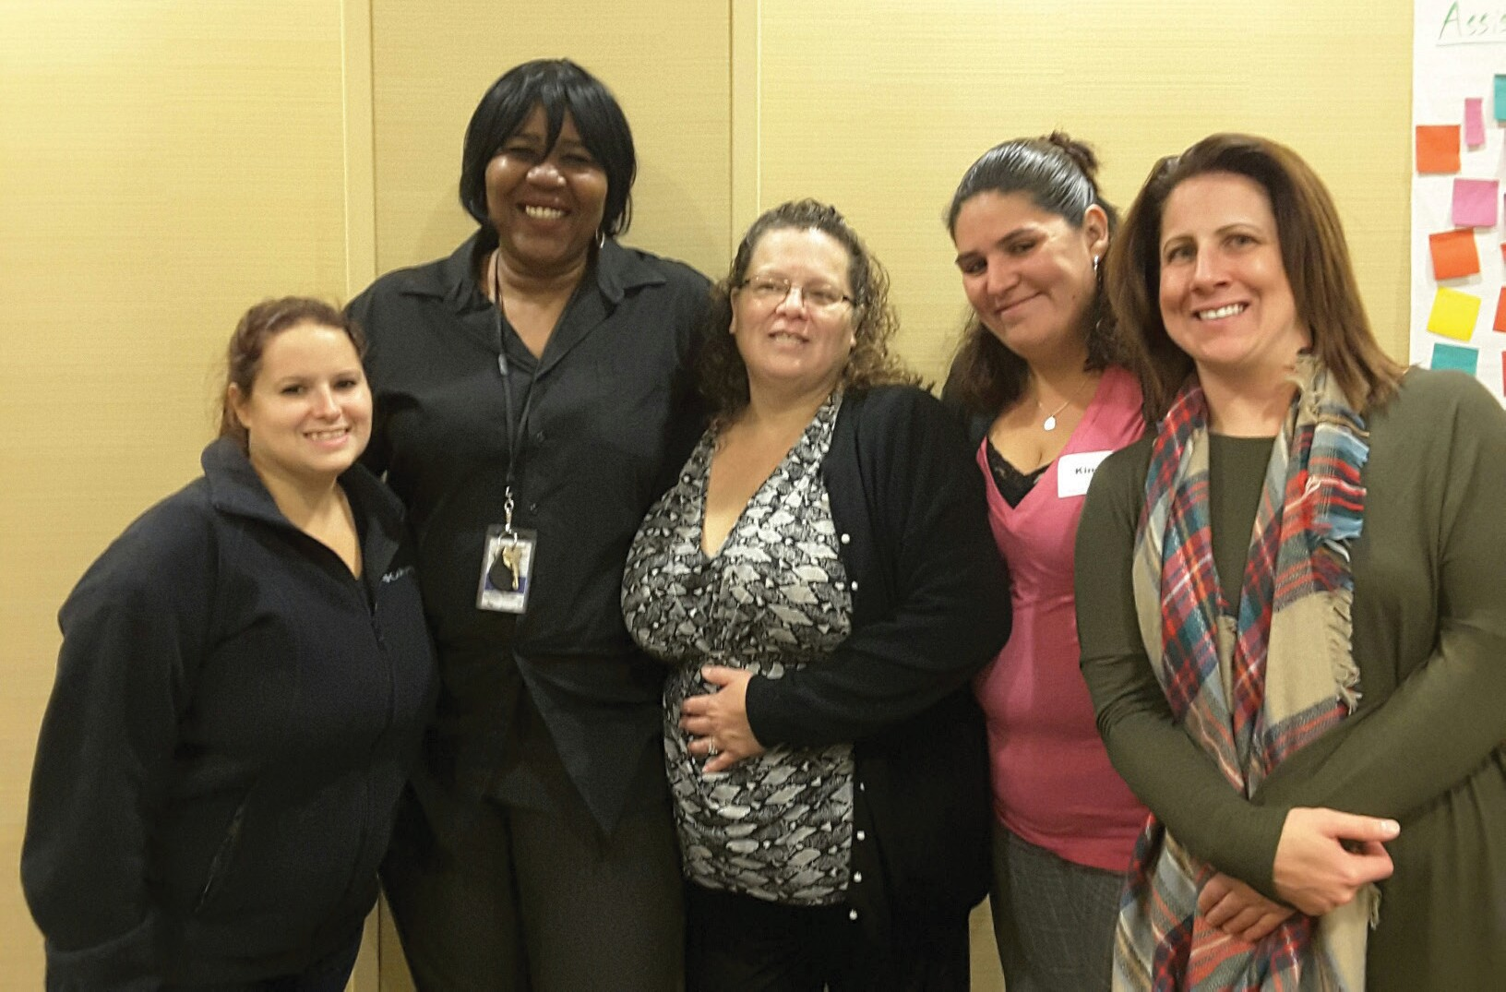

OAHIIO Vignettes 2015-2016

- Monique, a 61-year-old Native American Indian woman with physical disabilities and mental health issues, requested assistance in finding affordable housing. Her needs required that it be an apartment located on the first floor, or have availability to an elevator. OAHIIO staff worked with Monique extensively for about one year, seeking to locate appropriate housing for her. After numerous applications to various apartment complexes, she found a suitable unit in a subsidized building
– but that was not the end of her difficulties. Due to a turnover of staff within the building complex, Monique was informed that she would have to re-apply and start all over again. OAHIIO Staff intervened and
advocated for her, and she was able to move in within a few months. She currently lives in an apartment that meets her needs and allows her to live as part of the community, independently.

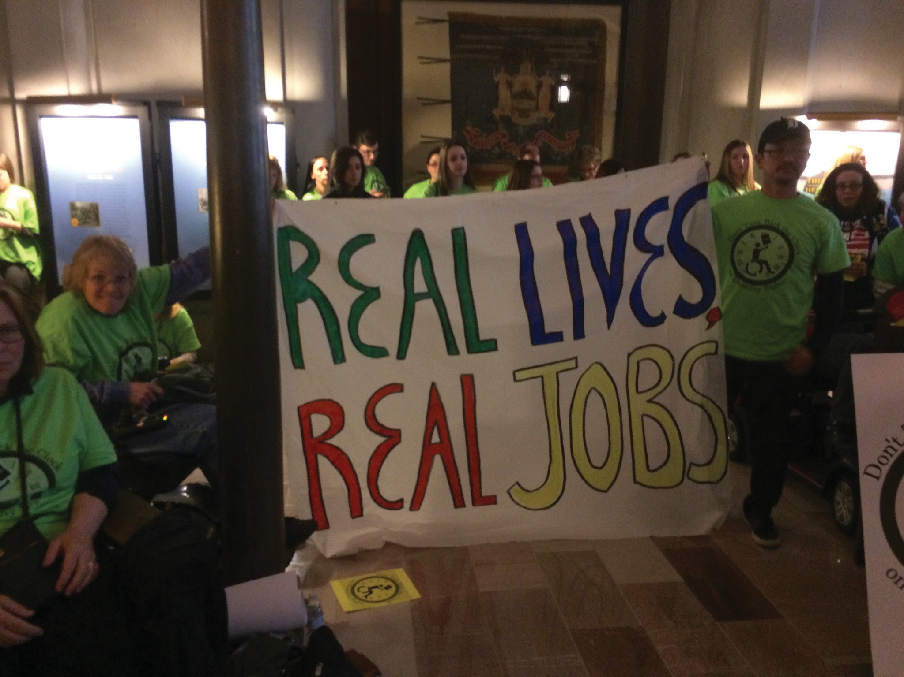

Annual Report 2015-2016 Statistics OAHIIO

Total Number of Consumers Served: 325

Number of Consumers by Age:
Under 5 years old: 10
Ages 5-19: 178
Ages 20-24: 28
Ages 25-59: 85
Age 60 and older: 22
Age unavailable: 2

Number of Consumers by Gender:
Female: 128
Male: 197

Number of Consumers by Race and Ethnicity:
American Indian or Alaska Native: 80 Black or African American: 27
White: 122
Hispanic or Latino: 5 Two or More Races: 10
Race/Ethnicity unavailable: 81

Number of Consumers by Disability:
Cognitive: 109
Mental/Emotional: 13
Physical: 35
Sensory (hearing, vision, etc.): 2
Multiple Disabilities: 165
Other: 1

Number of Consumers by County of Residence:
Allegany: 2
Cattaraugus: 6
Chautauqua: 7
Erie: 183
Franklin: 2
Genesee: 5
Niagara: 114
Orleans: 4
Wyoming: 1 Outside of NY: 1
*County numbers include consumers with disabilities as well as casual contacts and information and referral for people with and without disabilities

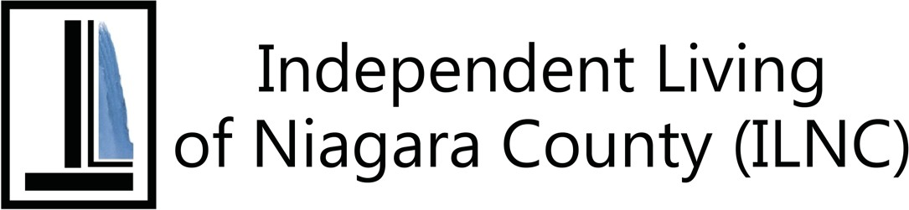

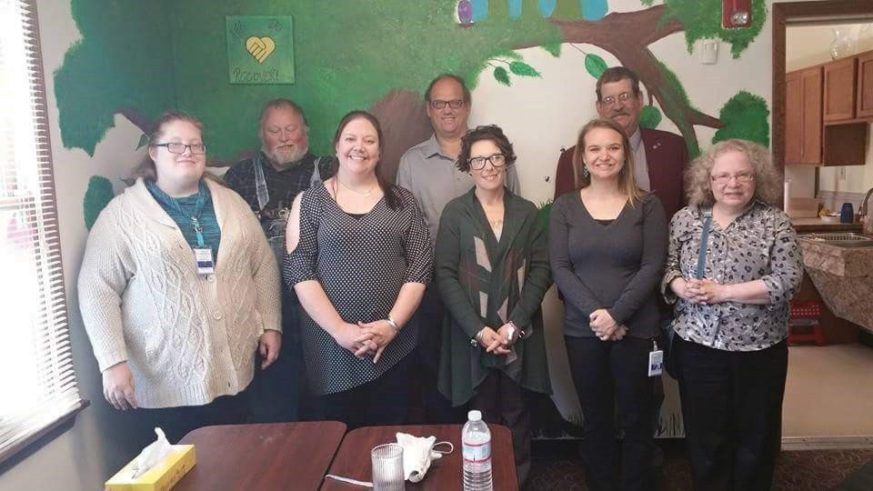

Independent Living of Niagara County

Independent Living of Niagara County (ILNC) works with people with disabilities, their families and their communities to continue our mission: Education, Empowerment and working for the Equality of people with disabilities in Niagara County. ILNC is always seeking ways to continue to expand our programs and services to meet the needs of people with
whom we work. As a result of the ILNC Team being actively involved within Niagara County, there were many accomplishments made during the Fiscal Year 2015-2016, an amazing year for growth, change, development and transformation at our Agency. Through the addition of new collaborations, partnerships and programs, ILNC’s team has continued to grow and augment our services to work from multiple locations.

ILNC’s “Taking Control” Consumer-Directed Personal Assistance Services
(CDPAS) Program has continued to serve more consumers.

ILNC Events:

  - October 2015. ILNC’s Meet the Candidates Day hosted several participants on the November ballot, including Niagara Falls Mayor Paul Dyster, Niagara Falls Councilman Ezra P. Scott, Jr., and Niagara County Clerk Joseph Jastrzemski.

  - December 2015. A Town Hall Meeting on Bullying Awareness and Prevention was held at ILNC’s offices, hosted by Todd Vaarwerk, WNYIL’s Director of Advocacy and Public Policy.

  - February 2016. Consumers and Staff from ILNC participated in the New York Association for Independent Living (NYAIL)’s Legislator Education Day in Albany. Visits were made to Senator Robert Ortt, Assemblywoman Jane Corwin, and Assemblyman John Ceretto to explain the importance of the local Independent Living Center (ILC), examine the vital issues facing the ILC’s and the state, and demonstrating the value of consumer choice, the impact of the involvement of the local ILC, and the ways that the consumers feel empowered.

  - March 2016. ILNC’s Policymaker Breakfast with Guest Speaker the Honorable Paul A. Dyster, Mayor of the City of Niagara Falls at Antonio’s Banquet and Conference Center.

  - June 2016. ILNC’s Disability Pride Niagara Olmstead Celebration at Niagara Falls’ Hyde Park, saluting the anniversary of the US Supreme Court’s Olmstead Decision, was marked by consumer involvement.
An opportunity was presented for ILNC participants and staff to share with Niagara Falls Mayor Dyster regarding the accessibility challenges found in the Cataract City. From this meeting, there was a commitment made to form a Niagara Falls City Accessibility Committee to assist local government in ensuring that compliance is kept.

  - July 2016. ILNC showed that donating to the cause can be pretty sweet, at its first Flapjack Fundraiser at the Applebee’s Neighborhood Bar & Grill in Niagara Falls.

  - July 2016. ILNC Staff and volunteers participated in WNYIL’s two-day
Disability Pride Celebration and Parade at Delaware Park in Buffalo.

  - August 2016. ILNC’s 11th Annual Bass Fishing Derby at the Old Fort Niagara Boat Launch attracted 31 anglers from different parts of the region and state, who were accommodated by 13 boat captains. At the Barbeque that followed at the Fin Feather and Fur Conservation Club in Lewiston, that number swelled to 54!

Increased accessibility for citizens with disabilities was won in the following areas, thanks to the advocacy of ILNC.
  - The Henry J. Kalfas Magnet School incorporated curriculum into its staff development training to introduce American Sign Language and disability awareness.

  - ILNC staff provided presentations at all Niagara County Nutrition Sites introducing IL Philosophy and all programs and services that are offered at ILNC.

  - Assisted the Niagara County Office for the Aging in becoming
accessible to people with disabilities.

Sarah Lanzo
Director

ILNC Vignettes 2015-2016

- Peter, a 60-year-old male, who is a quadriplegic and had been living in an institution for a long period of time, wished to live independently in his own home again. Through WNYIL’s Taking Control Consumer-Directed Personal Assistance Services (CDPAS) Program, Peter was able to hire his own Personal Attendants and return home, where he is happily living the life that once was only a dream. He’s now thinking of volunteering at some service organization to get out in the community and enjoy time with other people.

- Ron is a 59-year-old male who has severe post-traumatic stress disorder, depression, and diabetic neuropathy. He lives alone, but has always depended on a friend who would help out whenever he had the time. After enrolling in the Taking Control CDPAS Program, Ron was given an availability list to help find a personal care attendant. After interviewing several people, Ron hired a Personal Attendant (PA) who, he says, has changed his life. He now looks forward to each day and, after years of being unable to leave his apartment, Ron made a trip to Walmart with his PA. He reported that he feels like living again, and couldn’t be happier.

- Cynthia is a 23-year-old female who has been diagnosed with Autism; and who also struggles greatly with her anxiety, especially when she’s essentially idle throughout her day. Over the last few years, Cynthia completed classes and trained at different jobs to enlarge her résumé. She also attended the Young Adult Life Transitions (YALT) program and thought she would be able to get a job through it, but she didn’t. She came to an Independent Living of Niagara County Medicaid Service Coordinator (MSC) and Employment Specialist, to see if they could help her find a path to employment. Over months of hard work by Cynthia and her team, they were able to get her involved in an Employment Training Program, where she is guaranteed to find a paid internship, with a high probably of being hired as a full employee.

- Bruce is a 54-year-old male, diagnosed with Cerebral Palsy, who also must deal with a lack of depth perception in his vision. For years, Bruce has been trying to sign up for Food Stamp assistance, but inexplicably, each time he applied for it, he would never get a response. His Independent Living of Niagara County Medicaid Service Coordinator (MSC) made some inquiries and discovered there was another Bruce with the same last name, who lived in a different county. Whenever his team would apply for Food Stamps, the other Bruce would receive the benefits. After discussions with both the Erie County and Niagara County

Departments of Social Service, the MSC was able to end this confusion and reapplied for the assistance. The MSC hand-delivered the application to the correct county, and was finally able to get Food Stamps for Bruce.

- John, a 51-year-old male who manages both a physical and mental disability, must deal with the long-term effects from a severe injury he sustained several years ago, along with an anxiety disorder. After lengthy discussions about him returning to work, he tried self-employment as a cab driver, but, after a month, he realized it wasn’t for him. Recently, John has been hired to work the night shift, approximately 15 hours per week, at a local Seven-Eleven Convenience Store. Since he is a Supplemental Security Income (SSI) recipient, he is interested in applying for a Plan to Achieve Self-Support (PASS Plan). Ideally, he would like to start his own business selling used cars. During this time, he has also been training a puppy to be his service animal to help defuse his anxiety.

- Karen is a 51-year-old married female who had been employed at HSBC Bank as an Administrative Assistant. In 2013, Karen was diagnosed with Leukemia and had to leave her job. Over a three-year period, she had to submit to extensive chemotherapy treatments, along with undergoing a bone marrow transplant. However, shortly following the transplant, Karen regained her strength and was able to return to work, 25 hours per week, in July, 2015. At this time, Karen and ILNC staff are exploring potential deductions for Impairment-Related Work Expenses (IRWEs), due to her high medical costs. They are also looking into the Medicaid Buy-In Program for Working People with Disabilities.

- Consumer “S” is a 37-year-old deaf single mother of one child, who moved to Niagara Falls, New York, but was homeless for several months. Her sister had received services from Independent Living of Niagara County, and she referred S to ILNC. Staff assisted S with temporary
and permanent housing and peer counseling, helping her fill out many applications for housing in Niagara County. As she sought employment, staff assisted her with filling out the application for Adult Career and Continuing Educational Services - Vocational Rehabilitation (ACCES-VR). S reports she is no longer homeless, but happy, living independently with her son in Niagara Falls, and looking forward to finding employment.

- Staff received a referral for an individual who intended to transition back to the community from a nursing facility. The consumer recently had been in a winter storm with no gloves, and received severe frost bite
on all of his fingers resulting in the amputation of those fingers. The
consumer was in Delaware Nursing and Rehab, getting rehab and training

on prosthetic fingers. The consumers insurance stopped covering the rehab, and the facility then attempted to discharge the individual as a “homeless discharge”. Staff from ILNC advocated for the consumer with nursing home staff, highlighting that this is not a safe discharge plan at all, and if discharged homeless, the consumer would no longer qualify for additional training with his new prosthetics, or any other follow up
care. Staff from ILNC found the consumer accessible, subsidized housing, and strongly advocated that the nursing facility wait for this alternative, safe discharge plan that would better serve the consumer, rather than the faster, homeless discharge. The nursing home relented, and the consumer successfully transitioned to the safer, accessible housing.

- Open Doors/Money Follows the Person staff received a referral for an individual who intended to transition back to the community from a nursing facility. Having been in a winter storm with no gloves, the consumer received severe frostbite on all of his fingers, resulting in
their amputation. He was in Delaware Nursing and Rehabilitation Center, getting rehabilitation and training on the use of prosthetic fingers,
when his insurance stopped covering it, and the facility then attempted to remove the individual as a “homeless discharge”. Staff from ILNC advocated for the consumer with the nursing home staff, stressing that this would not be a remotely safe discharge plan, and observing that, if discharged homeless, the consumer would no longer qualify for additional
training with his new prosthetics, or any other follow-up care. Additionally, staff from ILNC identified accessible, subsidized housing for the consumer, and strongly advocated that the nursing facility wait and implement this alternative, safe discharge plan that would better serve the consumer, rather than the faster homeless discharge. The nursing home relented, and the consumer successfully transitioned to the new housing.

Annual Report 2015-2016 Statistics ILNC

Total Number of Consumers Served: 631

Number of Consumers by Age:
Under 5 years old: 9
Ages 5-19: 90
Ages 20-24: 38
Ages 25-59: 327
Age 60 and older: 165
Age unavailable: 2

Number of Consumers by Gender:
Female: 316
Male: 314
Gender unavailable: 1

Number of Consumers by Race and Ethnicity:
American Indian or Alaska Native: 91 Asian: 5
Black or African American: 114 White: 384
Hispanic or Latino: 17 Two or More Races: 10
Race/Ethnicity unavailable: 10

Number of Consumers by Disability*:
Cognitive: 308
Mental/Emotional: 373
Physical: 665
Sensory (hearing, vision, etc.): 180
Multiple Disabilities: 439
*Some consumers may have indicated more than 1 disability category.

Number of Consumers by County of Residence:
Albany: 2
Cattaraugus: 1
Chautauqua: 1
Cayuga: 1
Erie: 160
Franklin: 3
Genesee: 7
Livingston: 1
Monroe: 18
Niagara: 914
Orleans: 5
Wyoming: 1 Outside of NY: 1
*County numbers include consumers with disabilities as well as casual contacts and information and referral for people with and without disabilities.

Number of Consumers by Veteran Status:
Veteran (served in US military): 14
Non-veteran (never served in US military): 614 Status unavailable: 3

Number of Consumers by Services Received*:
Advocacy/legal services: 230 Architectural barrier services: 2 Assistive devices/equipment: 10
Children’s services: 2
Communication services: 40
Counseling services: 14
Family services: 4
Housing and shelter services: 125 Information and referral services: 732
IL skill development and life skills services: 71 Mobility training services: 3
Peer counseling services: 153 Personal assistance services: 171 Recreational services: 18
Transportation services: 18
Youth services: 12
Vocational services: 55
Plan for the achievement of self support services: 3 Business/Industry/Agency services: 1
Benefits advisement services: 184 Voter registration services: 2 Other services: 31
*Some consumers may have received more than 1 service.

Number of Businesses/Agencies Served: 199

Independent Living
Genesee Region
of the

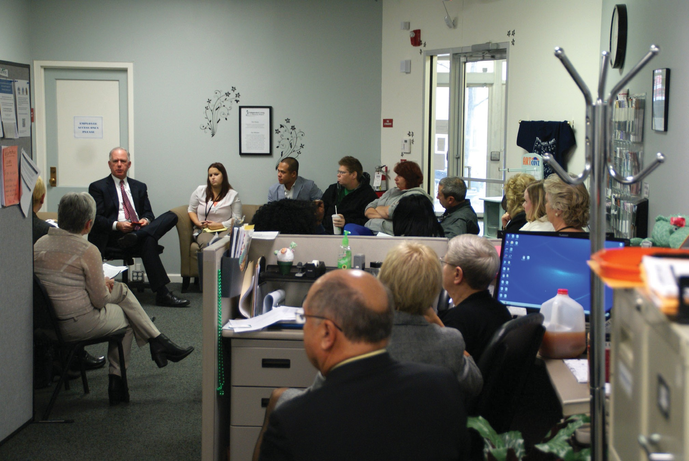

Independent Living of the Genesee Region

Independent Living of the Genesee Region (ILGR) provides easy access to services at our Main Street location in the City of Batavia and has been in operation for almost seven years. Our Center is staffed by fifteen dedicated individuals who live in all parts of our service delivery area, including Genesee, Orleans and Wyoming Counties. We recently expanded and opened an office in Perry, NY to serve Wyoming County residents directly in their community. Our staff participate in over thirty community and
human service meetings regularly; advocating for system’s wide changes on behalf of people with disabilities. We have established the Genesee Region Advisory Committee for People with Disabilities, which provides a voice to the legislative body in Genesee County.

Some of our services have remained the same over the years. They include free durable medical equipment from our loan closet; Peer counseling; advocacy and assistance with social services, landlords, social security, and employment.

New programs include the “Careers” Job Club, facilitated by a Certified Rehabilitation Counselor who can also meet with people one to one. The Careers program is a six-week soft-skills training class which includes instruction in communication skills, networking, resumes, interviewing, removing barriers, work ethic, job searching, and more.

Our current roster of support groups includes Anger Management and Grief and Loss Support. The Anger Management group is a 12-week series utilizing the SAMSHA curriculum. Grief and Loss support group meets to provide assistance for individuals struggling with the loss of a loved one.

Our center conducts an annual disability simulation entitled “Lunch in the Dark”. We collaborate with the NYS School for the Blind so that participants can get a better understanding of eating and socializing with vision
loss. We also provide Blind Etiquette training for the staff of our partner organizations.

Classes to stay well have been added to our services. We provide Stanford University evidence-based workshops entitled Chronic Disease Self- Management Program (CDSMP) and Diabetes Self-Management Program (DSMP). These are on-going and scheduled in several counties.

As our agency has grown, we have focused on encouraging people to stop by our reception area. It is being redesigned as an exhibition site for the artwork of people with disabilities. Along with our partner, University Heights Arts Association, we provide free fine art materials and projects for stress reduction and to enhance creativity. Additionally, we’ve begun a juried competition called “ARTiculations” which allows for quarterly exhibition of artwork.

To further enhance our reception area we have plans to conduct a lecture series with qualified speakers on wellness related topics. Some of the proposed speakers include a pharmacist on drug interactions, massage therapist regarding diabetic foot care, and a yoga teacher on stretching throughout the day.

ILGR is determined to meet the needs of the community of people with disabilities. Our strength is a group of dedicated peers dedicated to the community they serve.

Rae Frank Director
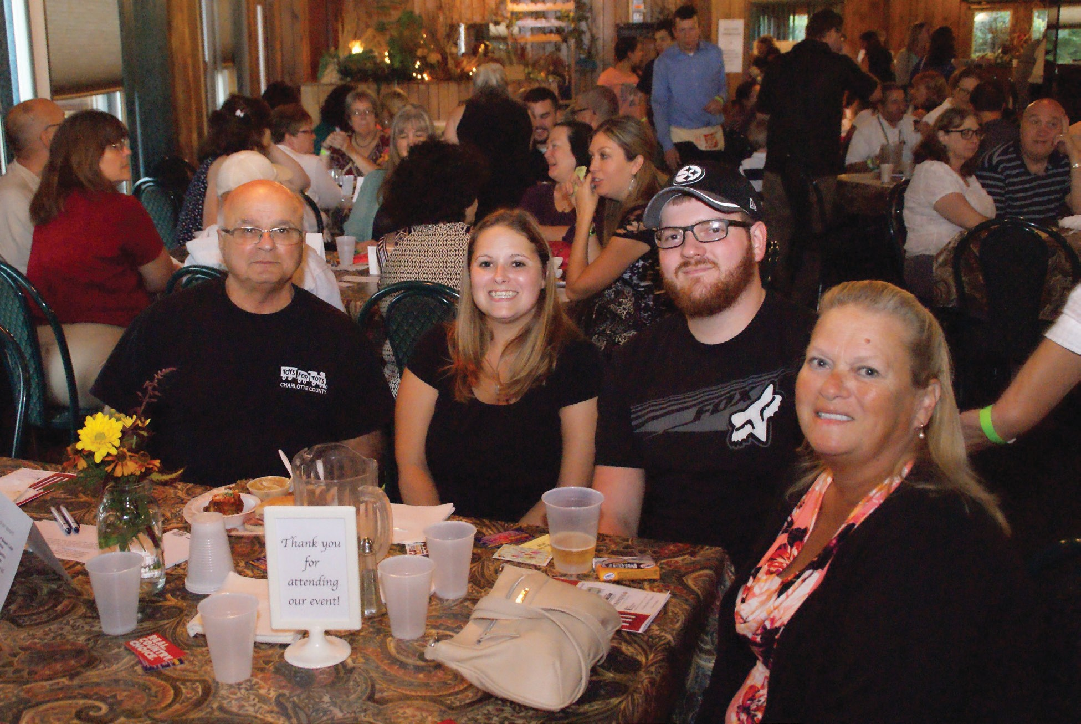

ILGR Vignettes 2015-2016

- ILGR staff attended a consumer’s last Worker’s Compensation hearing, at which the judge asked if she understood that Worker’s Comp wasn’t going to be paying her medical bills anymore. When she was hesitant with her answer and didn’t know how to respond, the judge adjourned the hearing so she could talk to her attorney. When they went into
a private room, the attorney started yelling at the consumer, saying that she had agreed to the settlement and now she is claiming not to understand. After the staff member asked the attorney to be allowed to explain to the consumer what was being said, she was reminded that she would be getting a lump sum payment. She could put part of the money into another account and use it for medical bills. That is, at this
point, Worker’s Comp. wasn’t paying each medical bill, but the settlement would provide an account to do that. She understood and her attorney was appreciative. We observe that it is preferable for people to just slow down and explain a situation, instead of getting frustrated when someone doesn’t immediately understand it.

- Many times, people with disabilities have come into ILGR without health insurance, but finally depart from us insured and with an understanding of their coverage. Recently, a woman sought medical insurance for herself and her husband. She was concerned that they would not be able to get prescription refills, but staff met with her and reviewed all the plan options. Staff was able to arrange insurance that same day and help her understand what her new coverage would provide. She left the office that day with tears in her eyes, stating that she was grateful there were people who were pleasant and could help her out.

- A consumer with both cognitive and neuromuscular disabilities has been receiving ILGR services since 2012. Various Independent Living Specialists have assisted him with food stamp re-certifications, Section 8 Housing, and registration forms for medical appointments over the
years. Also, he was provided advocacy during the sale of his family home and his relocation to the apartment complex of his choice. Staff was
able to help him when his faithful companion went missing for several days. After he put up posters and called animal shelters, his beloved cat was found. Recently, staff helped him complete a WRAP plan (Wellness Recovery Action Plan), with which he sought to use his WRAP wellness toolbox to control his urge to smoke. He makes contact regularly, is achieving his goal, and often expresses his appreciation.

- One never knows who will seek our services. A woman who came to ILGR in need of equipment from our Loan Closet immediately recognized a staff member from the latter’s previous employment at another agency, and stated, “Oh, am I happy to see you!” The woman was in need of several pieces of medical equipment, as her husband had recently suffered a severe stroke. The employee was able to help her with everything she needed, and recalls, “The look of relief on her face and the gratitude towards our agency was priceless!”

- The goal of ILGR’s Medicaid Application Assistance Program (MAAP) is to assist people who are aged (over 65 years old), blind, and/or otherwise disabled with completing the paper Medicaid application process. A
staff member assisted a legally blind gentleman with his application, helping him gather all of the necessary documentation, and submitted the completed application on his behalf to the local Department of Social Services. After a short period of time, his Medicaid application to receive assistance in his home was approved, and he was referred to our Taking Control program. He now has a personal care aid, who comes to his home and helps him with cleaning, cooking, grocery shopping, and other basic needs, at no cost.

- Several of ILGR’s BIP (Balancing Incentive Program) staff members started working with youth that were graduating from Batavia High School and transitioning into adulthood. A few of these consumers had developmental disabilities, were only “couch surfing”, and at risk of being homeless. The Housing Specialist was able to help them obtain assistance from several programs, including securing Section 8 vouchers for housing support. A young woman went to her school counselor and shared that she was homeless and didn’t have any food. Our team worked to find
her food resources, adequate housing and suitable employment. She started out working twelve hours per week, but, once she graduated from high school, she went to full time. The woman is still working and her supervisor regularly informs us that she is an excellent employee. Also, she has been maintaining her apartment, and is actively trying to get into college, part-time.

Annual Report 2015-2016 Statistics ILGR

Total Number of Consumers Served: 763

Number of Consumers by Age:
Under 5 years old: 1
Ages 5-19: 28
Ages 20-24: 34
Ages 25-59: 302
Age 60 and older: 375
Age unavailable: 23

Number of Consumers by Gender:
Female: 451
Male: 312

Number of Consumers by Race and Ethnicity:
American Indian or Alaska Native: 7 Asian: 1
Black or African American: 44 White: 687
Hispanic or Latino: 17 Race/Ethnicity Unavailable: 7

Number of Consumers by Disability*:
Cognitive: 266
Mental/Emotional: 329
Physical: 826
Sensory (hearing, vision, etc.): 94
Multiple Disabilities: 369
*Some consumers may have indicated more than 1 disability category.

Number of Consumers by Veteran Status:
Veteran (served in U.S. military): 58
Non-veteran (never served in U.S. military): 678
Status unavailable: 27

Number of Consumers by Services Received*
Advocacy/legal services: 161
Assistive devices/equipment: 393
Communication services: 59
Counseling services: 33
Family services: 6
Housing and shelter services: 112 Information and referral services: 444
IL skill development and life skills services: 159 Peer counseling services: 32
Personal assistance services: 57 Recreational services: 2
Transportation services: 9
Youth services: 11
Vocational services: 33
Plan for the achievement of self support services: 4
Benefits advisement services: 141
Other services: 16
*Some consumers may have received more than 1 service.

Number of Businesses/Agencies Served: 45

Independence
EXPRESS
Transportation Services

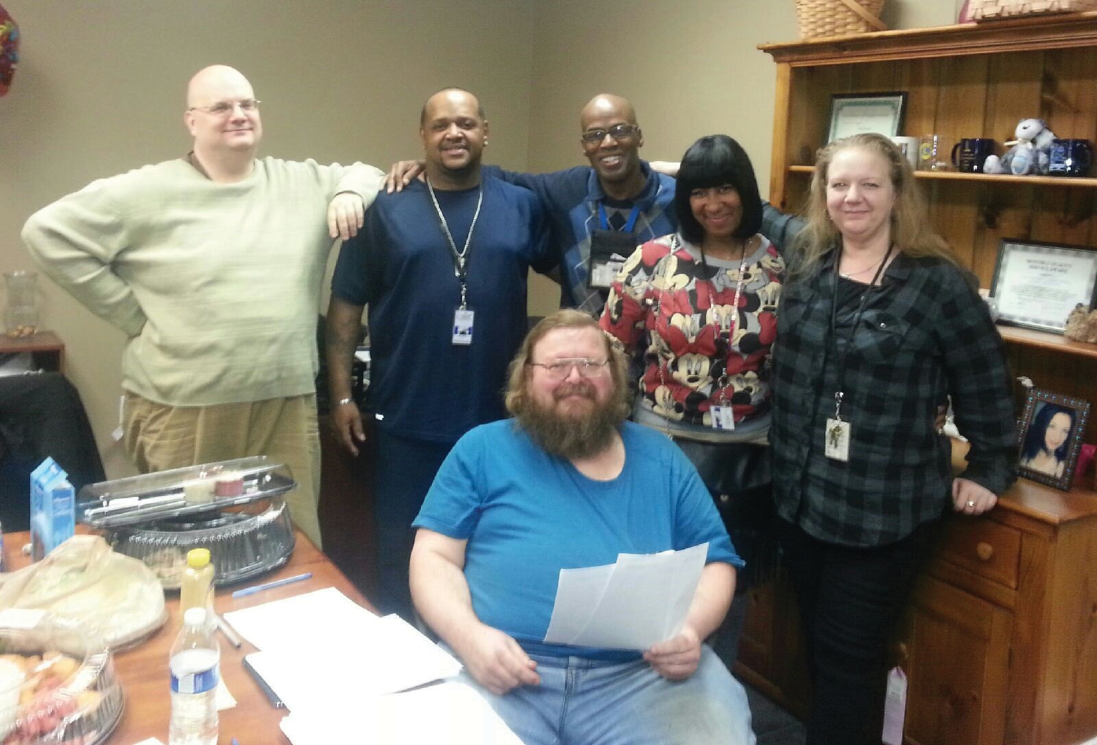

Independence Express Transportation Department

WNYIL has been providing transportation for people with disabilities for over
35 years. It started with one van for the agency with any staff member that was available driving. Through the years, an actual Transportation Department was formed, developed and now we have a small fleet of vans, drivers and support staff. Our budget is now over $400,000 and hopefully will be growing larger every year.
Now our own department, Independence Express (IE), has several different funding sources to provide rides to people throughout Erie, Niagara, Genesee and Orleans Counties. Some of our programs also include funding for bus passes. We also offer Fee-For-Service transportation. If an individual does not qualify for a grant program, they may pay $15 each way, plus
$0.50 per mile to ride on our vans and travel anywhere in our service area. As always, people receiving service at one of our agencies, attending functions of, and attending groups at, WNYIL receive transportation at no cost when available. WNYIL currently has four wheelchair-accessible vans and two minivans available to serve Western New York.
In the 2016 Fiscal Year, IE served over 250 people. These individuals either rode on the vans, many of them on multiple occasions, or received a bus pass. In the same span of time, our vans drove over 300,000 miles throughout the four counties getting people to various destinations.
Also in this fiscal year, WNYIL was able to purchase two wheelchair accessible vans to replace aging vehicles in our fleet. This was accomplished with: monies from fundraising efforts, such as the annual “Night for Independence Gala”; a 5310 “Enhanced Mobility of Seniors and Individuals with Disabilities” Grant from the Federal Transit Administration; and WNYIL’s contributing administrative funds. Currently, we have the largest, newest fleet of accessible vehicles in Agency history.
Another notable aspect of the Independence Express department is that two staff members reached their 20-year anniversary with WNYIL! Two other staff members in the department reached eight and six years. We are very proud to have such a long history serving the transportation needs of people in this region.
In the coming year, we will continue to explore new funding sources to continue to provide safe, reliable transportation to people with disabilities throughout WNY.
Catherine Colicchia Director

Western New York Independent Living, Inc.

3108 Main Street, Buffalo, NY 14214
(716) 836 - 0822 (Voice/TDD)
(716) 835 - 3967 (Fax)
Independent Living Center (ILC) Mental Health Peer Connection (MHPC)

OAHIIO “The Good Path”

Independent Living of Niagara County
746 Portage Road, Niagara Falls, NY 14301 (716) 284 - 4131 (Voice/TDD)
(716) 284 - 3230 (Fax)
(855) 366 - 1042 (Toll Free)

Independent Living of the Genesee Region
113 Main Street, Suite 5, Batavia, NY 14020
(585) 815 - 8501 (Voice/TDD) (585) 815 - 8502 (Fax)

