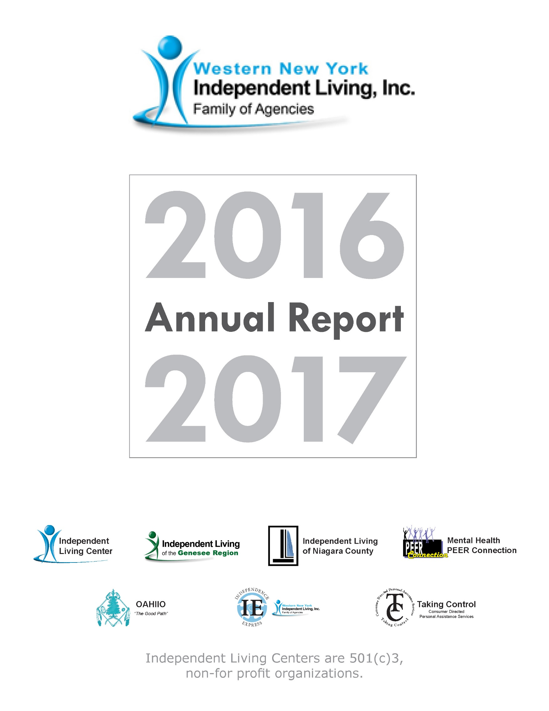

Western New York Independent Living, Inc.
Annual Report
Table of Contents
Western New York Independent Living, Inc. (WNYIL)
Vision, Services 3
History, Mission, WNYIL Board of Directors 4
ILGR, MHPC, OAHIIO, ILNC Councils 5
President’s Report 6
Executive Director’s Report 9
Vignettes 2016-2017 11
WNYIL Statistical Report 14
Statement of Financial Position 18
Statement of Activities 19
Mental Health Peer Connection (MHPC)
Director’s Report 21
Vignettes 2016-2017 23
Statistical Report 26
OAHIIO “The Good Path”
Director’s Report 29
Vignettes 2016-2017 32
Statistical Report 33
Independent Living of Niagara County (ILNC)
Director’s Report 36
Vignettes 2016-2017 39
Statistical Report 42
Independent Living of the Genesee Region (ILGR)
Director’s Report 46
Vignettes 2016-2017 48
Statistical Report 49
Independence Express Transportation Department
Director’s Report 53

Vision Statement WNYIL Inc. family of agencies is a catalyst for systems and individual change, enhancing the quality of life for people with disabilities while respecting diversity and promoting choice and alternatives for independent living in our societies.

The Independent Living Center provides Peer Services, Advocacy, Information and Referral, Independent Living Skills and Transition Services. In addition to services provided by our independent living specialist ILC also provides educational advocacy, MFP Open Door Nursing Home Transition, NY Connects expansion and enhancement for region 1, and Medicaid Service Coordination for the 7-county catchment area of Allegany, Cattaraugus, Chautauqua, Genesee, Orleans, Niagara and Erie Counties.

Independent Living of Niagara County (ILNC) is an independent living center that provides the five core services of Peer Counseling, Independent Living Skills, Advocacy, Transition Services and Information and referral which empower people with disabilities on both the individual and community level.

Independent Living of Genesee County (ILGR) is a community pathway for an empowered life for people with disabilities by providing Independent Living Skills, Advocacy, Information and Referral, Peer Counseling, Transition Services and financial advisement in Genesee, Orleans and Wyoming Counties.

Mental Health PEER Connection (MHPC) provides institutional, community and vocational-based services assisting consumers in their recovery process.

OAHIIO is a “walls free” program that provides independent living services to all Native Americans with disabilities, on and off Native Indian Territories in WNY. Programs consist of Independent Living Skills instruction specialists, SSI and SSDI Benefits Advisement, Engagement and Referral Specialists to educate, arrange, and enroll people into Independent Living services, and NY Connects Independent Living Specialist to connect aging or disabled individuals, particularly the Seneca Nation of Indians, to established support programs.

Taking Control is a Consumer Directed Personal Assistance (PA) Service (CDPAS) where individuals who are eligible to receive third party payer services can arrange to have WNYIL act as their Fiscal Intermediary providing recruitment assistance, PA Orientation, Consumer training, payroll and Human Resource assistance, as the consumer or their Directing

Representative, manages their own in-home care.

Independence Express WNYIL operates fee-based and funded transportation services to help people with disabilities to participate in full inclusion throughout Western New York.

History
Born in the nationwide independent living and civil rights movement, college students with disabilities who were fed up with discrimination and the lack of access for people with disabilities, decided to make their own opportunities and assist their peers to do the same. In 1979 “The
Independents,” a group of students with disabilities at the State University of New York at Buffalo, investigated the independent living movement and began operating what was then known as Western New York Independent Living Project (WNYILP). The agency was awarded a Federal Title VII grant in 1980 and opened its own facility early in 1981.

Mission Statement
Western New York Independent Living, Inc. is a multi-cultural, grassroots, peer directed, civil rights organization that provides a full range of assistance, programs, and services to enhance the quality of life for all individuals with disabilities.

Executive Committee
Dennis Kessel (President); Sean Quinn (1st Vice-President); Richard Dread (2nd Vice-President); Paul Beakman, Sr. (Treasurer); Sue Ann Sehl (Secretary).

Board Members
Kimmarie Brown, Lisa Maria Cruz, Barbara Gaetano, Richard Koch, Ellen Lawson, Donald Le Ber, Michael May, John Schappacher, Ann Scherff.

Independent Living of the Genesee Region Council
Ann Scherff (Chair); Kelly March (Vice Chair); Nathan Moffett (Secretary); Barbara Hoffman (Treasurer); Linda Makson; Ida Caldwell; Jonathan Doherty.

Mental Health PEER Connection Council
Donald LeBer (Chair); John Rooney (Secretary/Treasurer); Ellen Lawson
Joseph Machia; Lawrence Nowell; Bobby Jo Meyer; Noel Young.

OAHIIO Council
Kimmarie Brown (Chairman); Miguel Santos; Lucille Sherlick Ph.D.; James Hill.

Independent Living of Niagara County Council
Paul Beakman (Chair); John Schappacher (Vice Chair); Barbara Gaetano (Treasurer/Secretary); Gracie Chambers; Darlene Cutonilli; Megan Diamond; Brigid Dillman; Lana Redell; Darren Sneed.

Report of the President of the WNYIL Family of Agencies

Thank you for choosing to read about Western New York Independent Living’s accomplishments over the 2016-2017 Fiscal Year. On behalf of the Board of Directors it is my pleasure to introduce this Annual Report of our 37th year to you, our supporters, consumers, and leaders of our multi- county area. As you explore the activities of the members of our family of agencies, you will find that we continue to meet the challenges of these changing times, empowering our brothers and sisters with disabilities to exercise their right to receive an appropriate education, and to be accepted as equal contributing citizens in our communities.

We continued to see growth in our organization over this past year,
and made additional progress working toward bringing people with disabilities into every aspect of our society. Let me share just a few of our accomplishments with you.

OAHIIO, our Native American Independent Living Center, was the recipient of a national grant to promote and extend Independent Living (IL) programs into our Native lands of Western New York. As one of only three recipients of this national competition, we employ several full-time Independent Living Specialists to establish IL services in the Tuscarora, Tonawanda, and Seneca Nation of Indians territories.

Independent Living of the Genesee Region continues to grow into the three eastern counties of Western New York: Orleans, Genesee, and Wyoming. In this past year, ILGR has: entered into contracts to provide Chronic Disease self-management trainings throughout their area of service; opened an office in Wyoming County to serve people with disabilities to the south of Batavia; advocated for audible street crossing signals for the blind; and has acted to correct inaccessible voting practices.

Independent Living of Niagara County continues to be strong by: pressing for, and receiving, a pledge from the Mayor of Niagara Falls to bring the Hyde Park picnic shelters up to federal codes for accessibility for people with disabilities; obtaining a contract with Niagara Falls Memorial Medical Center to offer our consumers Health Home care coordination services; and securing New York State funding to provide Addict 2 Addict peer services in Niagara county. Addict 2 Addict-Niagara will be one of the County’s tools in fighting the opium epidemic, utilizing peers to link users to resources and programs that will assist both the individual and their families to overcome the terror of addiction.

Mental Health PEER Connection (MHPC) continues to be a statewide leader in peer services by bringing an Independent Advocate to the City of Buffalo Mental Health Court. This ensures that all mental health consumers will have the opportunity to utilize a peer advocate on their road to recovery, without requiring them to link up to a specific service or program to be eligible to engage with a peer. MHPC has entered into a tri-partnership with Restoration Society, Inc. and Housing Options Made Easy, Inc., both peer- run, to initiate a Living Room Crisis Diversion Program. This is an alternative to Hospital Emergency Rooms, which will connect peers who have needs after business hours to various community services, programs, and benefits. And if that isn’t enough, MHPC has been identified as a member of the Executive Committee of the group working to establish an Independent Practice Association (IPA), uniting statewide peer-run organizations. IPAs have been effective elsewhere, setting standards and practices for similar programs to sell peer services to the various Managed Care Organizations that are now becoming the financial resources for Medicaid funding.

Then, there is the Independent Living Center (ILC) here in Erie County. Under the ILC’s direction, we are taking a lead in a collaboration with eight other Centers for Independent Living, covering a 17-County area,
Opening Doors to seniors and people with disabilities to access the services, programs, and advocacy of Centers for Independent Living. This multi- county initiative will strengthen the state’s New York Connects program, which can then do a better job linking people with disabilities to the various services and programs needed to live their lives in the communities of their choice. Even more good news: we continued to see our Medicaid Service Coordination (MSC) efforts double in the past year, bringing this service to dozens of underserved people of Western New York, thanks to the Balancing Incentive Program. We have been able to enroll people in the MSC program, due to our innovative practice of paying for exams and assessments that otherwise would have been out of consumers’ reach, or not available for many years.

The Western New York Independent Living Family of Agencies continues to seek equality for people with disabilities in all aspects of life. We have: fought for equal service for people with disabilities when it comes to “app- driving” or “ride-sharing services”; pushed for equal access in the Buffalo Common Council chambers; advocated for affordable healthcare; and pursued adequate funding for programs serving people with disabilities.

Our efforts have once again: provided services to over seven thousand people and their families; changed our communities by eliminating many of the barriers that prevented our brothers and sisters with disabilities from equally participating there; and educated the community on the abilities and contributions of citizens with disabilities, when they are able to contribute.

I appreciate our friends’ support of WNYIL, and I thank our volunteers and staff for all the work you have done this year. We all look forward to your further accomplishments in education and empowerment for people with disabilities, so all are equal.

Dennis M. Kessel
President

Report of the Chief Executive Officer
of the WNYIL Family of Agencies
A greeting to all of our friends! I would like to echo the sentiments of Board President Dennis Kessel in thanking you for taking the time from your day to read this 37th version of Western New York Independent Living (WNYIL)’s Annual Report. Presumably, you are browsing this document because you have a personal or professional interest in what we do, and/or you are curious as to just who, and what, we are. It is the latter impulse that I am going to take a few minutes to address, as we are probably different from most traditional organizations that assist individuals with disabilities with which you may be familiar.

WNYIL is a community-based organization that is overseen by a Board of volunteer Directors, of which a majority are people with disabilities. The leadership and staffing of WNYIL is also composed predominantly of citizens with disabilities; and those with whom we work are consumers with disabilities. And what do we do? Simply, whatever needs to be done
to ensure that individuals with disabilities can have a choice — the deciding vote, in fact — in the decisions that impact their lives. Our ultimate goal: to ensure that people with disabilities can compete, play, work and interact
with society, as equal, contributing members of our communities. We do not focus on any specific disability, or class of impairment; we push for inclusion of all. It doesn’t matter to us if you have a physical, intellectual, behavioral, hearing, visual, environmental, cognitive, or a combination of any two or more of these disabilities; you are entitled to work with, and/or receive the programs and services of, WNYIL. In fact, it is a point of pride to us that
we serve all people with any disability, from all communities of our region,
regardless of their age, culture, or belief systems.

Personally, I feel that is the primary source of WNYIL’s strength: the fact that all peoples from all cultures are working and receiving programs and services at our Center. Thus, we are able to benefit from the perspectives and experiences of both lifelong and new Americans to improve the way we conduct business. While those from more traditional agencies may find it daunting, we feel it’s an exciting challenge for us to bring our peer philosophy to newly arrived consumers who still have old-world beliefs that disabilities bar them from most of life. We never tire of sharing the emotionally uplifting moment when such a person realizes that peers in
wheelchairs, who are deaf, or blind, are the people teaching them so much.
Such as, how to navigate our bureaucratic systems; how to prepare for a job; and, more importantly, that people with disabilities do not have to

face a life of being cared for, but can get out there, themselves, work for a
living, and raise a family.

But the education works both ways. I have personally seen, many times, the ways our programs and services are enriched when staff from one of our new communities brings their values and beliefs to the job. That is, how this interchange of ideas expands our older staff’s awareness of the lands beyond our borders, the dialogue becoming a world-view perspective, not limited to the myopic thinking of a walled-in community.

I have spent time in the U.S. Army, which gave me the opportunity to travel to several countries around the world, where I shared ideas, and acquired knowledge from the citizens of those countries. By so doing, I came to a realization: how wonderful it is that our Country can welcome, embrace, and support the differences of new arrivals, thereby making us all stronger, better, and more knowledgeable. Now, after spending decades in the human services arena, I’ve also concluded that it is our country’s embracing these differences that have improved the lives of people with disabilities. We have returned the favor, improving rehabilitation science, organizing grass-roots advocacy, and advancing the rights of people with disabilities, culminating in the Americans with Disabilities Act, a ground-breaking piece of legislation that is being duplicated throughout the world.

We at WNYIL open our arms to all Americans, both old and new, to come and be part of our efforts of Education and Empowerment, so that all Americans with disabilities regardless of their race, creed, color, belief systems, and lifestyle preferences, can participate Equally in all that America has to offer.

Douglas J. Usiak
Chief Executive Officer

WNYIL Vignettes 2016-2017

- “Mary”, a 49-year-old female with Multiple Sclerosis (MS) and various other physical, emotional, and psychological disabilities, needed assistance with obtaining funding to pay back-lot rent and prevent her eviction from her trailer home. Due to her limitations and financial
hardship, she was unable to complete the task of requesting grant money for this on her own. Staff advocated for Mary at the Collins Town Court house and was granted an adjournment of six weeks, then sought leads from co-workers on any grants that would help her keep her trailer. Three contacts were suggested: the Multiple Sclerosis (MS) Society, the Maria Love Fund, and Western New York Heroes, Inc. Staff applied for all three grants and Mary was awarded $500 from the MS Society, $300 from the Maria Love Fund, and $3,000 from Western New York Heroes “Bridging Hearts” grant program, for a total of $3,800, the checks going directly to the landlord. The opposing lawyer informed staff that the adjournment court date was canceled, because the situation had been resolved. All these steps were necessary to prevent Mary from becoming homeless and to help her keep her trailer home.

- “Dave”, a 24-year-old male who has many allergies and other environmental illnesses, was residing with a friend and wanted to work. Dave had no income, nor did he have Social Security Benefits, nor other public benefits. However, as he is a certified Personal Care Aide (PCA) and attended a year of college, staff helped Dave create a résumé and apply for PCA job opportunities. As a result, he obtained a permanent position at a facility for 30.2 hours per week at $10 per hour. To further his independence, Dave is now saving money to move out of his friend’s apartment and into his own place.

- “Larry”, a 53-year-old male who has a vision impairment, cognitive disabilities, a spinal cord injury and back pain, and who faced possible eviction due to his home being unsanitary, needed help with cleaning his apartment due to his physical disabilities. Staff helped him apply for Western New York Independent Living, Inc. (WNYIL)’s Taking Control Consumer-Directed Personal Assistance Services (CDPAS) program, and he was approved for four hours of environmental assistance per week.
Larry’s daughter was interested in becoming his Personal Attendant (PA); she had already worked for WNYIL as a PA on other cases, and she lives close to her father, so she could get to him quickly, if necessary. The staff’s efforts getting Larry approved for CDPAS hours prevented him

from being evicted due to the condition of his home environment.

- “Karen”, a 46-year-old female with Rheumatoid Arthritis, Depression, and Metabolic Syndrome, wanted to enjoy a Town park near her home, and was told she could not have easier access by using a certain road. To advocate for Karen, two staff members met with Town officials to discuss viable solutions in making the park more accessible to Karen and other people with disabilities. After three hours of discussion, the
officials decided to give Karen the phone number of the Town’s Americans with Disabilities Act (ADA) office, to enable her to inform them that
she will need the gate opened. As she was promised that this would be done within 30 minutes after the call, Karen was very happy with this arrangement.

Additionally, the agreed-upon plan called for one staff member to work with the Town officials to update their website to include the ADA office phone number, and other easily-accessed information on filing for an accommodation. Other provisions are: the creation of an advisory council that will meet twice annually, allowing disabled citizens to voice their concerns; and that the handicap accessibility of the parks will be reviewed, and changes made, within five years.

The personal success of the Agency’s advocating for Karen’s goal also achieved change at a systemic level, which hopefully will benefit more consumers in the long run.

- “Robert” is a 58-year-old male with mental illnesses, addictions, cognitive disabilities, visual impairments, drug-related psychosis, and dyslexia. Due to his mental illness, Robert was unable to maintain an apartment for long before being evicted, was living on the streets, and his disabilities prevented him from utilizing the city shelters. The Erie County Department of Social Services (DSS) only allowed him a few days to stay in a motel. WNYIL paid for a one-day motel stay, while staff obtained consents from all parties involved, and applied on-line for the County’s adult Single Point Of Access (SPOA) housing assistance. Staff completed a Vulnerability Index Service Prioritization Decision Assistance Tool (SPDAT) form for screening, and Robert scored high, so he was placed at the top of the list for housing. Spectrum Human Services admitted him into their program and placed him in a rooming house.

- “Paul”, a 61-year-old male with a visual impairment, a spinal cord injury, and other cognitive disabilities because of a stroke, came to the Agency seeking Personal Assistance Services, as he could not be left alone, due to his disabilities. Acquiring a Personal Attendant (PA) would alleviate some stress for his wife, “Diane”, who needed to go out for her own appointments.

Living in a rural area, Paul and Diane had not been able to find a home care aide through traditional services, so staff helped them apply for our Taking Control Consumer Directed Personal Assistance Services (CDPAS) program — and Paul was approved. Once staff helped Paul and Diane to advertise for a PA, and assisted in the interview process, they hired a PA, “Sarah”, thereby enabling Paul to avoid having to be placed in a nursing home.

- “Juan”, 49-year-old male with Schizophrenia and a back injury, had his own apartment for over 12 years, but was evicted due to non-payment of rent and disruptive behaviors, (claimed the landlord). Enrolled in Social Security Disability Insurance (SSD), Juan had an income a bit higher than if he were on Supplemental Security Income (SSI). He also did not qualify for Erie County adult Single Point of Access (SPOA) services, as he had not been hospitalized recently, and he had not sought any treatment for his illness in some time. Our Independent Living Specialist (ILS) assisted Juan to secure a bed from The Society of St. Vincent DePaul;
he was able to get help from friends and family in paying the security deposit, and could acquire other furniture on his own. This placement prevented Juan from going into a group home or a psychiatric facility.

Annual Report 2016-2017 Statistics

WNYIL

Total Number of Consumers Served: 2874

Number of Consumers by Age:
Under 5 years old: 23
Ages 5-19: 339
Ages 20-24: 156
Ages 25-59: 1320
Age 60 and older: 1030
Age unavailable: 6

Number of Consumers by Gender:
Female: 1598
Male: 1276

Number of Consumers by Race and Ethnicity:
American Indian or Alaska Native: 45 Asian: 57
Black or African American: 829 Hawaiian or Other Pacific Islander: 3 White: 1561
Hispanic or Latino: 131 Two or More Races: 21
Race/Ethnicity unavailable: 227

Number of Consumers by Disability*:
Cognitive: 1161
Mental/Emotional: 1649
Physical: 2264
Sensory (hearing, vision, etc.): 733
Multiple Disabilities: 1647
*Some consumers may have indicated more than 1 disability category.

Number of Consumers by County of Residence:
Albany: 2
Allegany: 57
Bronx: 1
Broome: 1
Cattaraugus: 59
Chautauqua: 101
Chemung: 1
Clinton: 36
Erie: 4011
Essex: 9
Franklin: 42
Genesee: 44
Jefferson: 91
Lewis: 7
Livingston: 1
Monroe: 2
Niagara: 333
Onondaga: 2
Orleans: 24
Rockland: 1
St. Lawrence: 66
Sullivan: 2
Wyoming: 14 Outside of NY: 8
*County numbers include consumers with disabilities as well as casual contacts and information and referral for people with and without disabilities.

Number of Consumers by Veteran Status:
Veteran (served in U.S. military): 115
Non-veteran (never served in U.S. military): 2496
Status unavailable: 263

Number of Consumers by Services Received*:
Advocacy/legal services: 390 Architectural barrier services: 4 Assistive devices/equipment: 55
Children’s services: 18
Communication services: 47
Counseling services: 66
Family services: 268
Housing and shelter services: 413 Information and referral services: 3704
IL skill development and life skills services: 274 Mobility training services: 17
Peer counseling services: 811 Personal assistance services: 533 Recreational services: 21
Transportation services: 268
Youth services: 29
Vocational services: 329
Plan for the achievement of self support services: 1 Business/Industry/Agency services: 3
Benefits advisement services: 1173
Voter registration services: 4
*Some consumers may have received more than 1 service.

Number of Businesses/Agencies Served: 34

Total number of individuals served in 2017 in Health Home Care Coordination: 497

Total number of individuals served in 2017 in Medicaid Application Assistance Program: 905

Total number of active consumers currently receiving services in our Consumer Directed Personal Assistance Services program: 920

Number of people served by WNYIL in Medicaid Service Coordination in 2017: 86

NY Connects/NYSOFA:
Allegany: 448
Cattaraugus: 325
Chautauqua: 24
Erie: 30
Genesee: 11
Livingston: 2
Monroe: 98
Ontario: 5
Orleans: 1
Wayne: 4
Wyoming: 1

Western New York Independent Living, Inc.

Statement of Financial Position September 30, 2017 and 2016

ASSETS
 | 2017 |  | 2016
Current assets:
Cash and equivalents | $2,088,252 |  | 359,722
Contracts and fees receivable | 7,036,313 |  | 5,127,062
Prepaid insurance and expenses | 18,579 |  | 20,404
Investments - non marketable securities | 9,962 |  | 9,962
Total current assets | 9,153,106 |  | 5,517,150
Property and equipment, at cost:
Leasehold improvements | 1,361,849 |  | 1,347,279
Office equipment | 373,305 |  | 330,185
Vans and related equipment | 251,399 |  | 252,599
Computers and related equipment | 397,147 |  | 355,070
 | 2,383,700 |  | 2,285,133
Less accumulated depreciation | (1,883,758) |  | (1,699,566)
Net property and equipment | 499,942 |  | 585,567
Other asset - security deposits | 5,230 |  | 2,500
 | $9,658,278 |  | 6,105,217
LIABILITIES AND NET ASSETS
Current liabilities:
Accounts payable |  | 275,705 |  | 379,454
Deferred revenue |  | 952,303 |  | 827,644
Accrued salaries |  | 1,209,202 |  | 824,159
Accrued expenses |  | 292,740 |  | 202,213
Total current liabilities |  | 2,729,950 |  | 2,233,470
Unrestricted net assets |  | 6,928,328 |  | 3,871,747
Total liabilities and net assets |  | $9,658,278 |  | 6,105,217

Western New York Independent Living, Inc.

Statement of Activities
Years ended September 30, 2017 and 2016

 | 2017 | 2016
Unrestricted revenue:
Contracts and grants | $5,270,872 | 4,935,887
Consumer directed personal assistant services | 28,772,215 | 19,416,860
Fees for services | 1,785,196 | 562,859
Contributions and membership | 1,430 | 2,263
Fundraising | 64,027 | 63,679
Investment income | 5,120 | 5,640
Other revenue | 29,144 | 16,164
Total unrestricted revenue | $ 35,928,004 | 25,003,352
Unrestricted expenses:
Program services | 30,161,456 | 22,235,923
Management and general | 2,709,967 | 1,605,574
Total unrestricted expenses | 32,871,423 | 23,841,497
Increase in unrestricted net assets | 3,056,581 | 1,161,855
Unrestricted net assets at beginning of year | 3,871,747 | 2,830,781
Prior period adjustment (note 8) | — | (120,889)
Unrestricted net assets at beginning of year, as restated | 3,871,747 | 2,709,892
Unrestricted net assets at end of year | $6,928,328 | 3,871,747

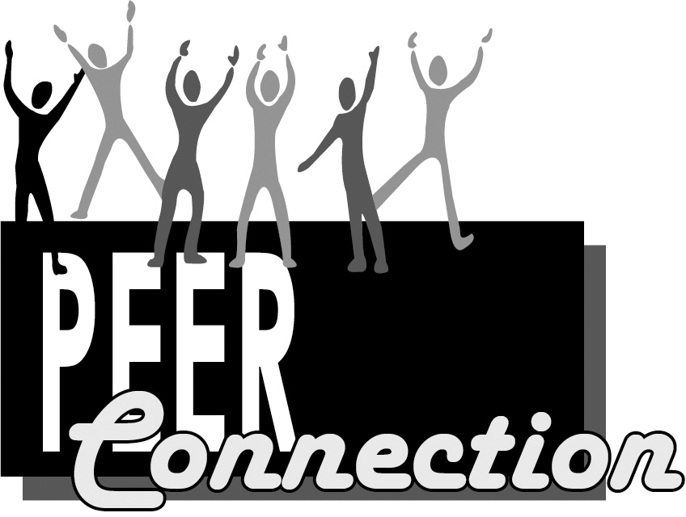

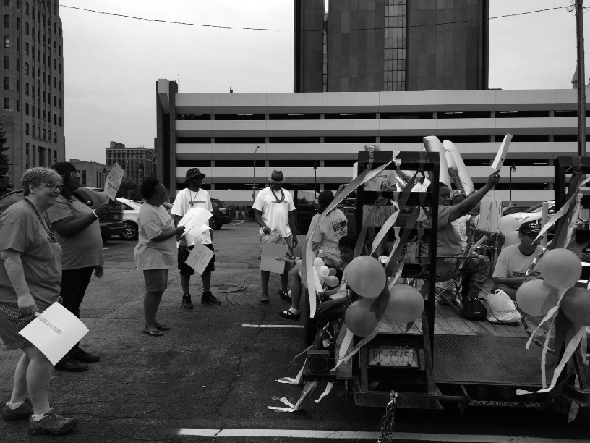

Report of the Director of Mental Health PEER Connection
“From the Inside Out”
Mental Health Peer Connection began its’ roots in 1994, when a strong Community Organizer and Peer, teamed up with WNYIL, to write a grant to change the way mental health services were delivered in Erie County, and to educate patients in the State hospital that recovery from serious mental illness is a real possibility. At that time, three Peers got paid to do this work. MHPC has grown 10-fold since then.

MHPC is everywhere. We are in the hospitals, with the police, working side by side with Crisis Services, we are in the Prisoner Re-entry meetings and trainings, we are in the housing Single Room Occupancy Buildings running
self-help groups. This year we established ourselves in the County Emergency Room assisting those coming in who have overdosed on drugs and alcohol.
We collaborated with two other Peer Agency’s and created a “Crisis Diversion” respite, called the “Parlor” when someone having a psychological crisis could come and just talk to another Peer.

We have most importantly embarked on the future of Peer services - we are billing for our services through our Home and Community Based Services (HCBS). No longer are our purse strings solely connected to government grants. We are becoming self-sufficient and generating our own income. We have struggled with this. Trying to deliver services in the most effective, intentional peer way that is person centered. At one time, we would compete with other agencies in trying to get government grants, now we compete with other agencies trying to get insurance companies and their subscribers to choose us.

Many traditional agencies, not peer run or lead, have hired peers and provide these services. Traditional agencies have always billed insurance companies and generate millions of dollars each year in doing so. Some agencies
have done this for decades and are very experienced in generating billable
services.

So, where does that leave us? At first, I think as the Director of this agency, how do we compete? How do we catch up? Well, it dawned on me. Peers know the mental health system inside out. We have been in the groups, the therapy office, pulling a number from a meat counter to see the psychiatrist. We have all been there. Disempowered, manipulated, coerced, force- medicated or institutionalized. We know this, and we do not want this. We can do better because we know what it is like. We can immensely better

serve our brothers and sisters, because we have been there, we know what it is like. It is this sensitivity and our decades of lived experience with each other that has made MHPC the real options for insurance companies to refer to and for fellow peers to receive our services. We are the real deal. We are led by people with mental illness, in me, the MHPC Council, and at least 51% of the WNYIL Board of Directors.

It is because of our lived experience, knowing mental health providers from being patients and clients that we know what not to do. This has been our mantra all along, since 1994 until today. We also know what to do. Most importantly we share with one another, making sure we don’t feel alone.
We present to you from our heart, using intentional peer support, trauma informed care, Wellness Recovery Action Plans, and any other tool or means to obtain one’s goals. Goals that relate to living in the community, avoiding police involvement and psychiatric Emergency Rooms, seeking help for a drug or alcohol addiction, participating in a peer led self-help group at the hospital, avoid re-institution, and getting real employment.

This is all what we have done in 2017. We have done it with our passion and our drive to help those who once were us. WE do it from the Inside Out.

Maura Kelley Director

MHPC Vignettes 2016-2017

- A 60-year-old African-American male, who suffers from substance abuse disorder and has been going in and out of treatment facilities for years, called the Addict 2 Addict; Family 2 Family (A2A) hotline in September 2016. The A2A staff person provided information and referred him to Stacy Spengler, the Assessment Counselor at Renaissance Addiction Services, Inc. (RASI)’s 291 Elm Street office in Buffalo. Once assessed, he was first admitted to a 28-day program in the facility, then into a longer care course of treatment. Upon completion, he was accepted into Unity House at 923 Sycamore Street, where he still lives and has over 12 months of sobriety. He also started a regular Monday night meeting for residents that continues today.
- A 25-year-old Caucasian man•, who had been struggling with addiction for a few years and wanted to get help as soon as possible, called the Addict 2 Addict; Family 2 Family (A2A) hotline in January 2017. He could not go to Renaissance Addiction Services, Inc. (RASI)’s House, as he had previously left the facility against medical advice, and needed an alternate agency in which to seek treatment. A2A staff contacted a Counselor at First Step Chemical Dependency Crisis Center in Niagara Falls, New York, who offered him a bed at their 2470 Allen Avenue facility, if he came promptly. With our information, he entered a 28- day treatment program, and, upon discharge, he followed their simple
suggestions, and began attending meetings. He did not return to his prior
situation but acquired a sponsor and home group, worked the program of recovery, and now has been clean and sober for nine months. He continues to employ our information, and is making better quality-of-life decisions.

- Mental Health PEER Connections staff assisted a 55-year-old African American male to find an apartment for himself and his daughter, by providing information and referral to a housing organization called Housing Visions. He was clean, abstaining from alcohol and drugs; however, his wife continued her struggle with drug use and ultimately lost custody of their daughter to him. The girl temporarily had to live with a friend of the family while he found work.

Already having been dealing with feelings of hopelessness, he was frustrated with working and looking for a place to live, fighting the conclusion that things would not work out no matter how hard he tried,

and he started to feel that “it just wasn’t worth it”. Staff gave him emotional Peer Support, keeping his hopes up that a satisfactory life would come eventually; it was just a matter of time. He is feeling much better about himself now, as the stability of having a home has renewed his hope that things will turn out for the better, with continued effort on his part.

- “Jonathan”, a 33-year-old African-American male, who has been battling depression, anxiety and panic attacks, first met Mental Health PEER Connection staff in Mental Health Court, where he faced three misdemeanor charges before Judge Russell.

In the course of six to eight weeks of PEER support and mentoring, Jon began looking towards the future, embracing his roles as a father-to-be, a husband, and a good neighbor.

Staff worked with him to revise his résumé, highlighting his electrical wiring certification and his previous employment as an electrical technician. At Panasonic’s Career Fair for its portion of the Tesla, Inc. solar panel factory (Solar City) in South Buffalo, Jonathan had an initial interview, and was invited back for a second interview.

Our PEER advocated for Jonathan’s release from Mental Health Court, and, recognizing his successes, Judge Russell granted a dismissal on all his misdemeanor charges. Therefore, Jon had a clear criminal history when the employer-sponsored background check was completed.

Following Jon’s second Panasonic interview, he was required to have a negative result from a urine analysis at a lab in Clarence, New York. His PEER arranged transportation to and from his toxicology screening via Independence Express, as Metrobus service was not available to the facility.

Ultimately, working with staff, Jon resolved his legal issues, started a new job at $14.00 per hour, and can now provide for his newborn baby boy and his wife. All these small successes greatly improved Jonathan’s self- esteem, adding up to a big win for him, his family and the community he lives in!

- In May 2015, “Rosalee”, a forty-one-year-old Hispanic female with a diagnosis of depression, and a history of anxiety and addiction, was referred to Mental Health PEER Connection by Erie County Department

of Social Services, to pursue employment and become independent of the system. While admitting to staff that she has had an on-going issue with using heroin, Rosalee had been clean for over a year. However,
the emotional aspects of her life were becoming overwhelming, which had increased her anxiety and depression levels, and led to thoughts about using, again. She met with staff once or twice per week for Peer Counseling, learning some self-help techniques her peer has used to deal with built-up emotions, such as journaling, exercising, taking a walk, etc. She also began taking anxiety medications, but found she did not like them, as they “weighed her down” and seemed too much like using
addictive drugs. Other holistic forms of healing were explored, to help her develop a “wellness toolbox” of techniques to use when her symptoms begin. She also attended basic life and vocational skills classes in our Enhancement Program, five hours per day, Tuesdays through Fridays.

During the next year, Rosalee continued receiving peer counseling and ongoing vocational support, using counseling to deal with her depression and anxiety, and continuing to gain basic life and vocational skills here in the Job Club. Eventually, she shared with staff that she was once again pregnant, which prompted her to consider establishing a career, instead of just finding another short-term job, so she worked with staff to develop a new goal: obtaining full-time employment. She fulfilled that goal within the next six months, and has maintained that employment for two years. Prior to her entering the Enhancement Program, she had never kept a job for more than three months.

Annual Report 2016-2017 Statistics

MHPC

Crisis Services Mobile Transition Team Program:
Total individuals enrolled: More than 135
Percentage of individuals successfully avoided hospitalization for 90 days
post discharge: 91%
Number of individuals who committed suicide: 0

Addict to Addict Peer and Family Support Program*:
Total number of interactions with individuals presenting with substance use issues: 459
Total number of individual follow up’s completed: 217
Total number of individual calls responded to within 2 hours: 459 Total number of interactions with families and caregivers of individuals
who have substance use issues: 481
Total number of continued support or families and caregivers: 255
Total number of family or caregiver calls responded to within 2 hours: 477 Total number of family support groups: 46
Total number of community presentations regarding family members in relationships with people who have substance use issues: 24
*Reflects January-December 2017 Data.

ECDMH Benefits Advisement, Life Coaching, and Work Support
Programs*:
Total number of individuals who received benefits advisement services: 347 Total number of individuals served whose qualifying benefits were
identified: 293
Total number of individuals who were certified or recertified for benefits: 27
Percentage of eligible employed individuals who maintained work
transition benefits: 100%
Total number of individuals who received life coaching services: 360 Total number of individuals who had an improved quality of life: 164 Total number of individuals whose basic needs (housing, financial,
mental, physical, wellness) were met: 59

Total number of individuals who completed a Wellness Recovery Action Plan (WRAP): 265
Total number of individuals who received work support services: 443
*Reflects January-December 2017 Data.

Enhancement Program:
Percentage of individuals who obtained employment through the program: 35%

Addicts asking for help: Over 630

Family members and loved ones asking for help: Over 382

Home and Community Based Services consumers we served: 49

OAHIIO The Good Path

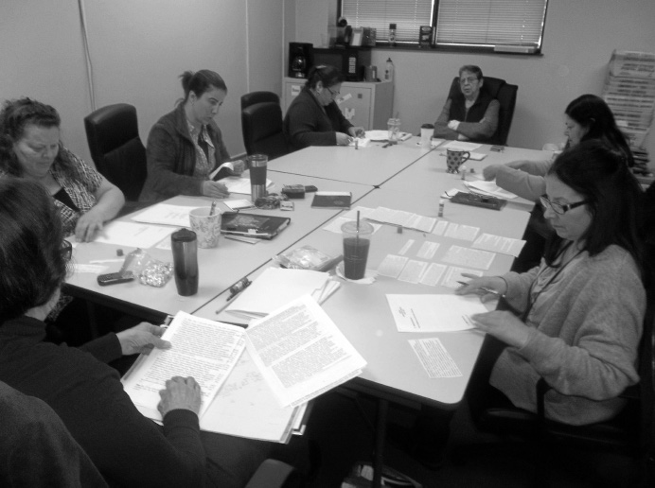

OAHIIO - ‘The Good Path’

OAHIIO — “The Good Path” in the Seneca language, is a non-profit Independent Living Center that is staffed and governed by Native Americans with disabilities.

OAHIIO has a “walls free” structure that allows advocates and specialists to work on-site with Native Americans residing both on and off Indian Nation Territories, allowing open dialogue between staff and consumer.

The OAHIIO Advisory Council, staff, and volunteers are comprised of Native Americans, the majority of which are individuals with disabilities. The Independent Living Philosophy that is employed when working with Native Indian consumers has a main focus- Choice- that is, consumer choice. The OAHIIO program is consumer-driven; we work to achieve an Independent Living Plan that is person-centered and created collaboratively with our consumers. OAHIIO staff, working one-on-one with Native Indian consumers, focuses on empowering consumers.

A few notable happenings for this past 2016 to 2017 Fiscal Year are:

  - October 4, 2016. The Executive Director of WNYIL, Inc. was informed by the U. S. Department of Health and Human Services’ Administration for Community Living that OAHIIO’s application for the Native American Independent Living Demonstration Project was approved. This funded hiring of additional staff for an outreach to introduce Natives with disabilities to the five core Independent Living services where they live.

  - February 22, 2017. Staff were included in the Seneca Nation of Indians (SNI) Disability Committee meeting at the Supportive Services Building, Thomas Indian School Drive, Irving, New York. SNI Disability Committee members are supportive of the practice of OAHIIO staff coming to SNI Territory to do outreach.

  - March 21, 2017. Staff met with Seneca Nation of Indians’ Seneca Strong Program, at 90 Ohiyo Way, Salamanca, New York. We explained Independent Living Program services to Seneca Strong, a recovery program for natives, emphasizing that OAHIIO staff were available
to assist them with individuals who are in recovery. Seneca Strong agreed to have OAHIIO as part of their program and offered us office
space in their building. 29

  - May 15, 2017. Staff met with: Dr. Michael Noe, Associate Dean of Public Health at University of Buffalo (UB); Susan Green, the Director of UB’s Institute for Trauma and Trauma Informed Care (ITTIC) in the School of Social Work; and Dr. Thomas Nochajski, Professor of Psychology. We discussed our proposal to train prospective Native Indian trauma care facilitators, who could then host a therapeutic support group of Native community members, to assist them in learning how to manage their trauma symptoms from past trauma events.

  - June 14, 2017. Staff met with Arlene Gonzales-Sanchez, the New York State Office of Alcoholism and Substance Abuse Services (OASAS) Commissioner, to discuss upcoming funding for community programs to abate opioid, heroin, and alcohol crises. We presented our request for funds from OASAS and the State Office of Mental Health (OMH),
to be distributed through the New York State Department of Health’s
Indian Clinics.

  - August 8, 2017. Staff met with the Tuscarora Language Committee Leaders at 333 First Street, Niagara Falls, New York. Present at the meeting was: Betsy Bissell, retired Tuscarora Language teacher and Adult Immersion Language Preservation Director; Tina Pinada, Tuscarora Indian School, Niagara Wheatfield Central School District (CSD) Teacher; Tricia Printup, Tuscarora Indian Language Niagara
Wheatfield CSD Middle School Teacher; and Lynette Printup, Tuscarora Language Preservation Specialist. We all discussed how OAHIIO can assist in the development of an Early Childhood Learning Center for Language Immersion/Informed Trauma Care project for the Tuscarora Nation community.

OAHIIO Services:

OAHIIO offers Five Core Services that consist of:
  - Information and Referral
  - Independent Living Skills Instruction
  - Individual and Systems Advocacy
  - Peer Support
  - Transition Services, from youth to adult, and from an institutional
setting back into the community.

These Core Services are provided through these staff members:

Independent Living Specialists
They provide assistance and instruction to Native American Indians
with disabilities and enable them to learn daily living skills. These include: managing family activities; performing household maintenance; accomplishing work and education assignments through the use of tools and techniques; and employing assistive technology.

Work Incentives Benefits Advisement (WIBA) Consultant and
Educational Advocate
She provides assistance and information about special Social Security Administration work incentives for Social Security Disability (SSD) and Supplemental Security Income (SSI) beneficiaries, explaining how work activity and other income will impact his or her cash benefits and/or health insurance.

Engagement and Referral Specialists
They actively make connections within Native communities and with individuals, to assist with educating, arranging, and enrolling consumers into Independent Living Services and external services, aimed at producing an increase in their quality of life.

NY Connects Independent Living Specialist
She works with the “No Wrong Door” Team in participating counties to connect aging or disabled individuals and their families, particularly from the Seneca Nation of Indians, to established support programs and critical pathways providers. They can help facilitate access to needed home and community-based supports and services, and will streamline access to public benefits and provide application assistance.

Cultural Competency and Sensitivity Training
We instruct outside people who deal with our constituency in the ways Native consumers differ from European-based American culture and practices, thus broadening more traditional service providers’ understanding of Native American Indians.

Cynthia Printup-Harms Director

OAHIIO Vignettes 2016-2017

- Monique, a 61-year-old Native American Indian woman with physical disabilities and mental health issues, requested assistance in finding affordable housing. Her needs required that it be an apartment located on the first floor, or have availability to an elevator. OAHIIO staff worked with Monique extensively for about one year, seeking to locate appropriate housing for her. After numerous applications to various apartment complexes, she found a suitable unit in a subsidized building
– but that was not the end of her difficulties. Due to a turnover of staff within the building complex, Monique was informed that she would have to re-apply and start all over again. OAHIIO Staff intervened and
advocated for her, and she was able to move in within a few months. She currently lives in an apartment that meets her needs and allows her to live as part of the community, independently.

Annual Report 2016-2017 Statistics

OAHIIO

Total Number of Consumers Served: 113

Number of Consumers by Age:
Under 5 years old: 0
Ages 5-19: 38
Ages 20-24: 3
Ages 25-59: 49
Age 60 and older: 21
Age unavailable: 2

Number of Consumers by Gender:
Female: 50
Male: 63

Number of Consumers by Race and Ethnicity:
American Indian or Alaska Native: 65 Black or African American: 8
White: 22
Race/Ethnicity unavailable: 18

Number of Consumers by Disability:
Cognitive: 23
Mental/Emotional: 5
Physical: 13
Sensory (hearing, vision, etc.): 1
Multiple Disabilities: 71

Number of Consumers by County of Residence:
Cattaraugus: 2
Erie: 47
Franklin: 1
Genesee: 1
Niagara: 60

Orleans: 1
Unknown: 1
*County numbers include consumers with disabilities as well as casual contacts and information and referral for people with and without disabilities

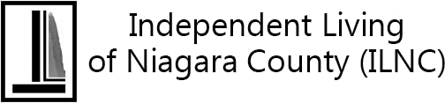

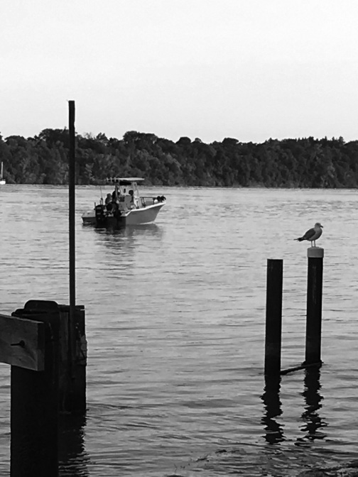

Independent Living of Niagara County

Independent Living of Niagara County (ILNC) works with people with disabilities, their families and their communities to achieve our mission: enabling Education, promoting Empowerment, and working for the Equality of people with disabilities in Niagara County. ILNC is always seeking ways to expand our programs and services to meet the needs of people with whom we work. As an end result of the ILNC Team being actively involved within Niagara County, there were many accomplishments made during the Fiscal Year 2016-2017. It was an amazing time for growth, change, development and transformation at our Agency. Through the addition of new collaborations, partnerships and programs, ILNC’s team has continued to grow and augment our services to work from multiple locations.

ILNC Events:

  - October 2016. ILNC’s Meet the Candidates Day hosted several Niagara County candidates who would be competing on the November ballot.

  - February 2017. Consumers and Staff from ILNC participated in the New York Association for Independent Living (NYAIL)’s Legislator Education Day in Albany. Visits were made to State Senator Robert Ortt, and Assembly Members Michael J Norris, and
Angelo J. Morinello, to explain the importance of the local Independent Living Center (ILC). We were able to examine the vital issues facing the ILC’s and the state, and demonstrate the value of consumer choice, the impact of the involvement of the local ILC, and the ways that the consumers feel empowered.

  - May 2017. ILNC’s Policymaker Breakfast with Guest Speaker Kirk Maurer, Director of the Western New York State Office for People with Developmental Disabilities (OPWDD), took place in Niagara Falls at Antonio’s Banquet and Conference Center.

  - June 2017. ILNC’s Disability Pride Niagara Olmstead Celebration at Niagara Falls’ Hyde Park, saluting the anniversary of the U.S. Supreme Court’s Olmstead Decision, was marked by consumer involvement. An opportunity was presented for ILNC participants
and staff to celebrate a ground-breaking ceremony for the new and
accessible changes that are coming to two picnic shelters in Hyde Park,
in Niagara Falls. 36

  - July 2017. ILNC Staff and volunteers participated in WNYIL’s two-day Disability Pride Parade and Celebration, concluding at Coca-Cola Field, in Buffalo, NY.

  - Also, in July 2017, ILNC was awarded a grant from the New York State Office of Alcoholism and Substance Abuse Services (OASAS), funded through Niagara County Department of Mental Health (NCDMH), to provide peer services for people who have substance abuse disorder. Addict 2 Addict Niagara will provide resources, linkages, and supports to people who wish to recover from their addictions.

  - August 2017. ILNC’s 12th Annual Bass Fishing Derby launched for the first time from the docks of Lewiston. This event attracted 19 anglers from different parts of the region and state, who were
accommodated by six boat captains. In addition to those who went out on the water, there were four competitors who chose to fish from land, so there was a total of 23 anglers who participated in our 2017 event! At the Barbeque and Award Ceremony that followed at the Fin, Feather and Fur Conservation Club in Lewiston, that number grew to over 70!

  - September 2017. “Addict to Addict Niagara,” created to offer peer- based substance abuse and recovery services, began hiring staff to provide these services in Niagara County.

ILNC-driven community improvements

Through the advocacy of Independent Living of Niagara County, the following changes were made to provide increased accessibility for citizens with disabilities in Niagara County:

  - In working with Niagara Falls Memorial Medical Center, the medical facility began to provide alternative format materials to persons who are visually impaired. (Braille)

  - As a result of successful collaboration between ILNC and YWCA of Niagara Frontier, we provided technical assistance and support to ensure that their housing program met the necessary accessibility requirements. We persuaded the YWCA of Niagara Frontier to go beyond the federal minimums and equip 20% of the total units so they would be accessible to persons with mobility or sensory impairments

  - YMCA Camp Kenan (run by YMCA Buffalo Niagara) became more accessible by adding wheelchair ramps to four of their cabins. Staff at ILNC was able to provide the Americans with Disabilities Act Accessibility Guidelines (ADAAG) requirements, as well as technical assistance and support, to help them expand the disability access to the cabins.

Sarah K. Lanzo
Director

ILNC Vignettes 2016-2017

- “NN”, a 40-year-old deaf female single mother of two children, from Niagara Falls, came to Independent Living of Niagara County (ILNC) seeking assistance in finding affordable housing and a part-time job.

First working on the housing search, a staff member helped her fill out applications for several apartments in Niagara Falls in which she was interested. As her two children were now in school, full-time, NN desired to work, part-time. Our staff member assisted her in filling out applications for many jobs, such as restaurant worker, and positions in
hotels and the hospitality industry. Having succeeded, she is pleased to be working four days per week as a dishwasher at Pane’s Restaurant.

- “PP”, a 47-year-old male who is deaf and has diabetes, was homeless when he came to Independent Living of Niagara County (ILNC), having been referred by another ILNC consumer.

Previously a full-time employee of Wegman Food Markets, Inc., PP has a 3-year-old son who does not live with him, although he is required to pay child support. Even while working, he struggled financially and was
unable to pay for insurance for his own health care. Then he became very ill, had to resign from his job, and was homeless with nowhere to go.

Staff members at Independent Living of Niagara County (ILNC) assisted him in applying for Medicaid, Food Stamps, Cash Assistance and Social Security Disability Insurance (SSDI), and he was heartened when the benefits were approved. With help of our staff, PP applied for support to get his own apartment, he was successful and, as this is written, he is in the process of moving in. He informed a staff member that, once he is all settled in, he would like to seek a part time job.

- “Steven”, a 38-year-old man who was diagnosed with terminal cancer, wished to be at home with his family for as long as he possibly could. His wife set up home care assistance through ILNC’s Taking Control Consumer-Directed Personal Assistance Services (CDPAS) Program, with her serving as his Designated Representative. She hired only family members to give Steven the care necessary to remain at home, which enabled him to have their loving care to comfort him, during the day-to- day trials.

Steven’s family were so thankful for each day they had with him, and, at
the end, called to express their gratitude that they were able to utilize

our Taking Control Program.

- “Lori”, a 21-year-old female living with Muscular Dystrophy, has a dream of following in her Father’s footsteps and becoming an Engineer. A full- time college student who must use a respirator, Lori needs almost constant care. Hired as an Attendant by ILNC’s Taking Control CDPAS Program, her Mother can accompany her to her classes, and attend to her daily health requirements.

Thanks to the Taking Control Program at ILNC, Lori can live her life with
dignity and has been empowered to pursue her lifelong dream.

- Consumer “E.W.”, a 48-year-old transgendered woman, had been residing in a nursing home for over a year. At the facility, E.W. was denied her medical needs, including not being given her medications, and not being allowed to see her primary care doctor. Even after she had been sexually assaulted by another resident, no action was taken to create a safe environment for E.W., nor to prevent future incidents. She was further traumatized, as she continued to see her perpetrator on a daily basis.

E.W. sought the help of Independent Living of Niagara County to move back into the community. Through the Olmsted Housing Subsidy for eligible Medicaid recipients, our Independent Living Specialist (ILS) was able to assist E.W. to resume living in her own apartment, by providing rental assistance and purchasing necessary household items. Since her return to the community, E.W. now volunteers at the fire department, has made new friends in her housing complex, and is a happy participant in her own life.

Having attended the New York Association for Independent Living’s Legislative Day trip to Albany, E.W. was clearly energized to be part of a community of advocates, and to have her voice heard. Most recently, with minimal support from her ILS, E.W. successfully advocated for herself to receive an emotional support dog.

- Consumer “Lilly” is a 58-year-old woman who was sent to a nursing home for rehabilitation. While there, she developed gangrene in her leg, which the nursing home attempted to treat, denying her request to see a different medical provider. By the time Lilly was finally permitted to see an outside doctor, it had worsened, and she was told that her leg would have to be amputated. After the amputation, Lilly was transferred from rehabilitation to long-term nursing, which resulted in her Social Security Disability (SSDI) being reduced to $30 per month, with the balance of

the money going to pay for her medical bill at the nursing home. With the loss of funds, Lilly was no longer able to pay her rent, causing her to lose her residence and all of her possessions. While living at the nursing home, Lilly was decompensating mentally from the inadequate care and the restrictions on her movement.

Our Independent Living Specialist (ILS) met Lilly at the nursing home, explained the Olmsted Housing Subsidy grant to her, and made her very interested in returning to the community. Most recently, Lilly has signed a lease, has received the keys to her new apartment, and is waiting on furniture — paid for by Olmsted — to be delivered so she can move in.
Knowing that soon she will be back in charge of her own life, “living as a
grown woman should”, Lilly is very hopeful and doing much better mentally.

- While “Shirley” had lived at her own home for over 47 years, after a fall that resulted in a fractured hip; she was placed in a rehabilitation unit a local Nursing Home. Although Shirley did complete the “rehab” program, by the time the physical therapist discharged her, Shirley’s Medicaid had been switched from short-term to long-term care, leaving her in the nursing home for another year! The first day ILNC’s Transition Specialist (TS) visited her, Shirley was so happy to see someone from Independent Living, she blurted out, “Are you here to get me outta here?”

As her job is to line up home-based services for the participant to ensure a safe discharge into the community, the TS worked closely with the social worker at the nursing home and her son to identify her needs,
her abilities and disabilities. Despite the physical therapy, Shirley’s mobility had declined since her fall: she could walk for brief periods with a walker, but not continue for a long distance. The physical therapist was concerned about the stairs she would have to climb to enter her home; but because Shirley had not lost all her mobility, she did not qualify to have a ramp installed through Medicaid. After weeks of exploring options with the TS for getting a ramp installed at her own expense, Shirley suggested taking the lift chair she already had in her home, and re- installing it in the rear entrance.

Our TS then worked on other supports for community life: picking a managed long-term care plan, signing up for Meals on Wheels, arranging transportation, exploring adult day centers and other informal supports. All the services she required were in place for the Discharge Plan Meeting, and Shirley was home in time to celebrate Easter Sunday with her family. Every time she sees her, Shirley still thanks our TS for helping her get out of that nursing home.

Annual Report 2016-2017 Statistics

ILNC

Total Number of Consumers Served: 510

Number of Consumers by Age:
Under 5 years old: 1
Ages 5-19: 38
Ages 20-24: 39
Ages 25-59: 251
Age 60 and older: 180
Age unavailable: 1

Number of Consumers by Gender:
Female: 273
Male: 237

Number of Consumers by Race and Ethnicity:
American Indian or Alaska Native: 13 Asian: 4
Black or African American: 137 White: 321
Hispanic or Latino: 13 Two or More Races: 4
Race/Ethnicity unavailable: 18

Number of Consumers by Disability*:
Cognitive: 230
Mental/Emotional: 314
Physical: 652
Sensory (hearing, vision, etc.): 185
Multiple Disabilities: 367
*Some consumers may have indicated more than 1 disability category.

Number of Consumers by County of Residence:
Albany: 2
Cattaraugus: 1
Chautauqua: 1
Cortland: 1
Erie: 100
Genesee: 5
Monroe: 2
Niagara: 790
Oneida: 1
Onondaga: 1
*County numbers include consumers with disabilities as well as casual contacts and information and referral for people with and without disabilities.

Number of Consumers by Veteran Status:
Veteran (served in U.S. military): 14
Non-veteran (never served in U.S. military): 483
Status unavailable: 13

Number of Consumers by Services Received*:
Advocacy/legal services: 83
Assistive devices/equipment: 5
Children’s services: 6
Communication services: 55
Counseling services: 15
Family services: 2
Housing and shelter services: 109 Information and referral services: 657
IL skill development and life skills services: 85 Peer counseling services: 118
Personal assistance services: 222 Recreational services: 3
Transportation services: 2
Youth services: 2
Vocational services: 24

Benefits advisement services: 100
*Some consumers may have received more than 1 service.

Number of Businesses/Agencies Served: 109

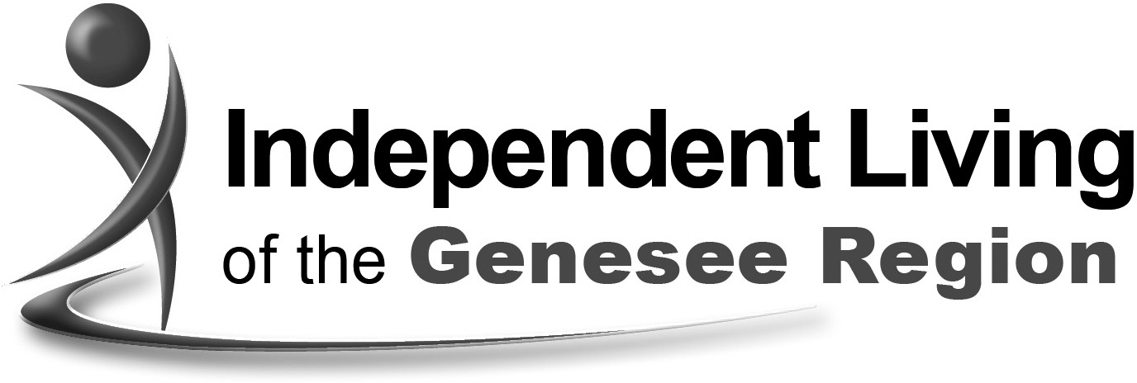

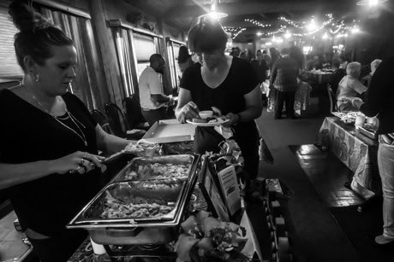

Independent Living of the Genesee region

Independent Living of the Genesee Region (ILGR) provides easy access to services at our 113 Main Street location in the City of Batavia, and has
been in operation for almost eight years. Our Center is staffed by eighteen dedicated individuals who live in all parts of our service delivery area, including Genesee, Orleans and Wyoming Counties. We have expanded and maintain an office in Perry, NY to serve Wyoming County residents directly in their community. Our staff participate in over thirty community and human service meetings regularly; advocating for system-wide changes on behalf of people with disabilities. We have established the Genesee Region Advisory Committee for People with Disabilities, which provides a voice to the legislative body in Genesee County.

Some of our services have remained the same over the years. They include free durable medical equipment from our loan closet; peer counseling; advocacy and assistance with social services, landlords, social security, and the “Careers” employment club.

New programs include the “Rapid Rehousing” program which provides rent and security deposit for homeless individuals and families. We are collaborating with Pathstones Inc. to provide wrap around services so that we don’t just leave people at the door. Our Independent Living Specialists continue to meet with consumers and make sure they reach true stability.

Our current roster of support groups includes Anger Management, and DeClutter Support Group. The Anger Management Group is a 12-week series utilizing the Federal Substance Abuse and Mental Health Services Administration (SAMHSA) curriculum. The DeClutter Support Group meets to provide assistance for individuals struggling with hoarding.

Our center conducts an annual disability simulation entitled “Lunch in
the Dark”. We collaborate with the New York State School for the Blind in Batavia, so that participants can get a better understanding of eating and socializing with vision loss. We also provide Blind Etiquette training for the staff of our partner organizations.

Classes which educate on how to stay well have been added to our services. We provide Stanford University evidence-based workshops entitled Chronic Disease Self-Management Program (CDSMP) and Diabetes Self-Management Program (DSMP). These are on-going and scheduled in several counties.

As our agency has grown, we have focused on encouraging people to stop by our reception area. It is being redesigned as an exhibition site for the artwork of people with disabilities. Along with our partner, University Heights Arts Association, we provide free fine art materials and projects for stress reduction and to enhance creativity in the ARTcovz kiosk in our Lobby. We are in our second year of hosting the juried competition called “ARTiculations” which allows for quarterly exhibition of artwork.

ILGR is determined to meet the needs of the community of people with disabilities. Our strength is a group of enthusiastic peers who are dedicated to the community they serve. Please contact us at (585) 815-8501 ext. 400 for further information or at www.wnyil.org/ilgr.

Rae Frank Director

ILGR Vignettes 2016-2017

- “JM”, who was struggling with a cocaine addiction, was referred to Independent Living of the Genesee Region (ILGR) by the Treatment Court Coordinator of Batavia City Court. Successfully completing an in- patient admission, JM returned to Batavia, acquiring a job cleaning hotel rooms. As she needed assistance finding housing, her Independent Living Specialist (ILS) helped her complete housing applications and provided housing lists. Once she found an apartment, ILGR assisted her to acquire the necessary security deposit. JM regained custody of her children, and should be graduating treatment court soon.

- Consumer RH came into the agency homeless and afraid because the local Department of Social Services would only offer transportation to a mission in Buffalo or Rochester. ILGR was able to determine his
eligibility for the Rapid Rehousing program which covered the expenses of a one-bedroom apartment. He received assistance with food, housing, employment and is on his way to financial independence.

- I began working with a family in the middle of October in Wyoming County because they were homeless, temporarily living in a motel paid for by Angel Action in Wyoming County. They are a family of five, with children ages ranging from six years old to thirteen years old. The family was struggling to maintain stable housing due to limited income from one parent working periodically on a farm. As an Independent Living Specialist, I was able to assist them with the Rapid Rehousing program. We were able to find them housing four days before Thanksgiving which gave them stable housing prior to the holidays. The program provided the security deposit plus rent for a portion of the time while the family works to become stable.

Annual Report 2016-2017 Statistics

ILGR

Total Number of Consumers Served: 920

Number of Consumers by Age:
Under 5 years old: 0
Ages 5-19: 20
Ages 20-24: 26
Ages 25-59: 393
Age 60 and older: 464
Age unavailable: 17

Number of Consumers by Gender:
Female: 542
Male: 378

Number of Consumers by Race and Ethnicity:
American Indian or Alaska Native: 9 Asian: 5
Black or African American: 60 White: 819
Hispanic or Latino: 13 Race/Ethnicity Unavailable: 14

Number of Consumers by Disability*:
Cognitive: 274
Mental/Emotional: 430
Physical: 1028
Sensory (hearing, vision, etc.): 154
Multiple Disabilities: 465
*Some consumers may have indicated more than 1 disability category.

Number of Consumers by County of Residence:
Allegany: 1
Cattaraugus: 1

Erie: 26
Genesee: 761
Livingston: 7
Monroe: 6
Niagara: 5
Orange: 1
Orleans: 105
Wyoming: 148 Outside of NY: 2
*County numbers include consumers with disabilities as well as casual contacts and information and referral for people with and without disabilities

Number of Consumers by Veteran Status:
Veteran (served in U.S. military): 78
Non-veteran (never served in U.S. military): 806
Status unavailable: 36

Number of Consumers by Services Received*
Advocacy/legal services: 204
Assistive devices/equipment: 408
Communication services: 111
Counseling services: 18
Family services: 2
Housing and shelter services: 166 Information and referral services: 441
IL skill development and life skills services: 212 Mobility Training: 2
Peer counseling services: 80 Personal assistance services: 144 Recreational services: 3
Transportation services: 7
Youth services: 2
Vocational services: 56
Plan for the achievement of self support services: 6 Business/Industry/Agency services: 1

Benefits advisement services: 176
*Some consumers may have received more than 1 service.

Number of Businesses/Agencies Served: 28

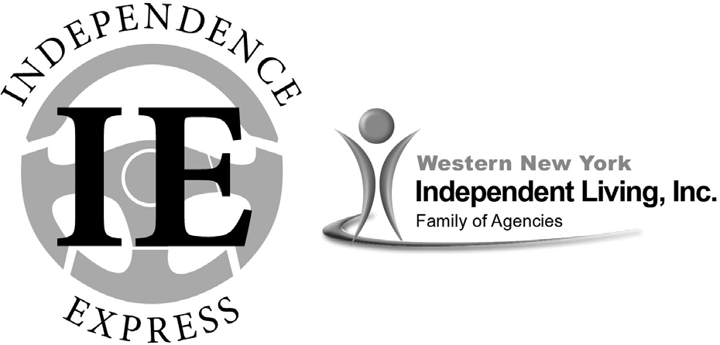

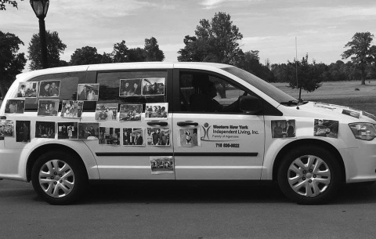

Independence Express Transportation Department

WNYIL has been providing transportation for people with disabilities for almost 40 years. It started with one van for the agency with any staff member that was available driving. Through the years, an actual Transportation Department was formed, developed and now we have a
small fleet of vans, drivers and support staff. Our budget is now almost
$500,000 and hopefully growing larger every year.

Now our own department, Independence Express (IE), has several different funding sources to provide rides to people throughout Erie, Niagara, Genesee and Orleans Counties. Some of our programs also include funding for bus passes. We also offer Fee-For-Service transportation. If an individual does not qualify for a grant program, they may pay $15 each way, plus $.50 per mile to ride on our vans and travel anywhere in our service area. As always, people receiving service at one of our agencies, attending functions of and attending groups at WNYIL receive transportation at no cost when available. WNYIL currently has 4 wheelchair accessible vans and 2 minivans available to serve WNY.

In the 2017 fiscal year, IE served over 150 people with 6,402 trips. These individuals either rode on the vans or received a bus pass. In the same span of time, our vans drove over 300,000 miles throughout the four counties getting people to various locations.

In the coming year, we will continue to explore new funding sources to continue to provide safe, reliable transportation to people with disabilities throughout WNY.
Catherine Colicchia Director

Western New York Independent Living, Inc.
3108 Main Street, Buffalo, NY 14214
(716) 836-0822 (Voice/TDD)
(716) 835-3967 (Fax)
Independent Living Center (ILC) Mental Health Peer Connection (MHPC)

Independent Living of Niagara County
746 Portage Road, Niagara Falls, NY 14301 (716) 284-4131 (Voice/TDD)
(716) 284-3230 (Fax)
(855) 366-1042 (Toll Free)

OAHIIO “The Good Path”
473 Third Street, Niagara Falls, NY 14301 (716) 284-4204 (Voice/TDD)
(716) 834-5647 (Fax)
1-800-348-8399 (Toll Free)

Independent Living of the Genesee Region
113 Main Street, Suite 5, Batavia, NY 14020
(585) 815-8501 (Voice/TDD) (585) 815-8502 (Fax)

