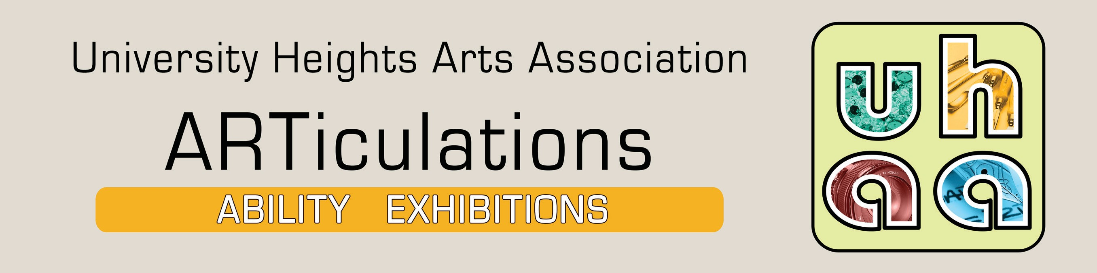

**WEbsitEs  
iLGR:** ilgr.org

**UHaa:** uhartsgroup.com

**Risk and LiabiLity:** Your signature on the registration form below constitutes agreement by you that there shall be NO LIABILITY on the part of ILGR and/or their staff or on the part of the UHAA and/or their officers or board

members for loss, damage, or destruction of any art work during the calendar period of the exhibition (from drop-off through pick-up).

**PR:** ILGR will coordinate press releases to local news media. UHAA will develop an online event page through it’s website and social utilities and will provide

the artist with complimentary posters and postcards. The artist may order additional posters and postcards.

Send the information requested on this entry form to the University Heights Arts Association: [**fineart@uhartsgroup.com**](mailto:fineart@uhartsgroup.com)

A UHAA Art Partnering Program

**Independent Living of the Genesee Region (ILGR)**

**113 Main Street, Batavia, NY 14020** | **(585) 815-8501-Ext. 411**

**WHY aRt PaRtnERinG FOR tHE disabLEd?** Art is for everyone irrespective of disability! Art promotes learning, inspires connection, and enhances personal identity. As a conduit for artistic expression, *ARTiculations Ability Exhibitions* promote the inclusion of artists and audiences with disabilities into the rich network of exhibitions offered throughout Western New York.

**Program**

**UHaa.** The University Heights Arts Association (UHAA), organized in North Buffalo, is a group of artists that serves as a driving creative force and educational resource through the arts that make a positive difference in people’s lives in each of several areas where they serve.

**EXHibitiOn PROGRaM.** A part of the UHAA Art Partnering Program which places art in businesses and community spaces, ARTiculations Ability Exhibitions displays art by artists who are disabled at ILGR through quarterly solo and group exhibitions.

**ELiGibiLity.** This program is open exclusively to artists who are disabled living in Genesee, Wyoming and Orleans counties.

**MEdiUM.** Photography, painting, illustration, collage, and mixed media

**siZE:** May not exceed 30 in. wide x 36 in. high including the frame.

**JURyinG.** Artists wishing to be considered for an exhibition must email photographs of at least three different artworks to: [**fineart@uhartsgroup.com**..](mailto:fineart@uhartsgroup.com)

**PREsEntatiOn:** All work must be framed and ready to hang. Either D rings or a “screw eye” may be used. No eye hooks. No “easel-back” photo frames.

**dROP OFF/PiCk UP:** A time will be scheduled with the artist to drop off the work to be exhibited and to retrieve it after the exhibition closes.

**RECEPtiOn:** An annual reception at ILGR will celebrate all of the ARTiculations Ability Exhibitions held that year.

**FEEs/saLEs:** Neither the UHAA nor ILGR charge the artist to participate in an exhibition. All proceeds from the sale of any work are payable to the artist at the end of the exhibition. Artists are *not* required to sell their work in order to participate in an exhibition.

**additional information**

**QUEstiOns?**

**Email** [fineart@uhartsgroup.com](mailto:fineart@uhartsgroup.com)

**telephone** ILGR: (585)815-8501 ext. 411

UHAA: (716)833-6260.

This Prospectus is available on the UHAA website at: [**http://www.uhartsgroup.com/aRticulations.pdf**](http://www.uhartsgroup.com/aRticulations.pdf) **Postal service:** 67 Highgate Ave, Buffalo, NY 14214

**iLGR OFFiCE HOURs.**

Mon.-Fril., 8:30 a.m.-5:00 p.m. Call (585)815-8501 ext. 411

before visiting.



**Exhibition Entry Form**

Email the information in below to [**fineart@uhartsgroup.com**](mailto:fineart@uhartsgroup.com) or mail to: **67 Highgate Ave., Buffalo, NY 14214**

Artist Biography or Statement:

**submissions**

Title

Medium

Title

Medium

Size

Price

Size

Price

Title

Medium

Title

Medium

Size

Price

Size

Price

Title

Medium

Title

Medium

Size

Price

Size

Price

Title

Medium

Title

Medium

Size

Price

Size

Price

Title

Medium

Title

Medium

Size

Price

Size

Price

Artist Address Phone Email: Website: Social Utilities: