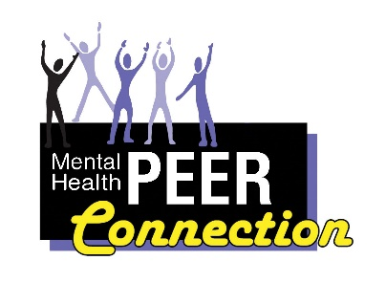Mental Health PEER Connection 6th Edition

Community Spotlight

Richard Dread, Vice President of WNYIL Board of Directors

I am proud to say that I am a recipient of a certificate of recognition for being a tremendous and continuous partner to veterans and their families. This was awarded by Ransom House, Inc and Johnetta R. Cole AMVETS Post No. 24. After accepting this certificate, it caused me to reflect on my life. I would like to share a little bit about my life history. I was born in Buffalo, NY. My family moved around to 18 different houses before I got out of high school. I am the youngest of all my siblings. I also attended 9 different schools. I believe that there were pros and cons coming up in a dysfunctional household. My mother served as a mentor in many ways. She was the head of our household and made sure all our needs were met. Unfortunately, my father left us when I was very young. However, there were three men my mother had children with too. My siblings and I did a number of small jobs in the community to support ourselves. We did everything from wagon service to shining shoes.

I was placed in special education classes from 4th grade until my 10th year in public school. I missed a lot of needed instruction—which would have made me more competitive with other students. It wasn’t until high school that some of my teachers took me under their wings and taught me how to learn. In order for me to be allowed to play sports, I had to stay academically eligible. In short, in learning how to play sports I found my calling where I excelled. However, my grades continued to be very low. Eventually, I completed the classes I needed to graduate. After high school, I got a job in a car factory over the summer.
By September I left Buffalo and moved to Pennsylvania. There I worked several jobs. I was told that a college near my town had a program geared towards helping minority students enter. This college gave me an opportunity to attend. I’m the only one of my siblings who went to college. After my fourth year, I was able to continue and work towards a master’s degree which I completed. I worked as both a substitute teacher and a regular teacher. After this, I went to work at 4 different state agencies. As a state employee with these agencies, I was a mid-level management employee.

Over my life span, I have had my ups and downs, but I always seemed able to rise up. Some of the things of which I am most proud are being featured in Sports Illustrated Magazine in 1969 and being inducted to Buffalo’s High School Harvard Hall of Fame for Football in 2016. In college, I made the National Jayvee’s Outstanding Young Man Award in 1974, that same year I also made it into Who’s Who Among College Students. After my retirement I started two businesses. One was contracting with Rite Aid Drug Stores cleaning and waxing floors in a number of stores in Pennsylvania. The other business was an import/export business in which I traveled between West Africa and the West Indies doing business deals.

I have three grandchildren by my son Aaron. I have also had three marriages that ended badly. I believe my lifestyle played a role in my failed marriages. When, I entered graduate school, this was the beginning of me becoming a social climber. At this time, I joined the Mason’s and Omega Psi Phi Fraternity, Inc. I got away from the business at hand and became a party animal all of which caught up with me and lead to my downfall. Life choices that I made then, continue to haunt me. I was like the lady in the commercials, I believed that I had fallen and could not get up. Today, I am the master of my faith and the captain of my soul.
Why I Love What I Do!
Todd Vaarwerk, Chief Policy Officer

As of this May, it will be my pleasure to work at Western New York Independent Living Inc. for 28 years. In that time while there is been a lot of change, there has also been just as many challenges that make the work of independent living just as critical today as it was the day I was hired.

First, I love working at WNYIL because I get to see change happening in real time.
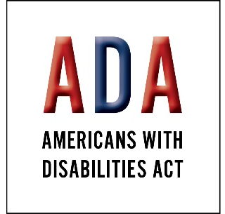
When I started in 1994, the Americans With Disabilities Act was a relatively new item. In my job as Systems Advocate back then it was my responsibility to learn this law inside and out and see to its application wherever systems and locations were inaccessible to people with disabilities. In the intervening years I’ve seen our local community build accessible stadiums and airports, reach a goal of a 100% wheelchair accessible public transportation system, including the implementation of paratransit, and seen the voice of people with disabilities be included in many important planning items within our community.

At the same time, people WNYIL have worked with since its founding have retired, agencies have changed focus, positions working with people with disabilities have been eliminated, and the regulatory framework on a lot of things that affect our lives has been fundamentally changed. Even after 27 years though, those situations present me with a challenge rather than a burden. It just continues to show me how important it is that we stay vigilant about the implementation of the ADA, even in 2022.

Second, I love working at WNYIL because our philosophy is unique.

In my job, I work with a lot of agencies, offices, legislators, and regulatory bodies. Over the years, a lot of what is in the nature of the independent living philosophy has been “repurposed” for many a legislative initiative. The problem is; however, they’ve never really gotten it right. Person-centered planning, for example, is a big buzzword these days. It comes from the independent living standard of consumer control - our right to drive our services in the need that serves us the best. But person-centered planning, is implemented by some of our state agencies, doesn’t quite gives us control. Someone always needs to approve or modify the plan. A key function of my job is to remind folks of core independent living values that have served our community for more than 50 years. That includes working with some of the best peers I’ve ever met to communicate that message and support our very freedom within the community.

Lastly, I love working at WNYIL because I get to see lives change - almost daily.

Even though my job doesn’t allow me to work with consumers on individual issues, in working with my fellow WNYIL Staff on issues presented by their consumers, I regularly get to see lives change for the better. People who never thought they could work again taking on that challenge. People finding their voice to express desires in their life. People getting out of hospitals, or more fully living their lives because of aide services that we helped them get.

Most recently, I had the opportunity to see Governor Kathy Hochul sign the Chief Disability Officer bill, restoring a voice for persons with disabilities in state government after almost 12 years. It wouldn’t have happened without a whole bunch of folks having cared enough about it (including you readers) to make it happen. As I left Albany to return home, I remember one reoccurring thought – “Is this a great job or what?”

Why I Love What I Do!
Lisa María Cruz, Mental Health PEER Connection Outreach Coordinator
I started working at the Mental Health PEER Connection (MHPC) on April 19th, 2017. I have been here for almost five years and I love my job. I have had the great good fortune to be able to do outreach for the MHPC. I go out into the community and share information about the programs and services that we offer. I do presentations in person and of course virtually as well. I get to interact with all kinds of people from all walks of life. I talk to individuals who frequent food pantries, public libraries, mental health and addiction treatment providers, homeless shelters, churches, health providers and human service agencies. I also communicate with the professionals who interact in those spaces as well. I’ll talk to anyone. I’m passionate about connecting with others and sharing about the MHPC. It’s what I enjoy most about my job.
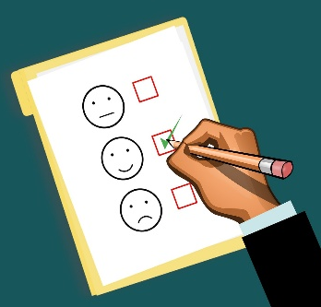
During the past five years, my position has evolved at the MHPC. With the onset of the Coronavirus pandemic, I began to offer a support group that meets virtually. The members of our group gather every Thursday night without fail from 7 to 8 p.m. It’s a fun group. We have people that sing, perform spoken word art and play musical instruments. It’s a friendly and safe space for individuals to connect and share our talents. We welcome performers of every type and every ability. So, whether you’re a seasoned artist or just starting out, you are welcome to attend our group. If you’re interested in joining in on the fun, you can reach me at lmcruz@wnyil.org or 716-836-0822 ext. 520.
Another responsibility I have taken on is the amazing MHPC Quarterly Newsletter. I take pleasure in being responsible for it. It’s a way for us to easily reach hundreds of people. It’s an effective way to disseminate information about the MHPC and the Western New York Independent Living (WNYIL). I fancy writing for and editing the newsletter. I also benefit from reaching out to my peers and encouraging them to submit articles. Everyone can be a writer. Everyone can contribute. If you have some ideas about a piece and would like to run it by me, please feel free to contact me. I would like to hear from you.
I also have the opportunity to connect with the people we serve and conduct our consumer satisfaction surveys. I am very fond of talking to our consumers. Whenever I call, it’s important to me to always be friendly, polite and compassionate. The reason why I and everyone who works at the MHPC and the WNYIL have our jobs is because of our consumers. Without them, we would not even be here.
I am thoroughly enjoying my journey here at the MHPC and the WNYIL family of agencies. There is no other place I would rather be. I feel hopeful and optimistic about my future here. I am committed to my job and our agency. I look forward to the future evolution of my role and the opportunities that will come.

Brain and Body Considerations
David Meyers, MHPC Volunteer
Mental health is a central component of everyday life. It affects behavior and decisions at every level. Physical health can fall short with poor mental health, and vice-versa. The Center for Disease Control states, “Mental health includes our emotional, psychological, and social well-being.” https://www.cdc.gov/mentalhealth/index.htm. This statement underlies the complexity of maintaining balance as a human being. While dealing with the effects of a mental health diagnosis, a person is required to cope every day with effects on both their mental health and physical health.

It is challenging to do so, but there are proactive ways to consider overall health in the lens of both mental health and physical health. In the depths of depression, making the body move at all can be a major chore, let alone exercise. It is easy to stay in the mindset of inactivity and not accomplish anything productive. Severe depression can effectively freeze the body and make it more difficult to think clearly. When it is difficult to think with clarity, it is that much more difficult to accomplish tasks such as exercise. Therefore, it is understandable that people with depression may exercise less often than most of the population.
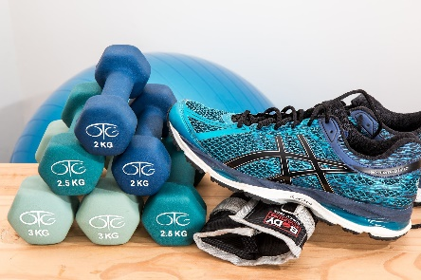
Yet its effects payoff: “Researchers from two London universities and Massachusetts General Hospital looked at data from 152,978 adults in the UK, aged 40 to 69, over seven years to compare measures of fitness with symptoms of mental health. They found that people with greater muscular and aerobic fitness at the beginning of the study were more likely to report good mental health during follow-up, after adjusting for lifestyle variables like diet, income, and chronic illness.” https://www.insider.com/less-exercise-linked-to-higher-risk-of-depression-anxiety-study-2020-11.

But arising to the occasion to actually follow through on doctors’ orders is difficult. With any kind of mental health disorder ranging from depression to schizophrenia, judgement can be clouded, and decision making becomes more involved. In fact, executive or total functioning level, is often stunted with depression and anxiety, and is further complicated by bipolar disorder, schizophrenia, obsessive compulsive disorder, traumatic injuries to the brain, and ADHD: https://www.medicalnewstoday.com/articles/325402.

Poor functioning complicates carrying out the tasks of everyday living, including maintaining physical health with diet and exercise. The importance of maintaining functioning with a mental health disorder underlies the necessity of communicating with a primary care doctor and psychiatrist alike. Indeed, finding appropriate help for a mental health disorder can affect physical health. For example, stress is a factor that affects both physical health and mental health in lockstep. Stress can lead to episodes, especially with bipolar disorder. The activity level of someone with bipolar disorder may be more elevated during a manic episode brought on by stress: https://www.ncbi.nlm.nih.gov/pmc/articles/PMC5205570/. However, in depression, stress may also adversely lead to inactivity. It can also affect digestion and sleep. Effectively, depression is a physical illness as well as a mental illness. https://www.talkspace.com/blog/6-reasons-why-its-hard-for-people-with-depression-to-.

The practice of meditation can lead to awareness of the entire picture. Holistic practice considers the brain and body as interconnected. Diet affects physical health, which in turn affects mental health. Mental health in turn affects interaction with others. Poor physical health therefore may affect the quality of life of someone. Since physical health and mental health are connected, it may be of interest to learn that research suggests that mindfulness benefits our bodies, not just our minds. http://greatergood.berkeley.edu/article/item/five_ways_mindfulness_medication_is_good_for_your_healt.

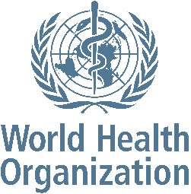
Although there are medical components of mental health, there are multiple perspectives to consider in regard to the treatment of mental issues. Some trains of thought see mental illness as a physical issue originating from the brain, while other perspectives deny the influence of illness at all in mental health issues. While taking medication is an accepted practice in consideration of mental health, therapeutic techniques such as dialectical behavioral therapy (DBT) supplements their usage. One group which seems to not view mental health issues as a disease is the World Health Organization, which specifies that “Mental health is more than the absence of mental disorders.” https://www.who.int/news-room/fact-sheets/detail/mental-health-strengthening-our-response.

While the perspective may free some from seeing within the disease model, Eric Kandel, MD, a Nobel Prize laureate and professor of brain science at Columbia University, believes it’s all about biology. “All mental processes are brain processes, and therefore all disorders of mental functioning are biological diseases,” he says. “The brain is the organ of the mind. Where else could [mental illness] be if not in the brain?” https://www.apa.org/monitor/2012/06/roots. The answer is hard to know and is continually under investigation, especially in the field of neurology, a field treating the brain which brings physical and mental health together. Over time, I wonder if neurologists will be more accepted as mental health practitioners than psychiatrists. Some evidence points in this medical direction, while there are organizations that treat mental health with more behavioral considerations. With faith from practitioners in science and sound therapeutic techniques, ultimately answers are arising. Effective methods of medical and behavioral treatment come with tested methodologies, and through the power of communication between doctors and individuals.
Recovery Starts with Me
Brenda Starks, Benefits Advisor

I cannot overstate, the importance of support and wellness while overcoming physical and mental health. Every day is a struggle when a person does not have positive supports in place to help with their physical and mental health. What I have learned in the last several months is that recovery from both physical and mental health is a process and that it starts with me. The road to recovery has not been an easy one but having the supports in place to help, listen and encourage you is essential to your well-being.
It gets lonely and hard at times to stay focused when there is no understanding or reason to work toward the process of recovery. But let me say this "the one thing that's important for me was overcoming the obstacles that had placed fear in my life." My suggestion is to have positive people in your life and to ensure that all your doctors are on the same page with you. Also, remember that just because something did not work, keep trying until you find the right fit that works for you. The road to recovery has a lot of crooked roads that may not go in the direction we want but in the end the outcome will become clear, and you will be able to see the end of the road.
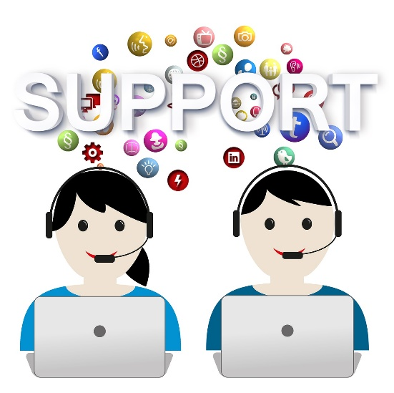
But let us talk about the "NOW" which means Nutrients, Opportunity, and Wellness. The NOW is something that I produced one day when things were just not going well, and I needed to stop feeling sorry for myself. The Nutrients for me means how I feed and maintain growth during the recovery. Opportunity for me means that anything is possible because quitting is not the answer and Wellness for me means that I continue working on my well-being mentally regardless of the obstacles. This is my life the NOW.

Benefits Advisor Services
Reah Brown, Certified Benefits Advisor and Home-Based Community Peer
Did you ever wonder what to do if you had questions about SNAP, Public Assistance, Social Security, and other governmental services available for anyone? A Certified Benefits Advisor can provide information about these services. If you need help applying for SNAP, Public Assistance, Social Security or even health care services, a Certified Benefits Advisor is more than willing to help you accomplish this task. A Certified Benefits Advisor is also capable of submitting a waiver when Social Security applications are denied for further examination of the benefits for possible approval. Finally, Certified Benefit Advisors can advocate for consumers with other agencies. My name is Reah Brown, and I am a Certified Benefits Advisor with the Mental Health PEER Connection. If you have any of these problems, please contact me at 836-0822 ext. 511.

Finding Value in Damaged Goods
Melissa Burns, Former Mental Health PEER Connection Program Assistant
I came to Buffalo, New York 3 years ago with what I thought was nothing. I’d been though the psychiatric system nearly a dozen times, jumping jobs and cities, simultaneously running from who I am and also toward who I wanted to be. At this point, I’d had low self esteem as long as I could remember and spent the better part of my adult life trying to bury the facets of my experience that made me crazy in different jobs, experiences, and hair colors. On the surface, I was a roving wreck, a body that spent its time falling short of achievement and avoiding it, sloppily covering up any indicator of neurotypical variance in a variety of experiences I’d claim I stumbled into like an imposter in disguise. At the age of 30 I would have told you that my personhood was defined more by lost potential than dreams I had achieved.
In November of 2019 I got a call that would change the way I created personal meaning. The week prior I had what I thought was the worst job interview I ever gave for an administrative assistant position outside of Amherst, NY. At the time, I had been travelling around the Midwest in a junky Taurus that was more rust than car. Naturally, I got pulled over (again) in the middle of nowhere Ohio for speeding in a rusted deathtrap. At the same moment the blue and red lights were reflecting in my rear-view mirror, I got a call from Maura Kelley, the then director of Mental Health PEER Connection (MHPC), asking if I still wanted the position, to which I said, absolutely because I have some surprise bills I’m going to have to pay.
This began my path into peer support and, to be honest, I had no idea what any of it entailed, or even how long I would last. But I went to orientation. And instead of going through the boring “business as usual” protocol, I got to listen to folks with a variety of disabilities tell me how they how they stood before the status quo-doctors, institutions, police officers, care homes, and employers-and continually proved that living with a disability or with trauma wasn’t something to be pitied, or hidden, but something that is worth embracing as one of the many ways a society can exist. For the first time in my life, my disability wasn’t a thing to be cured, or some generic Oprah story meant to make others feel good, it was something that made me wise. I felt understood. I felt empowered to tell my story, to stand up for what made me unique, and to say once and for all, that I didn’t need a cure that erases my mental health experience and turns it into a ghost I run from.
As I depart MHPC to begin life with my partner in a new state, I now carry my mental health disability with me, not as excess baggage, but as a valuable packed in bubbled wrap, an heirloom whose experience is worthy of preservation, whose presence has the potential to help other so-called misfits in their journey toward embracing identity. My hope is that anyone reading this can also take note of their damaged goods and fill whatever cracks and vacancies that embody them with the kind of gold Independent living Philosophy and MHPC has bestowed in me. If MHPC has taught me anything, it’s that In spite of what others may say you’re missing, your flaws can be what make you whole.
Medicaid Liens: An Attack on the Poor
Rafiq Salim, ICAN Coordinator
ICAN is the New York State Ombudsprogram for people with Medicaid who need long term care or behavioral health services. Long-term care plan benefits include home care, adult day care, nursing home care, medical supplies, durable medical equipment, home modifications and transportation services. ICAN assists members by providing formal and informal advocacy when a plan member disagrees with a plan decision to deny or reduce a long-term care plan benefit.

ICAN will assist anyone enrolled in or eligible for Managed Long-Term Care (MLTC), Health and Recovery Plans (HARP) or long-term care services through a Medicaid Managed Care plan (MMC). We also help educate people who are newly eligible for enrollment in a Medicaid managed care plan and provide choice counseling. We will talk with individuals, family members, or anyone who is helping the individual with healthcare decisions.

One of the challenges poor people face is whether to accept Managed Long-Term Care for fear of incurring a Medicaid lien. This becomes a particularly difficult decision when the potential recipient has a home they wish to pass on to descendants.

Medicaid is not free health care; payment for services received through Medicaid are, in fact, indefinitely deferred. If the recipient receives a settlement, New York State is obligated to sue to recoup the money spent by Medicaid. (I discovered this several years ago cashing a jackpot receipt at a state casino.) If the recipient dies and owns a home, New York State is obligated to attempt recovery of money spent by Medicaid. Since 1993, New York State has no choice but to attempt recovery. The change from elective to mandatory recovery by the states was part of the budget negotiations between President Bill Clinton and congress. Ironically, only about 1% of Medicaid dollars are recovered through Medicaid liens. So why does the government do this?

Advocates have been asking this question since 1992. And all states did not agree with the governments new mandate. West Virginia sued the federal government arguing that the new rule violated the 10th Amendment infringement on state powers, an attempt at interposition and nullification put to good use. The case was settled in 2002 and West Virginia lost. Wisconsin refused to implement the rule until threatened with loss of all Medicaid dollars. New York, like other states, tows the line.

Today, Medicaid liens are again called into question. February 2022 Congresswoman Jan Schakowsky (D-IL), a Senior Chief Deputy Whip and Co-Founder and Co-Chair of the House Democratic Task Force on Aging and Families, introduced the Stop Unfair Medicaid Recoveries Act, a repeal of mandatory Medicaid liens on estates for repayment of Medicaid long-term care services.

What has become clear to legislators and activists is that the Medicaid lien recovery program punishes the poor by forcing sale of homes and preventing the accumulation of generational wealth. Moreover, the legal strategies to avoid Medicaid liens are not always understood by the poor.

“By forcing the sale of family homes, Medicaid estate claims keep families in poverty and increase the risk of homelessness,” says Eric Carlson, Directing Attorney, Justice in Aging.“ The Stop Unfair Medicaid Recoveries Act will fix this problem so that low-income persons don’t have to risk the family home in order to receive needed long-term care.”

What can we do? Tell our United States Senators and Representatives to support the Stop Unfair Medicaid Recoveries Act.

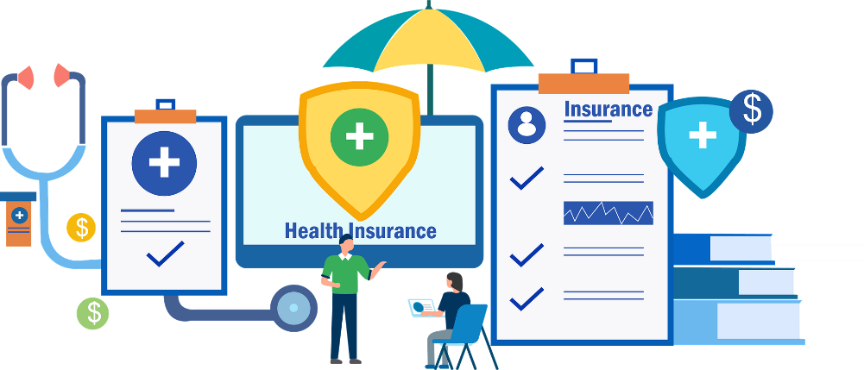
Joyful Rhymes
Lisa Maria Cruz, MHPC Outreach Coordinator

Miracles meander mightily.
Tattered twinkies twitter truthfully.
Negligent noodles never needle.
Boisterous boys’ bountiful beetles.

Delightful divas demand dandies.
Crunchy crows command and catch candies.
Broken bottles bitterly babble.
Righteous redheads randomly rattle.
Look! Lemons lightheartedly litter.
Bright birds brim boisterously bitter.
Savage seesaws saunter and simmer.
Delightful divas demand dinner.

Naughty Nanceys neglectfully nod.
Tearfully Teresa tortures Todd.
Mercifully moonlight meanders.
Drunken doubtful donkey delivers.

Crazy cookies crumble crookedly.
Bountiful broken books bounce badly.
Saucy singers sinfully saunter.
Hungry hasty hippos hurry her.

Horrendous hippos handsomely hum.
Forever fickle friends fight for fun.
Willful willows wander and wiggle.
Gigantic gophers grunt and giggle.

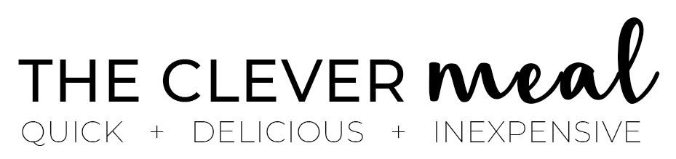

Lemon ricotta pasta & spinach

This light and zesty lemon ricotta pasta with spinach makes a delish weeknight meal ready in less than 15 minutes. Simple, fresh ingredients, delicious flavor, and minimal effort.

Prep Time: 13 mins. | Course: pasta | Cuisine: Italian | Keyword: Lemon ricotta pasta | Servings: 3 | Calories: 538kcal | Author: Katia

Ingredients
- ½ lb. (8oz/220 grams) pasta (spaghetti, linguine, penne, fusilli...)
- 1 cup (9oz/250 grams) whole-milk ricotta
- 8 oz. (230 grams) fresh baby spinach, washed
- 1/3 cup (35 grams) grated Parmesan cheese, plus extra to serve
- 1 unwaxed lemon, zest and juice
- 3 lemon wedges, to serve (optional)
- 1 Tbsp. extra virgin olive oil, plus extra for drizzling
- 1 garlic clove, grated or pressed
- salt and black pepper, to taste
Instructions
- In a large pot of boiling salted water, cook pasta according to package directions until al dente. Meanwhile, make the ricotta sauce.
- In a medium bowl, combine ricotta, olive oil, parmesan cheese, garlic, lemon zest and juice. Season with 1/4 tsp. of salt and a good pinch of pepper.
- Stir until well combined, taste and make sure you're happy with the seasoning.
- In the last minute of the pasta's cooking time, reserve 1/2 cup of the cooking water, then and add spinach to the pot. Stir well and push the leaves down to submerge them in water.
- After 1 minute, drain and return pasta and spinach to the same pot.
- Add the ricotta sauce and part of the reserved cooking water. Stir well to evenly coat the pasta in the sauce, add more cooking water as needed, you want a smooth and creamy texture.
- Serve immediately and garnish with grated or shaved Parmesan cheese, a drizzle of extra virgin olive oil and lemon wedges if desired (for extra freshly squeezed juice, but I leave it optional). Plus, I love adding a good pinch of red pepper flakes, you might give it a go. Enjoy!

Notes
Cooking water: add pasta water gradually, you might not need all of it. You don't want to water down the flavor, but only make spaghetti nice and moist. If you think the reserved water is not enough, you might add a few Tbsps. of milk.
Pasta: you can use any short, large or long pasta shapes that work well to capture the creamy ricotta. I love spaghetti, but penne, fusilli, conchiglie work fine. Mini pasta shapes like orzo or even elbow macaroni doesn’t work well in the recipe.
NOTE: Nutritional values are estimates only.

Nutrition
Calories: 538kcal | Carbohydrates: 64g | Protein: 26g | Fat: 20g | Saturated Fat: 10g | Cholesterol: 53mg | Sodium: 314mg | Potassium: 743mg | Fiber: 5g | Sugar: 4g | Vitamin A: 7661IU | Vitamin C: 41mg | Calcium: 403mg | Iron: 4mg

