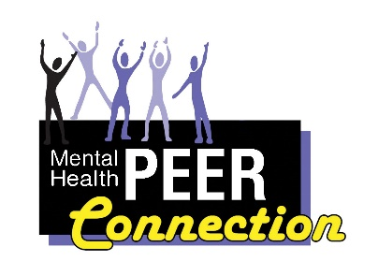Mental Health PEER Connection 7th Edition

Addict 2 Addict & Family 2 Family Program
Eddylees Guzman, eguzman@wnyil
716-836-0822 ext. 164 or 716-931-0280

I, Eddylees Guzman, am the Family 2 Family Peer Support Specialist for Addict 2 Addict & Family 2 Family (A2A / F2F) at Mental Health PEER Connection (MHPC). Most of the time, we family members are too busy focusing on our loved one’s addiction and we forget about ourselves and what a toll this takes on our own mental health. My goal is to spread awareness, education, and support surrounding addiction to families who are struggling with a loved one in active addiction or recovery with Family Support groups, including Virtual Support groups, online.

Our Addict 2 Addict & Family 2 Family program collaborates with other affected families and MHPC staff in an effort to help the individual with substance use disorder and the family members affected by their loved one’s behavior. Both A2A & F2F offers 1-on-1 peer counseling for the individuals with substance use disorder and their loved ones. Our unique approach brings together both perspectives of relating to someone who’s been through it with our peer-lived experiences. Our A2A & F2F programs also offers Narcan (opioid overdose antidote) trainings, presentations, and community outreach events. We also have our A2A / F2F of Erie County Peer Support hotline that anyone can call to leave messages 24-hours / 7-days, but calls are answered from 8 AM to 11 PM. With our A2A / F2F hotline, we give out resource information, linkages to the community, and we will do our best to find the help you need!

I am asking that we unite as a community to continue breaking down the stigma, so together we can provide that extra support. After all, how can we better serve our community than through collaboration? I hope this is a great start to making a better connection in our community.

If you are interested in our Addict 2 Addict & Family 2 Family Support groups, Virtual Family Group or Narcan trainings, personally or within your agency, please feel free to contact me at your earliest convenience by email or phone.
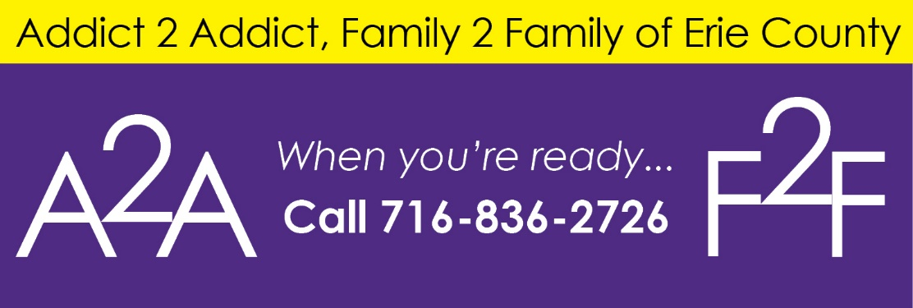

Mental Health Peer Connection Support Groups
Lisa Maria Cruz, MHPC Outreach Coordinator

As a service to the community of individuals with behavioral health issues, Mental Health Peer Connection (MHPC) is offering a number of support groups on different topics. Seven are conducted on-line, and participants must register in advance to be sent the Zoom link. Four in-person MHPC groups are held in locations throughout the Greater Buffalo area, and another run by an outside facilitator is hosted on the Western New York Independent Living campus in Buffalo’s University District. Those who wish to take part are asked to pre-register so that we can plan, but participation in any group is anonymous, and no information about participants is made available outside MHPC.

MHPC Virtual Support Groups

A Journey to Healing
Wednesdays, 1pm – 2pm
Eddylees Guzman, 836-0822 ext. 164 or email at eguzman@wnyil.org contact to register.
We will bring awareness, education, and support surrounding addiction to families who are struggling with a loved one’s addiction. Participants will learn how to set healthy boundaries, learn the stages of grief & loss, model coping skills, and the importance of self-care.

Positive Perspective
Wednesdays, 1pm – 2pm
Bobbie Fullenweider, 836-0822 ext. 129 or email at bfullenweider@wnyil.org contact to register.
How do we change our thinking? Let’s find the positive in this very negative world!!

Building Foundations of Recovery
Wednesdays, 3pm – 4pm
Addict 2 Addict & Family 2 Family Peer Support Group
Eddylees Guzman, 836-0822 ext. 164 or email at eguzman@wnyil.org contact to register.
This is an all-inclusive group supporting multiple pathways of recovery to educate individuals of the resources available to help them develop a strong foundation to their recovery.

Hand & Hand
Thursdays, 1pm – 2pm
Ashanti Brown, 836-0822 ext. 160 or email at ashbrown@wnyil.org contact to register.
Reaching out to the community with a trauma and support group.

MICA (Mental Illness Chemical Addition) Group
1st and 3rd Thursdays, 3pm – 4pm
Brett Dunbar, 836-0822 ext. 509, or email at bdunbar@wnyil.org contact to register.
Learn how to understand and challenge both mental illness and chemical addiction.

Virtual Open Mic: Freedom of Expression
Starting, September 1st, 2022
1st and 3rd Thursdays, 4:30pm – 5:30pm
Lisa Maria Cruz, 836-0822 ext. 520 or email at lmcruz@wnyil.org contact to register.
People can freely express themselves through spoken word, singing, playing musical instruments, theater, dance and comedy.

Walk with Me
Addict 2 Addict & Family 2 Family Peer Support Group
Fridays, 3pm – 4:30pm
Eddylees Guzman, 836-0822 ext. 164 or email at eguzman@wnyil.org contact to register.
We will meet with individuals with Substance Use Disorder (SUD) and their family members to discuss effective communication, conflict resolution, trust building, co-dependency recovery and coping skills.

Mental Health Peer Connection in-Person Groups

Hope Heals Family Support Group
Tuesdays, 12pm – 1:30pm
Sparks of Hope, 107 Main St, Hamburg, NY 14075
Alan Tomaski, atomaski@wnyil.org or 931-0380 to register. Please wear a face covering for the duration of the group.
As family members, our pain grows as we watch our loved ones suffering from substance abuse. The confusion on how to help can be overwhelming. Anger and fear become a part of our everyday lives.

In-Person SMART Recovery
Thursdays, 12:30pm – 1:30pm
Revive Wesleyan of Hamburg, 4999 McKinley Parkway, Hamburg, NY 14075
Alan Tomaski, atomaski@wnyil.org or 931-0380 to register. Please wear a face covering for the duration of the group. (Room is open 30 minutes before and after group.)
Our goal is to help individuals gain independence from addictive behavior and lead meaningful and satisfying lives.

Healing Families
Every other Friday starting October 22nd, 2021, 1pm – 2:30pm
Rural Outreach Center, 730 Olean Road, East Aurora, 14052
Alan Tomaski, atomaski@wnyil.org or 931-0380 to register. Please wear a face covering for the duration of the group.
Come join us for our peer family support group. We can help rebuild our lives after the devastation of substance use in our homes.

Wellness for All Group
Every other Friday starting on July 1, 2022 from 3pm to 5pm.
Amity Club, 340 Military Road, Buffalo, NY 14207.
Randy Oaks, 836-0822 ext. 182 or roaks@wnyil.org to register.
Peer support group for socializing. A pool table, dart board and television are available. Drinks and snacks can be purchased on site.

Support Group Sponsored by Depression and Bipolar Support Alliance (DBSA)

Depression, Anxiety, OCD and Bipolar Support Group

Mondays, 6pm – 8pm
Western New York Independent Living, 3108 Main Street, Buffalo, NY 14214
Marie Therese Kersten, (716) 435-0238 or jmtdkersten@yahoo.com.
Open to anyone with any mental health challenge. Please call before attending for the first time.

An important note about the RSVP process and privacy: To maintain your privacy, we do not publicly share the phone numbers and links to our virtual meetings. We will respect people's wishes to remain anonymous.
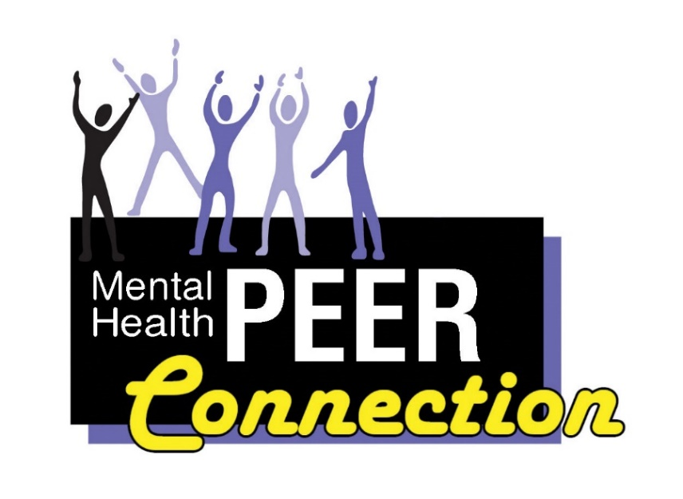
Buffalo Infringement Festival
Lisa Maria Cruz, MHPC Outreach Coordinator

The Buffalo Infringement Festival is a fun set of events for anyone to attend, offering eleven days of music, art, poetry, dance and theater. This year, it will take place from Thursday, July 28, 2022 through Sunday, August 7, 2022 at various venues throughout Buffalo’s Allentown District. Many of their events are free or low-cost.

The organizers say, “The Buffalo Infringement Festival is a non-profit-driven, non-hierarchical grassroots endeavor bringing together a broad range of eclectic, independent, experimental, and controversial art of all forms. Visual, performing, and media arts are all welcome here.” For more information about this year’s Buffalo Infringement Festival feel free to visit their website at https://infringeeveryday.wixsite.com/mysite.

My husband and I plan to joyfully participate in this year’s festival. We will infringe as much as possible and to our heart’s content. I’m really looking forward to it. I have friends who are performers too; Deedee and Pam are musicians and writers; it will be fun to catch their performances. I will be performing as well, sharing my own original works of spoken word art. I have participated in the Buffalo Infringement Festival for many years.

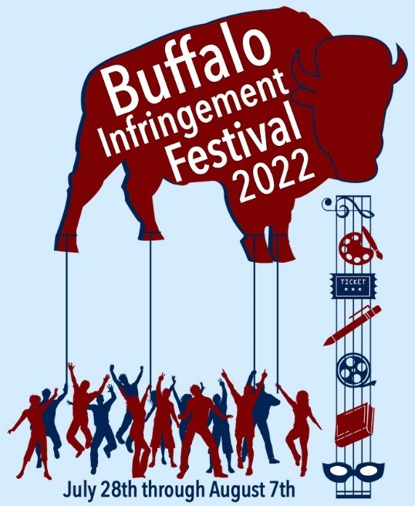
My collection of Buffalo Infringement Festival t-shirts has grown over the years. I always look forward to seeing their new design of the year and purchasing my own t-shirt. It will be in person this year and that is going to be incredible. You will be able to access their schedule on the Internet. If you visit their website, listed above, you can check out their schedule for July/August 2022. This year’s schedule is not up yet, but I encourage you to visit their website if you have any interest in the arts. I will most definitely be there performing and checking out other artists. Maybe I will see you there!!

Erie County Medical Center Peers
Josué Roman, Peer Advocate Navigator

My official title is Peer Advocate Navigator, but most of my coworkers refer to us, collectively, as “ECMC Peers”. Our role at the Medical Center is to work alongside the staff to assist people with behavioral health or addiction issues with their recoveries. We are commonly known for holding Peer Groups right there in the units, in which we gather and discuss a group topic that relates to recovery. In these groups, we come together, all learn from each other and show support for one another. We also do one-on-one Peer Counseling.

It’s commonplace that a patient may prefer to speak with a Peer over the hospital medical staff, because they know that we have lived experience and understanding. If someone lacks clothing, we bring them items from the volunteers’ closet. Also, the rest of the team at Mental Health PEER Connection (MHPC) may contact me if someone they serve is in ECMC’s care; to ensure they have a Peer alongside them. Both the patients and staff appreciate our services.

Although hospitalization with the involvement of a Peer may be a major part of one’s recovery, it is not the entirety of it. That is why I refer everyone I meet to MHPC for additional supports and services. I explain all the ways that an MHPC Peer can help with their recovery, adding that Peers offer services free of charge and will even locate services outside of our agency.

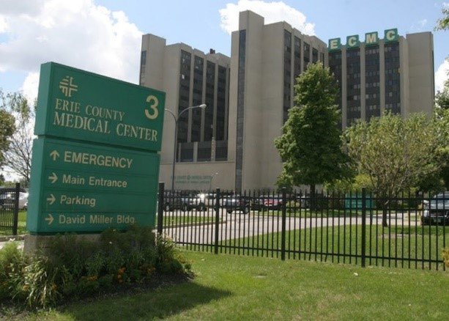
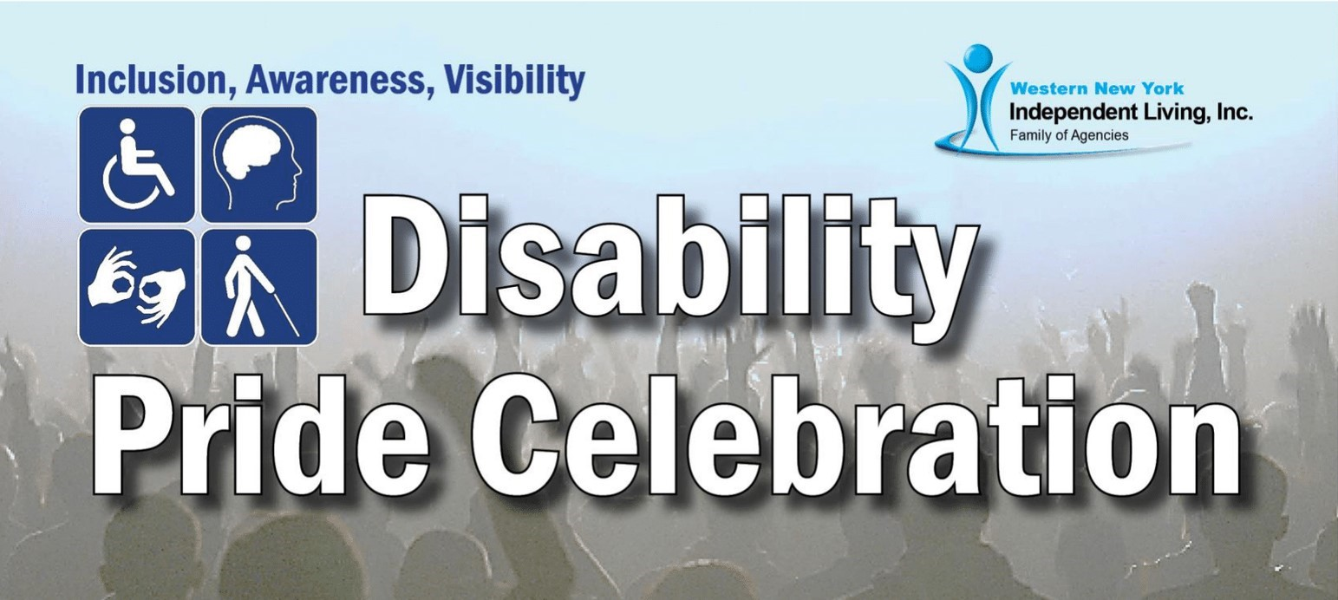

MHPC and our community partners invite YOU
to a really big deal!

Mental Health PEER Connection (MHPC), its sister agencies in the Western New York Independent Living Family, and many other organizations will be holding a Disability Pride Celebration on Sunday, July 24, 2022 at Canalside Buffalo from 11:00 AM to 2:00 PM. With free admission to the Disability Pride tent and outside, you will be able to enjoy free food, participate in adaptive water sports, and learn more about the services of MHPC and the other sponsoring organizations. We organizers anticipate over 400 participants, including consumers, their families, and friends, plus frequent Canalside visitors.

It’s all about how, on July 26, 1990, the Americans with Disabilities Act (ADA) was signed by then-President George Herbert Walker Bush. Why was this so important? Its provisions barred discrimination in employment, in programs by state and local governments, in services by places of public accommodation (stores, restaurants, hotels, theaters, salons, etc.) and could subject the violators to legal penalties. Plus, there were additional provisions for accessible public transportation, and telephone communication by hearing impaired individuals. Its ultimate consequence was eliminating barriers and increasing the independence and full integration of people with disabilities into our society, enabling them to access goods, services, and government programs, attain competitive work, and become tax-paying citizens. The ADA’s passage was the single biggest event in over one hundred years of advocacy to provide a “level playing field” for individuals with impairments!

Responsible organizations are invited to set up literature stations with a table and a chair provided, for a donation of $50 inside the Disability Pride tent and $25 outside. They would need to apply by July 15, 2022 to Community Engagement Coordinator Hayley Joyce at mailto:hjoyce@wnyil.org, or by submitting a Vendor application to WNYIL, Inc., 3108 Main Street, Buffalo, NY 14214.

More exciting event details are being put in place; for information, watch our Facebook page, www.facebook.com/MentalHealthPEERConnection, or call Hayley at 716-836-0822, extention146.

Overcoming Barriers with Inspired Creativity
By David Meyers, Contributing Writer

Creative expression helps to relieve symptoms of mental health conditions, since it allows a real freedom of emotion. So often in everyday life, choices can be limited, but putting pen to paper or pastel to pad creates a sense of empowerment that no other discipline can offer.

In a conventional rule-bound mindset, language is constrained, and only a proper path can be followed. With allowing a freedom of expression in him or herself, an artist or writer can overcome serious limitations put there by others, or even by himself. These limitations are often obstacles a person faces because of strict expectations created. The right amount of independent expression can allow greater freedom of language of any genre, ranging from poetic to the narrative.

As often is the case with many of us who deal with mental health conditions, expectations can be imaginary. There are many ways to break through this wall but coming to terms with the available feeling allows real depth inside to arise. Authentic feeling in a person can be accessed through a variety of methods. Observation of others’ creations, including listening to music, reading poetry, or looking at art all work with the brain to create ideas. The greater the diversity of creative pieces observed, the greater the likelihood for a novel work to arise.

Latent, or buried emotion can come forth through experimenting with different methods. It is easier for difficult emotions such as depression or anxiety to arise if buried emotion is not teased out in some way. Creative and artistic expression provides the means for serious processing of feelings to occur.

The benefits of creative expression are cited from https://nyctherapy.com/therapists-nyc-blog/creativity-is-your-secret-advantage-for-mental-health-and-well-being: “In 2015, psychologist and art therapist Dr. Cathy Malchiodi cited multiple studies confirming that being creative can increase positive emotions, lessen depressive symptoms, reduce stress, decrease anxiety, and even improve immune system functioning.”

Personally, I have faced many challenges with my expression overall. Occupational therapy brought forth the possibilities of artistic expression for the first time when I was a teenager, and art therapy brought out positive expression later on in life.

I have overcome at times severe symptoms of schizoaffective disorder such as rumination, and symptoms of my Traumatic Brain Injury (TBI) such as rigid thinking, by being given the freedom to use my choice of color and lines in a group setting.

Writing is another avenue to healing with the creative arts. For a couple of years, I had the opportunity to facilitate groups on creative writing as a volunteer for the New York State Office of Mental Health. Doing this provided a more effective mode to express myself than the scientific communication I was studying in classes. It was usually very fun to help people think of things to write about and aid them in the process. It also helped me to express myself in an authentic way and helped me function in the community as I was growing past long-term hospitalization.
Eventually, as I had this position, my course of study did not make sense to me, as the fluidity of my thought process suffered. Looking back, I feel that meditation at that time could have helped me fall out of the rigidity I was in. Certainly now, I find meditation is an aid towards freedom of expression. I believe that grounding meditation and stress management have been instrumental in my TBI recovery since I started it daily, two years ago.

As cited on the website https://www.forbes.com/sites/alicegwalton/2015/02/09/7-ways-meditation-can-actually-change-the-brain/?sh=6ded47981465#:~:text=In%202011%2C%20Sara%20Lazar%20and,areas%20of%20the%20brain%20that: “In 2011, Sara Lazar and her team at Harvard found that mindfulness meditation can actually change the structure of the brain: Eight weeks of Mindfulness-Based Stress Reduction (MBSR) was found to increase cortical thickness in the hippocampus, which governs learning and memory, and in certain areas of the brain that play roles in emotion regulation and self-referential processing.” In this manner, I found that meditation helped me with creative expression through helping me process anxiety. In fact, meditation was strongly encouraged to help me overcome symptoms of my TBI.

In sum, no matter what Mental health issue one is facing, there are proven ways to get better to supplement with medication, even if it only lasts for a 60-minute class. However, repetition strengthens the resolve to contribute creatively. As we have seen, negative symptoms take less hold with a continued practice in some type of creative expression, and meditation allows the space for new ideas and inspiration to form. It pays to be prepared to write an idea, since Inspiration can be found at any time.

Un poco de español para principiantes
A little Spanish for beginners

Vamos a tener una lección pequeña en cada boletin informativo. Porque todo el mundo puede hablar el español!
We are going to have a small lesson in each Newsletter. Because everyone can speak Spanish.

Bienvenido!
Welcome!

Me llamo Lisa Maria Cruz.
My name is Lisa Maria Cruz.

Cómo se llama?
What is your name?

Como está usted?
How are you?

En que puedo servirle?
How may I help you?

*Note when meeting someone for the first time it is probably safest to use usted. But there is some variability with each individual. If you don’t know, just ask, ?Puedo tutearle? May I use tu with you? If they say no, don’t be offended. It’s best to respect people’s boundaries.

Individuals with Behavioral Health Issues,
mark July 16, 2022 on your calendars!

Our colleagues in the New York State Office of Mental Health (OMH) have informed us that it will be easier for Empire State residents with mental health emergencies to seek fast assistance in the very near future. As of July 16, 2022, when it goes live, 988 will be a simple three-digit dial to reach the Behavioral Health Crisis Hotline in New York State. Dialing this easy-to-remember number will connect one to National Suicide Prevention Lifeline call centers.

Also, OMH has created a monthly newsletter that will provide updates, education, and information on 988. To stay current on the development and implementation of this procedure, sign up for the 988 Updates and Education newsletter with an email to mailto:listserver@svc.ny.gov with “subscribe omh.ls.988updates” in the Subject line. All you will need to do is press send and you will be signed up for the newsletter. The first issue went out at in May 2022.
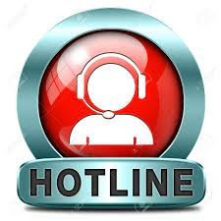
All WNYIL jobs are in one place
Good news! Visitors to the MHPC Facebook page will no longer have to wade through job announcement after job announcement, mostly from other members of the Western New York Independent Living Family of Agencies (WNYIL), to find events and news of interest to them.

A full slate of job listings for all the WNYIL Agencies is now being shared on a dedicated Facebook page, “Jobs at WNYIL”.

A mention of available Jobs would still be posted to the page of each appropriate agency, but only as a short listing with a link to the new Jobs at WNYIL Facebook page for additional detail.

To look over the openings, just use this URL: https://www.facebook.com/JobsAtWNYIL

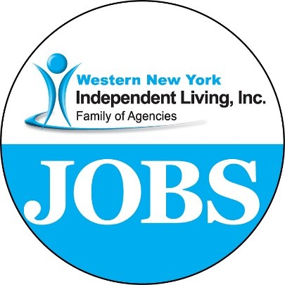

This is THE Place:
Maura Kelley, Behavioral Health Peer Liaison, mkelley@wnyil.org
“Peers Like Me” Podcasts
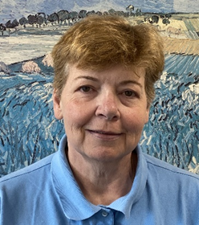
Often people having mental health difficulties, myself included, find we are lost and feel totally alone, misunderstood, and empty. Unfortunately, that is what many people with mental health issues struggle with every day of their lives. It is often very difficult having healthy relationships when one is depressed, angry at the world, forgetful, and confused. These feelings only serve to deepen mental health issues. And having these emotions make it seemingly impossible for those close to us to be there and show their love and concern.
The occurrence of this awkward, ill-at-ease state of mind is increasing up to 25% in recent years. Traditionally, people who have had mental health issues were said to number 1 in 5 Americans. Since COVID, that statistic has increased to 1 in 4 Americans having these concerns. And with this significant increase of people, in not-so-visible pain, there is an expanded huge unmet need for personnel to try to assist this population. There are too few providers, filled-up support groups, and waiting lists to be admitted into acute care psychiatric hospitals.
People suffering are not even seeking help because they see it as not being available. Since the consequences of having a mental illness are frequently total isolation and loneliness, their world view is often narrow and difficult to see through. But -- as I have been told repeatedly -- “Don’t believe everything you think!”
There is a place in the City of Buffalo, located here in Erie County, NY, where people who have also been suffering and struggling with mental health issues -- currently or in the past -- are getting and giving much needed support, understanding, community resources, fellowship, and a sense of belonging, despite how one feels, to others with mental health issues. This is all happening in a “Non-judgmental” Way!
It has been my experience that I have many epiphanies, or “Ah Hah!” moments, only when I am with others that have shared the same experiences and world view at one point in time or another. I see the “Ah Hah!” moments happening at Mental Health PEER Connection (MHPC) on a regular basis. The people they have designed their agency around are the people that are seeking services, so staff are totally geared toward assisting individuals with their personal goals, not the agency’s objectives.
Some of the goals I hear people talking about in the community are aspirations that help people recover and move ahead in their lives toward achieving peace of mind and a sense of belonging. I see people state these goals and other intentions to advance their type of mental wellness, not anyone else’s idea of wellness, at MHPC. This individualized care at MHPC is their standard way of doing business, not “one size fits all”. MHPC also works very well with other mental health agencies, always collaborating and being solution-focused to meet the needs of those they serve.
Most importantly, what I see at MHPC is a unique perspective that openly presents an atmosphere of a nonjudgement zone, “This is THE place.”
To get more information on Mental Health PEER Connection, just call 716-836-0822 extension 126. WNY Independent Living will answer the phone, because WNYIL, assists everyone with any disabilities, and they will make sure you’re directed to MHPC for your individualized specific needs.

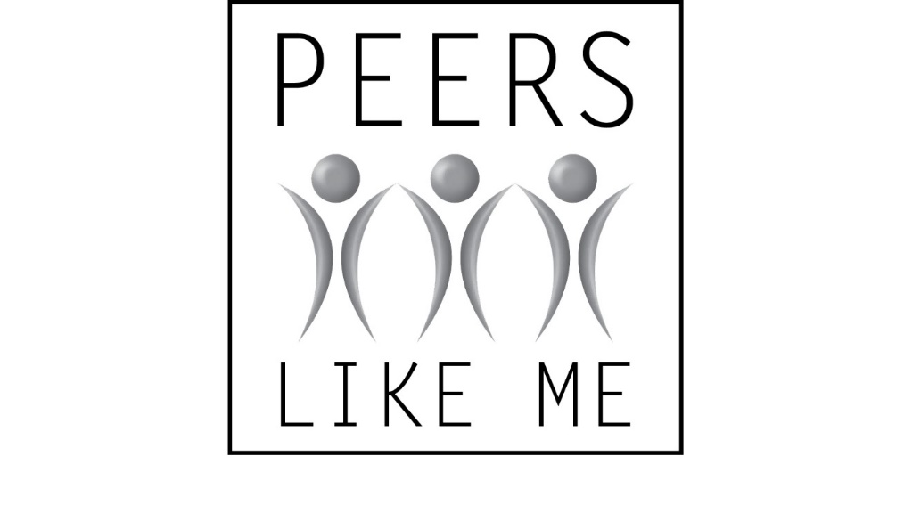

“Peace from Complexity”
David Meyers, Contributing Writer
Though I wish to get a clearer picture
My yearning comes back to that concept
Of diversifying my output
Allowing beauty to unfold
The divine is within and without
The light Jumps out suddenly
We are taken to the land of refuge
Of communing saints
The banquet allows dining
And people to celebrate
Conflicting ideas are resolved through a slice of bread
I am lowly yet I rise
Clarity comes from rest
Speech simplifies the song
Selected ideas allow me to be vulnerable
And like a swan, birth floats to a new day
“Safe Landing”
Dave Meyers, Contributing Writer

Awkward, I advance into a scattered place
That brings refuge
No one is looking at me
I feel impactful
I make moves
And advance toward my goal
Through many lands I toil
Until I reach the end
I am not clear on the meaning of the collage
I sort the pieces, and one thing is clear
That moment in obstruction allows this piece to burst forth
Though it is confusing
My place In time makes sense slowly
And falls faster

“Procession”
Dave Meyers, Contributing Writer

I proceed through this passage
And light seeps it’s way In to illuminate my thoughts
Intentions bolden
And choices are made
What is left behind does not return
And color comes forward in the path before me
Though there is separation moving on
And It seems The goal is far ahead,
Like nature I come to myself
And come alive to loved ones

