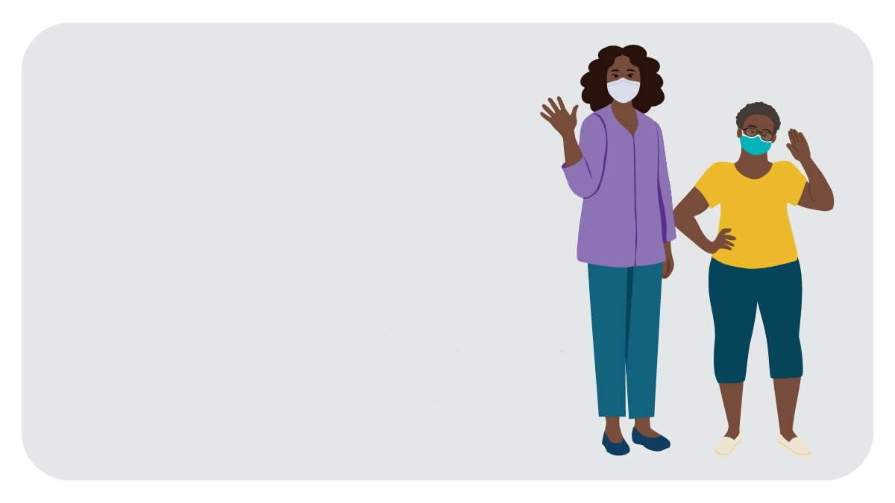Thank you for your support in promoting our new COVID-19 vaccination materials for people with intellectual and developmental disabilities (IDD) who have extreme low literacy (ELL). We are excited to introduce these materials with the aim of giving people with IDD and ELL and their caregivers the information they need to help them stay safe from COVID-19.

New from CDC

COVID-19 Vaccination Materials for People with Intellectual and Developmental Disabilities

Help spread the word!

Why get involved?

People with IDD have a higher incidence of COVID-19 than people without IDD. They are also more likely to be admitted to the hospital from COVID-19 complications, have higher rates of intensive care unit stays, and are more likely to die from COVID-19. Yet people with IDD often don’t have the information they need to protect themselves. To fill this gap, CDC is creating materials about COVID-19 and emergency preparedness that are specifically designed to meet this population’s needs — including a poster and social story promoting COVID-19 vaccination.

Who should use this promotion kit?

Explore the materials

Check out the social story: <https://go.usa.gov/x6gQN>



This kit is for disability service and advocacy groups, health care and public health organizations, and anyone else who is committed to improving communication and messaging about COVID-19 vaccination for people with IDD and ELL, their caregivers, and the organizations that support them.

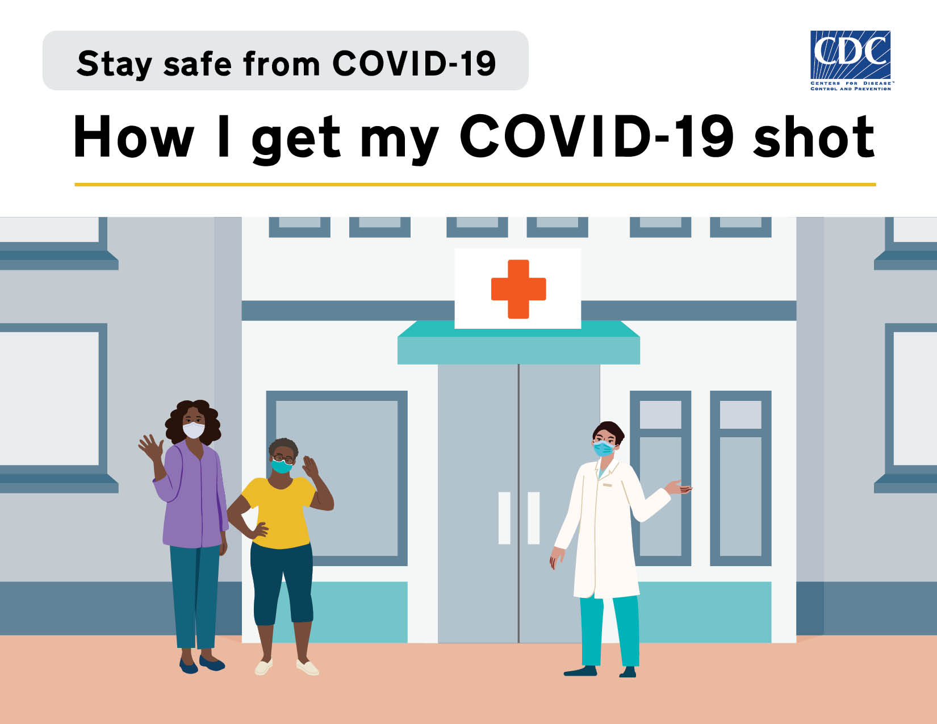

How do I use this promotion kit?

To help us raise awareness of these resources, you can use the sample language and images below when sharing the materials on social media, by email, and through other communications methods (e.g., newsletters, websites, or blogs). You are welcome to customize the promotional text as needed.

How can I help?

|  |  |
| --- | --- |
| 1 | Share our sample social media posts  Help generate interest in these COVID-19 vaccination materials on social media. When you share, please tag @CDC_NCBDDD on Twitter and @CDC on Facebook and LinkedIn and use #COVID19DisabilityInclusion to help us track engagement. These posts are just examples — you can edit the language to meet your organization’s needs. We encourage you to include an image with each post, since people are more likely to share posts with pictures. |

Posts for Twitter, Facebook, and LinkedIn

|  |  |  |  |
| --- | --- | --- | --- |
| **Post** | | **Image Options** | **Audience** |
| Stay safe from #COVID19! Learn about the COVID-19 shots: <https://go.usa.gov/x6gQN> | |  | **People with IDD / Self-Advocates** |
| Learn how to get a #COVID19 shot.  Check out CDC’s new social story! <https://go.usa.gov/x6gQN> | |  |
| Learn how you and your friends can stay safe from #COVID19! Check out CDC’s social story: <https://go.usa.gov/x6gQN> | |  |
| Do you care for someone with an #IntellectualDisability? Check out CDC’s free vaccination social story to help protect your loved one from #COVID19: <https://go.usa.gov/x6gQN> | |  | **Caregivers of people with IDD** |
| Want to help protect your loved one from #COVID19? Download CDC’s free vaccination social story for people with #IntellectualDisabilities! <https://go.usa.gov/x6gQN> | |  |
| Have you talked to your loved one about the #COVID19Vaccine? Access CDC’s free social story for people with #IntellectualDisabilities to help you start the conversation: <https://go.usa.gov/x6gQN> | |  |
| Need help educating your patients with #IntellectualDisabilities on how to get a #COVID19Vaccine? Check out CDC’s new vaccination social story! <https://go.usa.gov/x6gQN> | |  | **Providers of patients with IDD** |
| Health care providers are a trusted source of #COVID19 information for patients with #IntellectualDisabilities. Download CDC’s vaccination poster designed for people with IDD: <https://go.usa.gov/x6gQn> | |  |
| Help support the caregivers of your patients with #IntellectualDisabilities by sharing CDC’s free social story on the #COVID19Vaccine. Check out this new resource from CDC: <https://go.usa.gov/x6gQN> | |  |
| We’re excited to help [@CDC_NCBDDD/@CDC] introduce a new suite of #COVID19 vaccination materials designed especially for people with #IntellectualDisabilities! Check out CDC’s new poster: <https://go.usa.gov/x6gQn> | |  | **Professional organizations/ adovcacy groups who serve people with ID** |
| We’re excited to announce CDC’s new suite of vaccination materials to help people with #IntellectualDisabilities stay safe from #COVID19! Check out CDC’s new social story: <https://go.usa.gov/x6gQN> | |  |
| Want to help people with #IntellectualDisabilities stay safe from #COVID19? Share CDC’s new vaccination poster with your networks! Take a look: <https://go.usa.gov/x6gQn> | |  |
| Did you know that people with #IntellectualDisabilities are more likely to get #COVID19 and have worse health outcomes than people without IDD? CDC has created a vaccination social story specifically designed for people with IDD. Check it out: <https://go.usa.gov/x6gQN> | |  | **Providers of patients with IDD and professional organizations/ adovcacy groups who serve people with IDD** |
| People with #IntellectualDisabilities are more likely to get #COVID19 and have worse health outcomes than people without IDD. Help keep people with IDD safe by sharing CDC’s vaccination poster with your networks:  <https://go.usa.gov/x6gQn> | |  |  |
|  | Send an email   Do you maintain an active email list, listserv, or e-newsletter? Send a short email or include a blurb about the CDC’s new COVID-19 vaccination materials for people with IDD and ELL. You can use the image options provided above in your email as well. | | |
| **Email Subject Line / Header** | | | |
| New CDC COVID-19 Vaccine Materials for People with Intellectual and Developmental Disabilities | | | |
| **Body of the Email** | | | |
| We need your help! Did you know that people with intellectual and developmental disabilities (IDD) in the United States are more likely to get COVID-19 and have worse health outcomes than people without IDD?  We are excited to share that the Centers for Disease Control and Prevention’s (CDC) National Center on Birth Defects and Developmental Disabilities (NCBDDD) has developed a new suite of COVID-19 vaccine materials specifically designed for people with IDD who have extreme low literacy and their caregivers. These free materials, including a poster and social story, use simple illustrations and easy-to-read messages to explain how to get a COVID-19 vaccine.  **Explore CDC’s new materials and share them with your networks!**  **[Check out the social story](https://go.usa.gov/x6gQN)**    **[Download the poster](https://go.usa.gov/x6gQn)**    We appreciate your help with sharing this important information with people with intellectual disabilities, their caregivers, and the organizations that support them. | | | |

2