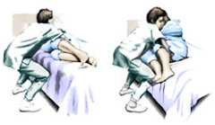

**Lifting Techniques for Home Caregivers**

If you are taking care of an individual in their home, you are at greatest risk for back pain when you are:

* Pulling a person who is reclining in bed into a sitting position.
* Transferring a person from a bed to a chair.
* Leaning over a person for long periods of time.

When you lift or move a person:

•

•

•

•

•

•

Maintain the proper alignment of your head and neck with your spine. Maintain the natural curve of your spine; don't bend at your waist.

Avoid twisting your body when carrying a person.

Always keep the person who is being moved close to your body. Keep your feet shoulder-width apart to maintain your balance.

Use the muscles in your legs to lift and/or pull.

If the person is too heavy, get help.

**Sitting Up in Bed**

To move a person lying in bed to a wheelchair, put the chair close to the bed and lock the wheels.

If the person is not strong enough to push up with his or her hands to a sitting position, place one of your arms under the person's legs and your other arm under his or her back.

Move the person's legs over the edge of the bed while pivoting his or her body so the person ends up sitting on the edge of the bed.

Keep your feet shoulder-width apart, your knees bent and your back in a natural straight position.

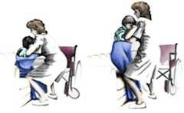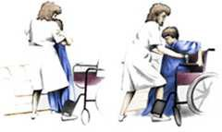

**Standing up**

If the person needs assistance getting into the chair, face the patient, place your feet shoulder- width apart, and bend your knees.

Position the person's feet on the floor and slightly apart. The person's hands should be on the bed or on your shoulders.

Place your arms around the person's back and clasp your hands together, nurses, physical therapists, and others in hospitals often use lifting belts, which are fastened around a person's waist. The caregiver grasps the belt when lifting the patient.

Hold the person close to you, lean back and shift your weight.

**Sitting Down**

Pivot toward the chair, bend your knees, and lower the person into the chair. The person should have both hands on the arms of the chair before lowering him or her down.

<http://orthoinfo.aaos.org/topic.cfm?topic=A00096>