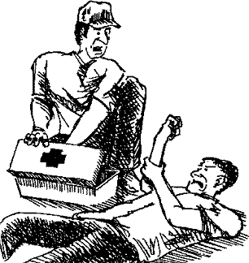

Aid



•

Division of Workers' Compensation

HS0l-017 C (02-14)

Keep A First Aid Kit Checklist

Get Medical Attention for All Injuries

Move the Injured Person Only When Absolutely Necessary Control Bleeding with Pressure

Treat Physical Shock Quickly

Perform the Heimlich Maneuver on Choking Victims Flush Burns Immediately with Water

Use Cool Treatment for Heat Exhaustion or Stroke

Respond Appropriately to the Form of Poisoning Report All Work-Related Injuries to Your Supervisor

3

3

3

4

4

5

5

6

6

6

**RESOURCES**

The Division of Workers' Compensation (DWC) also offers several free Agriculture safety publications online at [http :// www.t di.texas.go v/wc/ saf ety/](http://www.tdi.texas.gov/wc/safety/) videoresources/ind ex.html , including: First Aid for Burns (bilingual), First Aid Kits (bilingual), First Aid for Severe Bleeding (bilingual) Safety Training Program.

DWC features a free occupational safety and health audiovisual

library. For more information, call 512-804-4620 or visit the DWC website at [http://www.tdi.texas.gov/we/safety/vi deoresou rces/avcata log.htmI.](http://www.tdi.texas.gov/we/safety/videoresources/avcatalog.htmI)

Safety information from Agsafe Project can be obtained by visiting the National Ag Safety Database website at [http :// www.nasd online.org/](http://www.nasdonline.org/) document/2125/d000101/ agsafe-ag ricultural-safety-training-materials.htm l.

Division of Workers' Compensation

Resource Center• 512-804-4620 • [resou rcecenter @t di.texas.gov](mailto:resourcecenter@tdi.texas.gov) Safety Violations Hotline• 1-800-452-9595 • [safet yhotline @tdi.t](mailto:safetyhotline@tdi.t) exas.go v

2

Basic First Aid

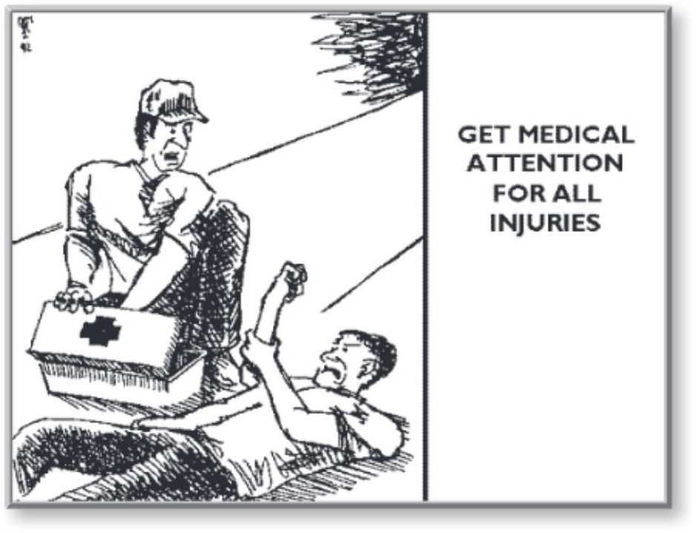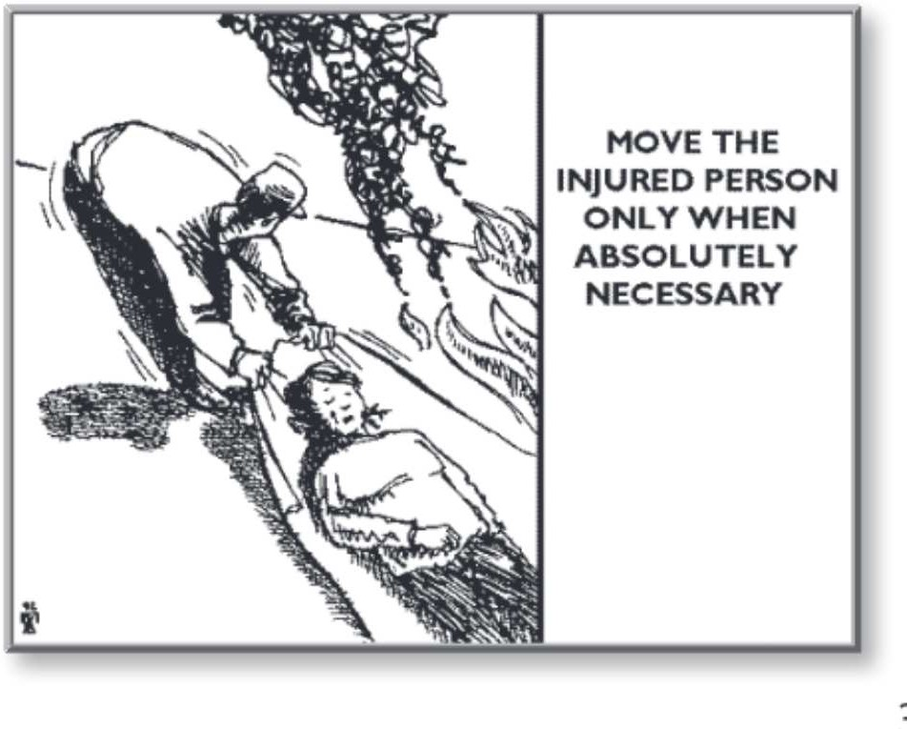

**KEEP A FIRST AID KIT CHECKLIST**

IFirst aid kits can be purchased commercially already stocked with the necessary supplies, or one can be

n order to administer effective first aid, it is important to maintain adequate supplies in each first aid kit.

made by including various first aid items:

•

•

•

•

Medical exam gloves;

Adhesive bandages available in a large range of sizes for minor cuts, abrasions and puncture wounds; Butterfly closures to hold wound edges firmly together;

Rolled gauze for securing dressings and/or pads to hard-to-bandage wounds and allow freedom of movement;

Nonstick sterile pads which are soft and super absorbent for bleeding and draining wounds, burns, and infections;

First aid tapes which are adhesive, waterproof and clear. Cloth and paper first aid tapes recommended for sensitive skin, because they are less irritating than adhesive tapes;

Tweezers;

First aid cream; thermometer;

an analgesic or equivalent; and an ice pack.

•

•

•

•

•

•

**GET MEDICAL ATTENTION FOR ALL INJURIES**

Iwork-related injury, regardless of how small you may think it is.

t is very important for you to get immediate treatment for every

Many cases have been reported where a small, unimportant injury, such as a splinter or puncture wound, quickly led to an infection, threatening the health of the employee. Even the smallest scratch is large enough for dangerous germs to enter the body. Therefore, immediately examine and treat every work-related injury.

What is first aid? It is simply those things you can do for the victim before medical help arrives. The most important procedures are outlined in this publication.

**MOVE THE INJURED PERSON ONLY WHEN ABSOLUTELY NECESSARY**

N

ever move the victim unless there is a risk of fire, explosion,

or another unsafe condition. The major concern with moving

a victim is making the injury worse, which is especially true with spinal cord injuries. If you must move the victim, try to drag him or her by the clothing around the neck or shoulder area. If possible, drag the victim onto a blanket or large cloth and then drag the

blanket.

3

Basic First Aid

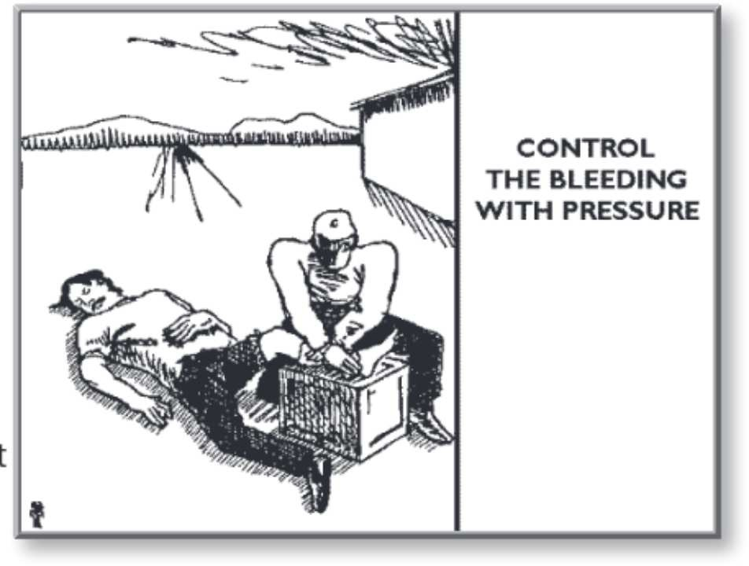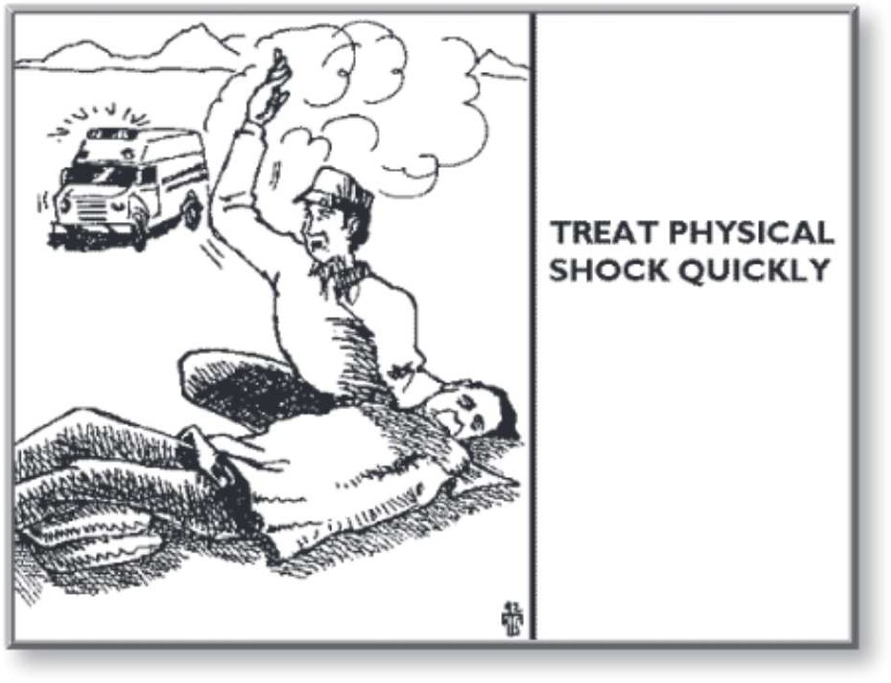

**CONTROL BLEEDING WITH PRESSURE**

B

leeding is the most visible result of an injury. Each of us has

between five and six quarts of blood in our body. Most people

can lose a small amount of blood with no risks, but if a quart or

more is quickly lost, it could lead to shock and/or death. One of the best ways to treat bleeding is to place a clean cloth on the wound and apply pressure with the palm of your hand until the bleeding stops. You should also elevate the wound above the victim's heart, if possible, to slow down the bleeding at the wound site. Once the bleeding stops, do not try to remove the cloth that is against the open wound as it could disturb the blood clotting and restart the

bleeding. If the bleeding is very serious, apply pressure to the nearest major pressure point, located either on the inside of the upper arm between the shoulder and elbow, or in the groin area where the

leg joins the body. Direct pressure is better than a pressure point

because direct pressure stops blood circulation only at the wound. Only use the pressure points if elevation and direct pressure haven't controlled the bleeding. Never use a tourniquet (a device, such as a bandage twisted tight with a stick) to control the flow of blood except in response to an extreme emergency, such as a severed arm or leg. Tourniquets can damage nerves and blood vessels and can cause the victim to lose an arm or leg.

**TREAT PHYSICAL SHOCK QUICKLY**

S

hock can threaten the life of the victim if an injury is not treated

quickly. Shock occurs when the body's important functions are

threatened by not getting enough blood, or when the major organs and tissues don't receive enough oxygen. Some of the symptoms of shock are:

•

•

•

•

a pale or bluish skin color that is cold to the touch, vomiting,

dull and sunken eyes, and

unusual thirst.

Persons in shock require immediate medical treatment, but until medical help arrives, all you can do is prevent the shock from getting worse. You can maintain an open airway for breathing, control any obvious bleeding and elevate the legs about 12 inches unless the

injury makes it impossible. You can also prevent the loss of body heat by covering the victim (over and under) with blankets or clothing. Don't give the victim anything to eat or drink because this may cause vomiting. Generally, keep the victim lying flat on their back.

A victim who is unconscious or bleeding from the mouth should lie on one side so breathing is easier. Stay with the victim until medical help arrives.

4

Basic First Aid

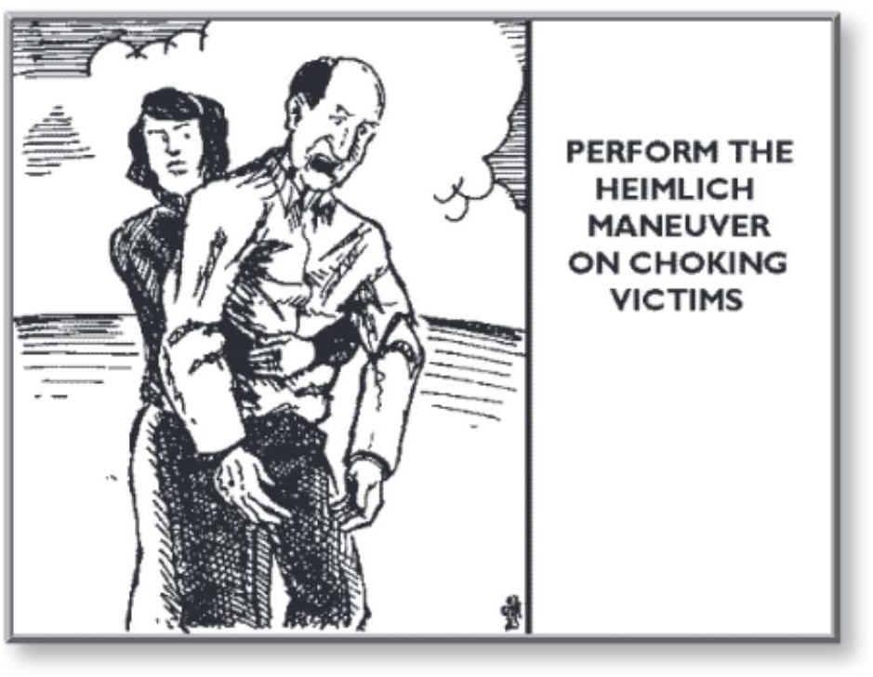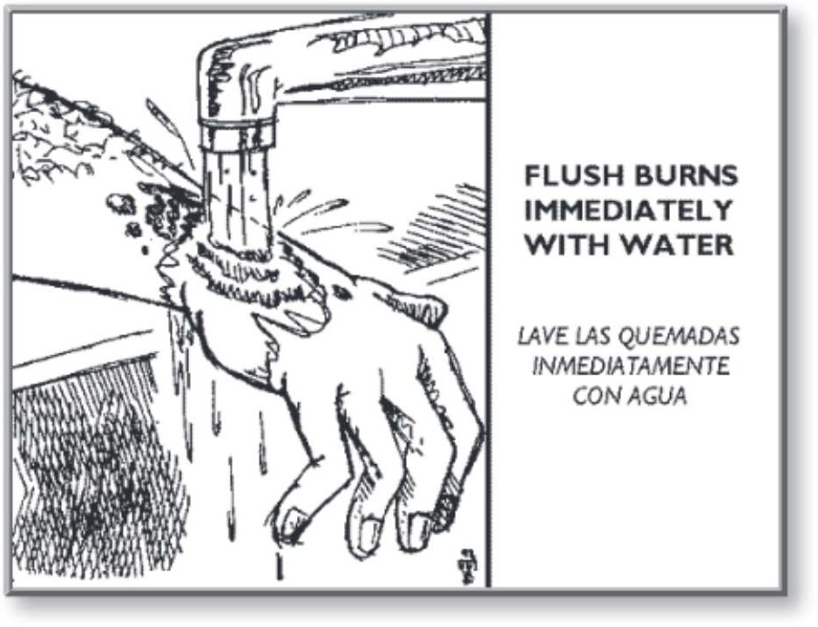

**PERFORM THE HEIMLICH MANEUVER ON CHOKING VICTIMS**

Anone of these things, stand behind the victim and locate the

sk the victim to cough, speak, or breathe. If the victim can do

bottom rib with your hand. Move your hand across the abdomen to the area above the navel, then make a fist and place your thumb side on the stomach. Place your other hand over your fist and press into the victim's stomach with a quick upward thrust until the object is dislodged.

**FLUSH BURNS IMMEDIATELY WITH WATER**

Tburns, chemical burns, electrical burns, or contact burns. For

here are many different types of burns. They can be thermal

thermal, chemical, or contact burns, the first step is to run cold water over the burn for a minimum of 30 minutes. If the burn is small enough, keep it completely under cool water. Flushing the burn takes priority over calling for help. Flush the burn FIRST. If the victim's clothing is stuck to the burn, don't try to remove it.

Remove clothing that is not stuck to the burn by cutting or tearing it. Cover the burn with a clean, cotton material. If you do not have clean, cotton material, do not cover the burn with anything. *Do not*

*scrub the burn or apply any soap, ointment, or home remedies. Also,*

*don't give the burn victim anything to drink or eat, but keep the victim covered with* a *blanket to maintain* a *normal body temperature until medical help arrives.*

If the victim has received an electrical burn, don't touch the victim unless they are clear of the power source. If the victim is still in contact with the power source, electricity will travel through the victim's body and electrify you when you touch the victim. Once the victim is clear of the power source, your priority is to check their breathing for any airway obstruction, and check their circulati on. Administer cardiopulmonary resuscitation (CPR) if necessary. Once the

victim is stable, begin to run cold water over the burns for a minimum of 30 minutes. *Don't move the victim, scrub the*

*burns or apply any soap, ointment, or home remedies.* After flushing the burn, apply a clean, cotton cloth to the burn. If a cotton cloth is not available, don't use anything. Keep the victim warm and still and try to maintain a normal body temperature until medical help arrives.

5

Basic First Aid

**USE COOL TREATMENT FOR HEAT EXHAUSTION OR STROKE**

Heat exhaustion and heat stroke are two different illnesses, although they are commonly confused as the same condition. Heat exhaustion can occur anywhere there is poor air circulation, such as around an open furnace or heavy machinery, or even if the person poorly adjusts to very warm temperatures. The human body reacts to heat by increasing the heart rate and strengthening blood circulation. Simple heat exhaustion can occur due to loss of body fluids and salts. The symptoms are usually excessive fatigue, dizziness and disorientation, normal skin temperature

with a damp and clammy feeling. To treat heat exhaustion, move the victim to a cool place and encourage drinking of cool water and rest.

Heat stroke is a much more serious illness and occurs when the body's sweat glands have shut down. Some symptoms of heat stroke are:

•

•

•

•

mental confusion, collapse, unconsciousness, or

fever with dry, mottled skin.

A heat stroke victim will die quickly, so don't wait for medical help to arrive - assist them immediately. First move the victim to a cool place out of the sun and begin pouring cool water over the victim's body. Fan the victim to provide good air circulation until medical help arrives.

**RESPOND APPROPRIATELY TO THE FORM OF POISONING**

The first thing to do in the event of poisoning is get the victim away from the poison. Then provide treatment appropriate to the form of the poisoning. If the victim is conscious, call the Poison Control Center at 1-800-222-1222. If unconscious, immediately call 911. If the poison is in solid form, such as pills, remove it from the victim's mouth using a clean cloth wrapped around your finger. If the poison is a gas, you may need a respirator to protect yourself. After checking the area first for your safety, remove the victim from the area and take them to fresh air. If the poison is corrosive to the skin, remove the clothing from the affected area and flush the skin with water for 30 minutes. Take the poison container or label with you when you call for medical help because you will need to be able to answer questions about the poison. Try to stay calm and follow the instructions you are given. If the poison is in contact with the eyes, flush the victim's eyes with clean water for a minimum of 15 minutes.

**REPORT ALL WORK-RELATED INJURIES TO YOUR SUPERVISOR**

As with getting medical attention for all work-related injuries, it is equally important that you report all work-related injuries to your supervisor. It is critical that the employer check into the causes of every work-related injury, regardless how minor, to find out exactly how it happened. There may be unsafe procedures or unsafe equipment that should be corrected.

6

Basic First Aid