Advocacy for Individuals: An Independent Living Specialist is available to meet with you alone to discuss your needs The Specialist can attend appointments with you and help you advocate for yourself.
Advocacy for System Change: Community accessibility affects us all Independent Living will advocate for needed changes with community leaders and offer technical assistance.
CDPAS Program (Member Directed Personal Assistant Services): allows your members to become the supervisor of their own personal
assistant. If your member has a functional limitation and needs to rely on others to assist them in daily
tasks, Having CONTROL over the decisions as to what and when things get done, is a key factor for getting what we all want out of life. To Take Control and use this service, an individual must be identified as eligible for personal assistant services by their health care insurance, have a working telephone in the member’s home; and be a self-directing person who can understand the decisions about medical needs and implement them. For more information on contracting or questions or concerns, please call: 716-836-0822
Benefits Advisement: It can be difficult to navigate the Social Security system. An Independent Living Specialist will help you create an online account and work with you through the entire process.
Budgeting: An Independent Living Specialist will help you create a budget and make informed suggestions on how to cut costs and work savings into your plans.
Educational Coaching: Bring an Independent Living Specialist to your next CSE (Committee on Special Education) meeting, someone can be there for both the parent and student.
Employment Network: Ticket to Work is a Social Security program designed to assist people receiving SS benefits with a return to the workforce while maintaining their benefits.
Housing: Independent Living does not provide housing. However, we do provide information on options in the community.
Job Search: Computer access, assistance with on-
line applications, cover letters, resumes, interview
tips, references and more.

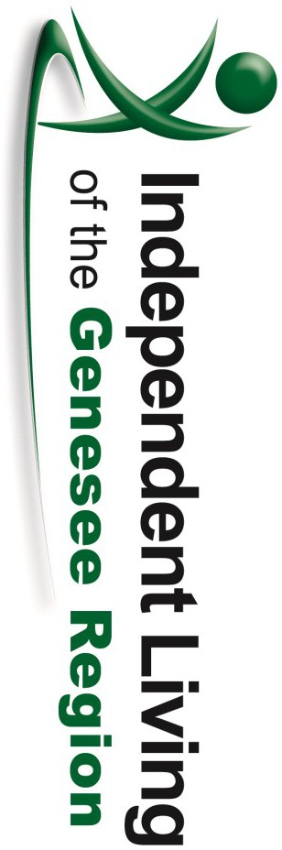
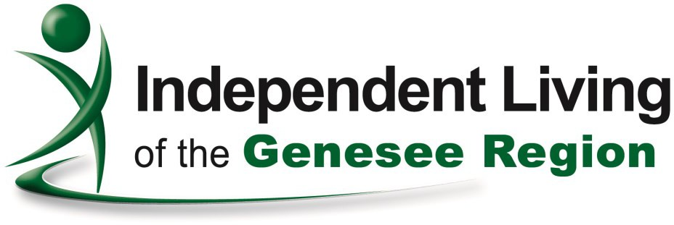
319 West Main St.
Batavia, NY 14020

Our Vision...
Independent Living of Genesee Region (ILGR) is a community pathway for an empowered life for people with disabilities.

319 West Main Street
Batavia, NY 14020
(585) 815-8501 ext. 400
(Voice/TDD) (585) 815-8502 (Fax)

Care Coordination & Integrated
Teams
Individuals with diabetes, two or more health chronic diseases; HIV/AIDS,
OR mental health concerns who are Medicaid eligible can access a Coordinator to improve communication between all providers and get back on track.

- Nursing Home Transition Program
Individuals in nursing homes can receive assistance with moving back into their home or a community based setting.

- Diabetes Self Management Program and Chronic Disease Self Management Program
A six week series of workshops developed by Stanford University provides practical education and tools for taking care of yourself with Type 2 diabetes or a chronic disease.
Affirmation of Equal Access
Independent Living of Genesee Region ensures equal access for all persons regardless of their significant disability in both communication and physical access to the IL’s services, programs, activities, resources and facilities, whether publicly or privately funded.
The Five Core Services Offered at ILGR
- Information & Referral-
We suggest you call ahead for availability.
585-815-8501 ext. 400
Crutches Wheel Chairs
- Raised Toilet Seats
•
Loan Closet
ILGR loans out gently used medical equipment such as:
- Walkers
- Commodes
- Shower Chairs/Benches
  - Canes
•
To assist persons with disabilities and professionals by identifying appropriate services and community resources that address specific problem areas.
- Independent Living Skills-
To provide persons with disabilities conceptual and experiential learning in adaptive communication and social skills that are necessary to obtain maximal levels of independent living.
- Individual & Community Advocacy-
Statement of Self Direction
Independent Living of the Genesee Region must assist persons with disabilities in exercising more freedom and control over their own lives.
Therefore, whenever possible, the individuals receiving services shall be instrumental in identifying needed services and the delivery of these services.
Consumers will be encouraged to:
- Develop their own goals.
- Direct delivery of services using their own abilities.
- At all times, consumers should be experiencing self advocacy.
- IL Staff will not impose their own judgments
upon the consumer.
To assist persons with disabilities with appropriate support services, when and where needed, to help live in the community.
- Peer Counseling-
To assist in the personal adjustment of a person’s disability and maximize community participation.
- Transition-
To facilitate the transition of individuals with disabilities from nursing homes or institutions to home and community based residences with the requisite supports and services.
Check out our website for more information
www.ILGR.org

Education, Empowerment & Equality for People with Disabilities

