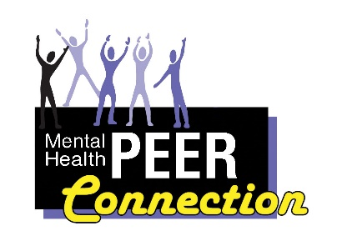Mental Health PEER Connection 3rd Edition
“Disability Pride - ‘What’s that all About?’”
From the Desk of the Chief Executive Officer -- Douglas J. Usiak
The other day, a person came up and surprised me with the question “’Disability Pride’ -- what is that all about?” Initially, I stammered a bit to collect my thoughts, because, as the CEO of a disability-run organization, I had just accepted the notion that where I go so does my disability, and thus also my satisfaction with what I had accomplished despite my impairment. My disability, I presumed, was just another of my attributes, along with the facts that I have grey hair, blue eyes, and (ahem) am still moderately handsome.
But after I got through that longer-than-necessary explanation of what I believed disability pride is all about, I was left displeased that I had not offered a more elegant and concise explanation. I decided to do a little bit of homework and see if I could come up with something better than a stumbling, bumbling narrative of what it is, beginning with the definitions:
- Disability-a physical or mental condition that limits a person’s movements, senses, or activities.
- Pride-a feeling of deep pleasure or satisfaction derived from one’s achievements, the accomplishments of someone with whom one is closely associated, or from having qualities or possessions that are widely admired.
OK, now I have the disability thing down…. right?
Simply stated, it is that something about me just does not work quite the way it should, preventing me from conducting that physical or mental activity the same way as most of the population. So, as a blind person, I am unable to see; but, with the use of a bunch of assistive technology, I can read through my fingers or ears. Admittedly, this makes pictures tough to appreciate; but with those “thousand words” (that a picture is worth), I can get the sense of what it is, complete my work, communicate the written word to others, keep up with the news, and pretty much stay on top of things like bills and taxes. However, then there are my brothers and sisters with other physical and/or mental-emotional functional limitations. What is out there for them?
Well, regarding mobility, there are canes, walkers, wheelchairs of all kinds for those who cannot walk, or have difficulty in walking.
Our science has identified medications that can limit or eliminate the effects of various diseases or organ insufficiencies, enabling our hearts, glands, and other bodily parts to continue the work we want them to do.
Now, there are therapies, medications, and counseling modalities that can assist those of us who need some assistance in getting through the stresses and other difficulties of life, providing us the ability to continue to interact and successfully meet our responsibilities of a fully participating member of society.
For us who have found ourselves on the wrong side of substance abuse, we have options and pathways of recovery to re-enter our community and engage in everyday society.
If we have hearing concerns, (or, should I say, have limited hearing or cannot hear at all), there are devices that can amplify sounds, and technologies that can translate the words we speak to text, and sign language interpreters to get us through the daily interactions of life.
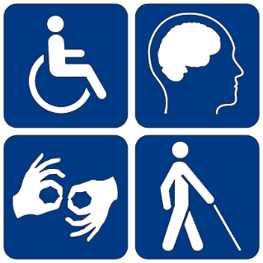
The list of what our society has developed for those of us with cognitive, physical, sensory, and mental or emotional disabilities is exhausting. Thanks to this, for the most part, many of us can fully interact, contribute, and meet our responsibilities as members of the human race. However, this is only if our neighbors, colleagues, and families can accept us as who we are and what we have to offer, instead of getting caught up with what deficits we have.
A whole other question is that “Pride” thing. Can people with a physical, sensory, cognitive, or mental limitation have something that they can be proud about? Or, better yet, something that the everyday person on the street could admire?
Let us see…What would you think about a woman who, one day, decided not to be homeless? That she determined to stop sleeping in her car and get a job?
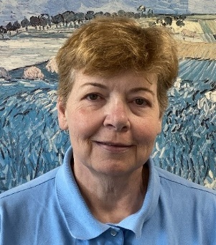
Now, what if that same woman not only decided to get a job but became part of several community groups that worked for the improvement of the quality of life for all within her community and State? Say that woman did not stop there but decided to become a leader in her chosen field, develop services and programs that provide avenues for people in need, who no longer want to be homeless, to consider? Furthermore, that her activities over two decades would assist thousands of people to find their way, get jobs, and advance themselves within their communities, helping them become part of their neighborhoods, heads of families, to pay taxes, and become leaders? That her actions and community work would not only assist thousands to find their life paths but result in research that proved the success of her programs, leading to legal changes in how our localities and State conduct business? The ultimate consequence? That once-homeless woman’s work would result in literally hundreds of people having jobs, causing millions of dollars finding its way into people’s pocketbooks and bank accounts through employment.
Now what would you say if I told you that woman has a serious mental health disability? That that woman is Maura Kelley, former Director of Mental Health Peer Connection?
I say “former”, because Maura has now chosen to take a new path: to go from administration of a highly admired program here in Erie County, to become Western New York Independent Living’s Behavioral Health Peer Liaison. Maura has taken another less traveled path, (a reference to the Robert Frost poem “The Road Not Taken”). Her practice of working to improve the lives of people with disabilities continues. She will go from leading in the provision of providing direct services, to leading the cause of the behavioral health peer. Working to ensure that vital programs and services exist in the upper five counties of WNY, and that New York State continues to meet their obligations of providing pathways to recovery for those of us who need it. Maura will be WNYIL’s ambassador to the local governments, legislators, and Statewide/National efforts to advance the quality of life for individuals dealing with behavioral health disabilities. Maura’s job, clearly stated, is to make sure that the “Family of Agencies” of Western New York Independent Living continues to be in the forefront of disability issues, efforts, and concerns. That the voices of those of us with disabilities continue to be heard, and that with “Disability Pride”, all of us with a disability can continue to live in our neighborhoods, work in our communities, and engage society as equal and proud Americans. Erie County residents can contact WNY Independent Living’s Behavioral Health Peer Liaison, Maura Kelley, at mkelley@wnyil.org, 716-836-0822, extension 162. Niagara County residents at 716-284-4131 ext. 162. And Genesee, Orleans, and Wyoming County residents at 585-815-8501 ext. 162.

The American with Disabilities Act Protects Me Too
Lisa Maria Cruz
MHPC Outreach Coordinator
I am protected by the Americans with Disabilities Act. Although I am not currently disabled at this time, this was not always the case. The law also protects individuals who have a history of disability. There was a time when I was severely impaired and unable to fully participate in society. I have no shame in saying that I have a history of disability.
I had a mental breakdown in October 1996. I was living and working in New York City. I worked for Editor & Publisher for a brief time. I was hired after graduating from the University at Buffalo. I had three semesters of experience as a writer for the Spectrum, the UB student newspaper. The job was an entry level editing position at their company. I spent half the day editing and half the day answering phones. It was not an ideal situation. I didn’t like answering the phone, but it came with the job and I wanted to be an editor. So, I did it.
Living in New York City was stressful. I was working a lot of hours and taking a writing class at night. I felt a lot of pressure to succeed. I thought I had something to prove not only to myself but also to other people as well. I felt like I was working more and more and getting less and less done. I was like a hamster in a hamster wheel spinning round and round. I didn’t realize it at the time, but my mental health was deteriorating.
I was walking towards the train station on my way to work, when a bird crapped on my blouse. I freaked out. I thought the bird was evil and that it was out to get me. I relayed this to my boyfriend, and he suggested that I stay home from work. I stayed in the apartment all day long and while I was there, I experienced auditory and olfactory hallucinations. When my boyfriend came home from work, he could see that I was not okay. He called his friend Tom and they tricked me into getting into his car and they took me to the psychiatric hospital.
He called my parents and told them to come get me. They drove the seven hours from Rochester to Queens. They went to the hospital and I was released to their care. We drove seven hours from Queens to Rochester and to this day, I don’t remember any of the ride back home. Maybe that’s just my mind’s way of protecting me.
My parents took me to the psychiatric hospital in Rochester. I stayed there for a few weeks. From there I went to a continuing day treatment program, where I would spend the next three years. It took me three years to get my life back. No one at the day treatment program was encouraging me to excel their goal was merely to keep me out of the hospital. I had an unwavering desire to get out of there. I had a life before my breakdown, and I was determined to have one again.
I started volunteering at the Center for Dispute Settlement a local non-profit agency in Rochester, NY. I helped the Public Relations Coordinator. I wrote press releases, public service announcements and contributed articles to their newsletter. My work as a public relations volunteer was a great experience and helped me to land my next job.
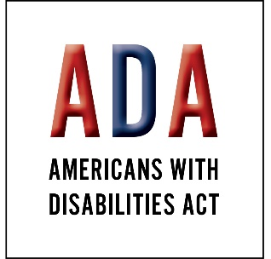
I learned of an opportunity to work as a marketing assistant at Diamond Saw Works in Chaffee, NY. I had my experience at the Spectrum and the Center for Dispute Settlement. Before my interview I looked over a marketing textbook. As I was being interviewed, I tossed out a few marketing terms like I knew what I was talking about. The interviewer was impressed and said that I knew more about marketing than the candidate with the MBA that he had interviewed.
I started working at Diamond Saw Works. The commute from Buffalo to Chaffee took me 52 minutes. I wasn’t used to driving and had very recently bought a car. The commute to work was exceedingly stressful for me. And as it turned out, I did need to know something about marketing, which I didn’t. I ended up getting fired after a few weeks.
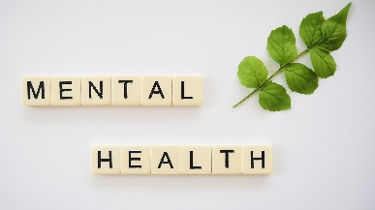
Afterwards, I started working a lot of temporary jobs. I went from temp assignment to temp assignment. They never lasted long, and I was never offered permanent employment. I was getting discouraged. Then, one day, on a whim, I applied to a job at Housing Opportunities Made Equal for a mobility counselor. I got the interview and landed the job. That was the beginning of my paid career in the non-profit field. Where I would work for over ten years.
My recovery has been like a sine wave. I have had times when I’m doing very well and times when I am struggling. Over the years, I’ve become good at surfing those waves.
I know that one reason I’m able to do so well is become I have a lot of support and wellness tools in my wellness toolbox. I am very happily married, and we recently celebrated our 19th anniversary. My husband has been by my side throughout all the undulations in my recovery. I also have a very strong Buddhist practice. I chant, “nam myoho renge kyo”, every morning and evening. I know that this is something which improves my mood and is essential to maintaining my recovery. I also have a loving family and many friends. I have a good life. I appreciate everything that I have, and I am very grateful.
I have no problem saying that I had been diagnosed with schizoaffective disorder. Having schizophrenia doesn’t mean your life is over. It’s possible to live with this disease and have a full and satisfying life. I share my story to offer hope to anyone else who is struggling or trying to come to terms with their mental illness. I am thriving as I live with schizophrenia and if I can do so, so can you!!
I’m grateful that the ADA exists to protects the rights of all people with disabilities. Whether your disability can be seen or not, your rights are still protected. The ADA is a civil rights law that was passed to protect the rights of all individuals who live with disabilities or who have a history of disability. Because of the ADA we have equal access to employment, housing and transportation. Pioneers in the disability rights movement fought so that we could have these protections. We owe them a tremendous debt of gratitude for the rights that we enjoy today. The ADA passed on July 26, 1990. Let’s take a moment to honor this tremendous achievement.

DISABILITY PRIDE 2021
On July 26, 1990, the Americans with Disabilities Act (ADA) was signed into law and discrimination against people with disabilities became illegal. We have reached a time to Celebrate the 31st Anniversary of the ADA becoming a law!
In recognition of this and to raise awareness within the community, the WNY Independent Living, Inc. Family of Agencies, along with many community partners, will be hosting a week-long virtual celebration highlighting the history of the disability rights movement, entertainment, pioneers in the disability rights movement, and many other activities the week of July 26, 2021.
A schedule of activities will be released in advance of July 26th so make sure to follow Mental Health PEER Connection’s Facebook page for up to date information. You can find it at https://www.facebook.com/MentalHealthPEERConnection
You can also contact Daniel Colpoys at dcolpoys@wnyil.org or 716-836-0822 ext. 166 for further information.
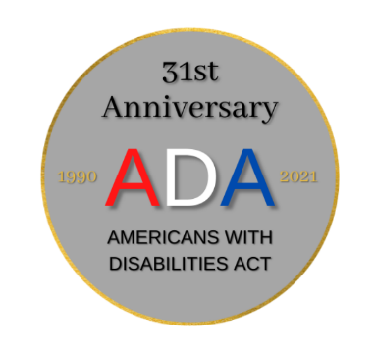
The Renewal Center
Michelle Wnek, MS, NYCPS, CASAC
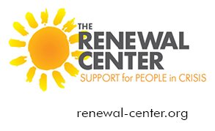
MHPC Engagement and Outreach Coordinator of The Renewal Center
The Renewal Center has a mission to provide a safe, supportive and non-judgmental environment that empowers those who are struggling with the principles of wellness and recovery. It is peer operated and staffed, to help individuals in a crisis from mental health and/or addictions. We have been there. It is a great, safe, comfortable place to go in times of need.
In addition to the engagement, outreach, and presentations that I do with agencies and the community, I have opened a door to some non-denominational faith-based recovery. Most of my engagement and outreach is through secular agencies and the community. This extra outreach increases referrals and allows individuals to talk about their faith and recovery if wanted. Spirituality can be helpful for some consumers. As an Ordained Minister, I am helping to increase the faith-based component, along with the other services for The Renewal Center. I am helping to increase referrals from this community, along with others. I have been doing Renewal Center outreach at ministries like: The Conquerors Today Broadcast every Friday on Facebook, an Addiction Conquerors weekly conference call, and while teaching, and doing community outreach events with churches and ministries. I have been putting up posters and information in churches, and different ministries. I have an updated weekly Christ-centered recovery meeting list via ZOOM. I am making that available to many staff and individuals, of course with the MHPC support groups that are provided here. Some of the peers at The Renewal Center are willing to talk with consumers about their spirituality, and how it helps with recovery. This includes any denomination. I am proud to be a part of The Mental Health Peer Connection and The Renewal Center.

Trial Work Period Explained
Brenda Starks
Certified Benefits Advisor
Faye was a referral from Adult Career and Continuing Education Services-Vocational Rehabilitation (ACCES-VR) for benefits advisement to understand how working would affect her Social Security Disability Insurance (SSDI) benefits. I met with Faye and her mom Susan, Faye’s representative/advocate.
Faye currently works at Target part-time 2 days a week and receives SSDI, Medicare and Medicaid. Faye had concerns because she had gone to the Social Security Administration (SSA) after receiving a letter that stated she currently had used 5 months of Trial Work Periods (TWP) to which Faye stated she had only used 2 months of TWP. I discussed with Faye whether an appeal was filed and stated that she had 60 days to file an appeal if she disagrees with the decision.
Faye stated that she talked with an SSA representative and was told her case would be reviewed and that she would be notified after SSA reviewed it. Faye said that another representative stated she would need to show proof that the 2 days she works was not in the previous month so that it would not trigger a trial work period. I suggested that by filing an appeal it would give Faye the opportunity to contact Target Corporate Office, Human Resource Department to discuss that she needs something stating how many days a month she works and her gross earning for that each month so that she could provide the documentation to SSA.
I suggested that moving forward Faye would have to submit her monthly gross earning every month to prevent triggering a TWP. Discussed that the Trial Work Period (TWP) is a Social Security Work Incentive that allows you to test your ability to work for at least 9 months in a rolling 5-year period. Mentioned that the 9 months do not need to be consecutive, but they may be. Discussed that during the TWP, you'll receive full SSDI benefits regardless of how much you earn, as long as you report your work activity and continue to meet Social Security's rules for disability.
I discussed that SSA compares your gross earnings, which is the amount of earnings you have in a month before subtracting taxes, to the TWP amount to decide if a month counts as a TWP month. I discussed that once you finish your TWP, other Work Incentives, like Impairment-Related Work Expenses (IRWE), may help you as you pursue financial independence through work. Discussed that SSA deducts the cost of certain impairment-related items and services that you need to work from your gross earnings when we decide if your work is substantial gainful activity (SGA) and that It does not matter if you also use these items and services for non-work activities.

Dreams do happen no matter what
Brenda Starks
Certified Benefits Advisor
Margaret came to the Mental Health Peer Connection in 2017 for assistance with housing, peer counseling and benefits advisement. When Margaret came to the agency, she had just been discharged from Erie County Medical Center after a 6 week stay on the behavioral unit. She was homeless and living in the shelter because she had no family in the area. Her lack of trust was very noticeable.
One day, Margaret’s peer asked her, “Where do you see yourself in 1 year?” Margaret’s response was, “Nowhere, because of my mental health it’s a dead end.” Margaret’s peer shared her life experience and provided hope at the end of the tunnel as she continues to come to every appointment. Together, they completed a housing application, and Margaret was accepted into the transitional housing program and this changed her life.
As time went on Margaret became established in her own apartment and things started to look differently. In Margaret’s words, “I never thought this day would come because of all the barriers that kept happening”. Determined to improve her quality of life, Margaret registered at Bryant and Stratton and earned her Associate Degree while working part-time as a school bus aide.
Now, Margaret’s favorite saying is, “I no longer have the fear of accomplishing my dreams because I have overcome what I thought would never happen - living with mental health it’s no longer a dead-end situation. And when you put your mind to achieving something the trials and experiences are just a way to either hold a person down or show you that you are better than what people say about you”.
Margaret continues to work part-time and is going back to school. And it’s not to say that it hasn’t been a rough road, all the bumps in the road that were put there to block Margaret and what she was trying to achieve gave her the experience to help her succeed. During that time, she learned that she’s able to do anything regardless of what life throws at her. Always remember never let anyone tell you that because of mental health you can’t achieve and accomplish your goals.

Working Past Deficit
Dave Meyers
It’s a little difficult to speak the right way.
I feel that others mock my demeanor.
No matter what clarity is not reached.
My brain creates confusion, though I discover methods which order my thoughts. But when I struggle to find the right word, I may lash out inadvertently. I crave for normalcy, yet my surroundings are scrambled, like my body was in that accident.
From wheelchair to walking, and from mute to chatterbox.
The hospital stays did me good, and restored normalcy.
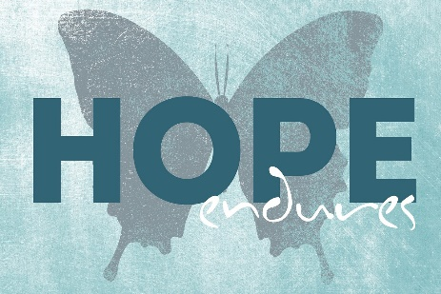
It’s good to take pride in seeking safety.
Believing things can improve is the essence of hope. Even when battered to the ground standing again can allow for speech to renew.

Show your support for the Mental Health Community
by sporting a "Make Your Mental Health a Priority"
car or refrigerator magnet!
Magnets are $3.00 each, and all proceeds benefit MHPC so they can continue supporting the Mental Health Community.
You can purchase your magnet online and have it shipped to you for an additional $0.50, or you can stop into our office at 3108 Main Street in Buffalo, NY.
Please reach out to Melissa at mburns@wnyil.org or 716-836-0822 ext. 170 to purchase.
As always, we appreciate your support!

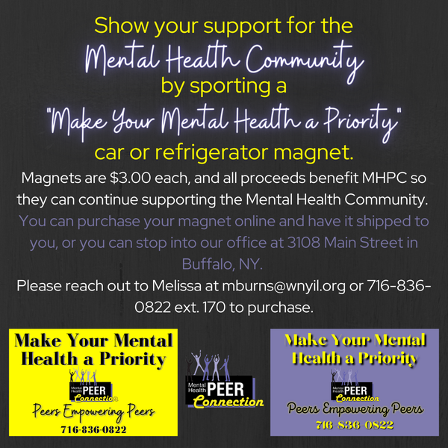

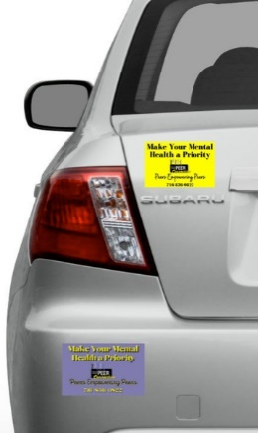

Level up your PEER Skills
New Levels / New Devils
Cathie Campbell
Addict 2 Addict Peer Support Specialist
Being a PEER is to work with someone (like you) and share your personal experiences as a road map, restoring hope that change is possible with the right information, healthier thinking, better decision making, etc. And if that individual is ready to level up you continue by redirecting them into full independence.
In my 18 years in the field I have often noticed people can become dependent upon their PEER because they represent a healthier way of living instead of simply existing. And the PEER does not know what to do next, so they look at the co-dependence as a bad thing. Not me! In the beginning I became so co-dependent of this healthier way of living and thinking because I was for the first time thriving, I wanted more of this positive experience! So, I kept a tight hold of that positive influence.
So, what happens if the individual does become dependent on you, the PEER providing this healthy information? No, we do not tell them: you are being very co-dependent upon my services so I will switch you to a new PEER. That is labeling and punishing the individual! This can and will result in the individual taking steps backwards in their recovery. Instead, I would navigate them towards a higher level of independence so they too can begin paying it forward!
Let us say the individual began attending a Healthy Relationships support group. In my opinion, the foundation of a self-help group should be transitional, not permanent. They enter the group to learn: the difference between a healthy relationship and an unhealthy one, healthy communication skills, conflict resolution skills, etc. Using this new-found information so it that it becomes repetitive to ensure that it eventually becomes easily understood so they can begin applying it to their relationships (personally and professionally).
So now let’s say the individual has attended said group for 1 year and they approach you and say, “Cathie I am getting bored and not learning new stuff anymore, because you have shared these same topics over and over again all year. Do you think you could start looking for new material, so I keep growing?”
Being a PEER that is exactly what I would have done. Today, I would notice they have become dependent upon the support group instead of the unhealthy relationship they used to be in. So yes, they have ended the unhealthy relationship but have also found something else to be dependent upon. THAT IS NOT INDEPENDENCE! And working for WNY Independent Living I learned the next step is helping them move from dependence to independence!
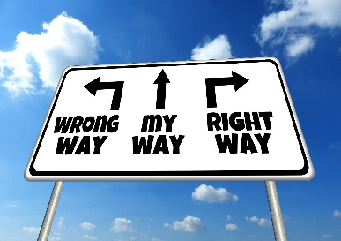
We must redirect them in a healthy way! And there are options! We ask them to begin co-facilitating the group and over time you see they are really paying it forward and guiding others and it is helping them to address their co-dependence. So, 6 months later you hand them the group topics and tell them you are going on vacation or needing a week off for something. Now they are taking the lead role as facilitator. After the first week, you rejoin the group as the co-facilitator. 6 more months down the road you say, “you are becoming so independent”!! I have been considering offering a new group for those (like you) who have leveled up in their healthy relationships and calling it Healthier Relationships – the Next Level, unfortunately I do not have time in my schedule to do both groups. Would you be interested in taking over this group so I could start the new group?
Another possibility, that I use all the time, is instead of new information in the group I redirect them towards considering becoming a PEER advocate. I share that they can go to AcademyofPeerServices.org and begin taking the classes to work on a PEER certification in NY state. Sharing that while working on their certification they can (just like me) keep learning new information so they can continue to grow into a greater version of themselves.
Recipe
Easy Red Beans and Rice
This is an easy and delicious take on a Louisiana classic that you can prepare and cook in 40 minutes! I use turkey kielbasa to cut down on the fat, but not the flavor. Season with hot pepper sauce if you like.
Prep: 10 mins
Cook: 30 mins
Total: 40 mins
Servings: 8
Yield: 8 servings

Ingredients
- 2 cups water
- 1 cup uncooked rice
- 1 (16 ounce) package turkey kielbasa, cut diagonally into 1/4-inch slices
- 1 onion, chopped
- 1 green bell pepper, chopped
- 1 clove chopped garlic
- 2 (15 ounce) cans canned kidney beans, drained
- 1 (16 ounce) can whole peeled tomatoes, chopped
- ½ teaspoon dried oregano
- salt to taste
- ½ teaspoon pepper

Directions
Instructions Checklist
- Step 1
In a saucepan, bring water to a boil. Add rice and stir. Reduce heat, cover and simmer for 20 minutes.
- Step 2
In a large skillet over low heat, cook sausage for 5 minutes. Stir in onion, green pepper and garlic; sauté until tender. Pour in beans and tomatoes with juice. Season with oregano, salt and pepper. Simmer uncovered for 20 minutes. Serve over rice.

Nutrition Facts
Per Serving:

289 calories; protein 16.3g; carbohydrates 42.4g; fat 5.7g; cholesterol 35mg; sodium 807.8mg.

MHPC’s Flea Market

Stay tuned for details about MHPC’s Flea Market to be held on Saturday August 21st at 3108 Main Street, Buffalo, NY 14214!

Details will be posted on MHPC’s Facebook page at:
https://www.facebook.com/MentalHealthPEERConnection

