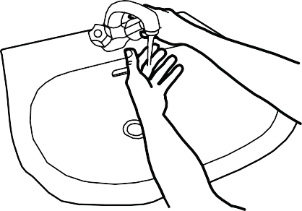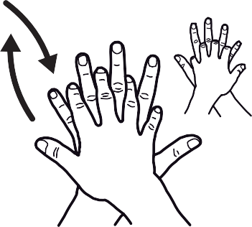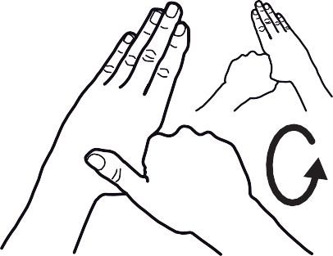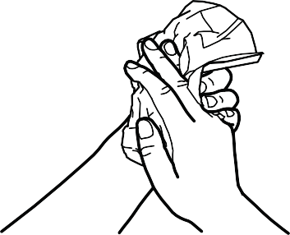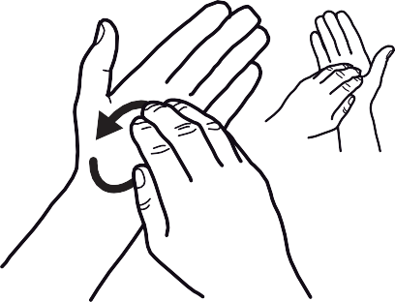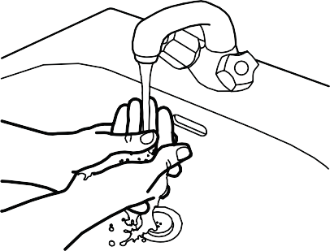

**How to Handwash?**

**WASH HANDS WHEN VISIBLY SOILED! OTHERWISE, USE HANDRUB**

**Duration of the entire procedure: 40-60 seconds**

Wet hands with water;

Apply enough soap to cover all hand surfaces;

Rub hands palm to palm;

Right palm over left dorsum with interlaced fingers and vice versa;

Palm to palm with fingers interlaced;

Backs of fingers to opposing palms with fingers interlocked;

Rotational rubbing of left thumb clasped in right palm and vice versa;

Rotational rubbing, backwards and forwards with clasped fingers of right hand in left palm and vice versa;

Rinse hands with water;

Dry hands thoroughly with a single use towel;

Use towel to turn off faucet;

Your hands are now safe.

May 2009

All reasonable precautions have been taken by the World Health Organization to verify the information contained in this document. However, the published material is being distributed without warranty of any kind, either expressed or implied. The responsibility for the interpretation and use of the material lies with the reader. In no event shall the World Health Organization be liable for damages arising from its use.

WHO acknowledges the Hôpitaux Universitaires de Genève (HUG), in particular the members of the Infection Control Programme, for their active participation in developing this material.

**11**

**10**

**9**

**8**

**7**

**6**

**5**

**4**

**3**

**2**

**1**

**0**