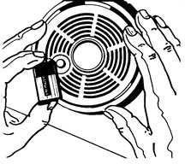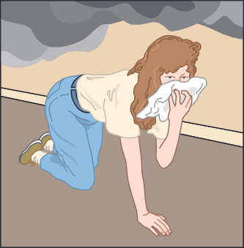

**House and Building Fires FactSheet**

HS02-038B (2-05)

Install A-B-C type fire extinguishers in designated areas of the building and teach employees how to use them. The appropriate fire extinguisher should be used to control a small area that will open a path of egress/exit.

A fire can engulf a structure in a matter of minutes. Understanding the basic characteristics of fire and learning the proper safety practices can be the key to surviving a house or building fire.

**Before**

Install smoke detectors. Check them once a month and change the batteries at

least once a year.

Develop and practice an escape plan. Make sure all individuals know what to do in a fire.

**Electrical Wiring**

•

•

Replace wiring if frayed or cracked.

Make sure wiring is not under rugs, over nails, or in high traffic areas. Do not overload outlets or extension cords.

Outlets should have cover plates and no exposed wiring.

Only purchase appliances and electrical devices that have a label indicating that they have been inspected by a testing laboratory such as Under­ writer's Laboratories (UL) or Factory Mutual (FM).

•

•

•

Draw a floor plan with at least two ways of escap­ mg every room.

Choose a safe meeting place outside the building.

Practice alerting other employees. It is a good idea to keep a bell and a flashlight in each area of the building for this purpose.

Practice evacuating the building blindfolded. In a real fire situation, the amount of smoke generated by a fire may make it impossible to see.

Practice staying low to the ground when escap­ ing.

Feel all doors before opening them. If the door is hot, do not open it and get out another way.

Learn to stop, drop to the ground, and roll if clothes catch fire.

Do not store combustible materials in closed areas or near a heat source.

**Cooking**

Keep the stove area clean and clear of combustibles such as bags, boxes, and other appliances. If a fire starts, put a lid over the burning pan or use a fire extinguisher. Be careful. Moving the pan can cause the fire to spread. Never pour water on grease fires.

**During**

Get out as quickly and as safely as possible Use the stairs to escape.

When evacuating, stay low to the ground.

If possible, cover mouth with a cloth to avoid inhal­ ing smoke and gases.

Close doors in each room after escaping to delay the spread of the fire.

•

•

•

•

•

Post emergency numbers near telephones. However, be aware that if a fire threatens your building, you should not place the call to your emergency services from inside the building. It is better to get out first and place the call from somewhere else.

Purchase collapsible ladders at hardware stores if you are in a multiple story building or home and practice using them.

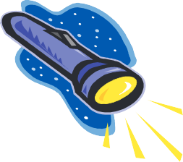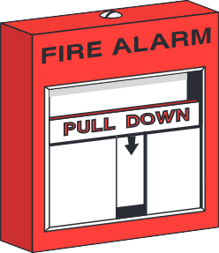

**Heating Devices**

Heating devices such as portable heaters, wood stoves, and fireplaces demand safe operation. Use portable heaters in well-ventilated rooms only. Refuel kero­ sene heaters outdoors only. Have chimneys and wood stoves cleaned annually. Buy only approved heaters and follow the manufacturers' directions.

If in a room with a closed door:

**Smoke Detectors**

Smoke detectors more than double the chance of surviving a fire. Smoke detectors sense abnormal amounts of smoke or invisible combustion gases in the air. They can detect both smoldering and burning fires. At least one smoke detector should be installed on every level of a structure. Test the smoke detectors each month and replace the batteries at least once

a year. Purchase smoke detectors labeled by the Underwriter's Laboratories (UL) or Factory Mutual (FM).

Contact your local fire department or American Red Cross (www.redcross.org) chapter for more information on fire safety.

•

If smoke is pouring in around the bottom of the door or it feels hot, keep the door closed.

Open a window to escape or for fresh air while awaiting rescue.

If there is no smoke at the bottom or top and the door is not hot, then open the door slowly.

If there is too much smoke or fire in the hall, slam the door shut.

•

•

•

Call the fire department from a location outside the building.

**After**

Printed in cooperation with the U.S. Fire Administration (www.usfa.fema.gov) who has additional information on fire safety and firefighting.

•

•

Give first aid where appropriate.

Seriously injured or burned victims should be transported to professional medical help immediately.

Stay out of damaged buildings.

Return home only when local fire authorities say it is safe.

Look for structural damage.

Discard food that has been exposed to heat, smoke, or soot.

Contact insurance agent.

Don't discard damaged goods until after an in­ ventory has been taken. Save receipts for money spent relating to fire loss.

Disclaimer: Information contained in this training program is considered accurate at time of publication.

•

•

•

•

•

•

The Texas Department of Insurance, Division of Workers' Compensation (TDI/DWC)

E-mail [**resourcecenter@tdi.state.tx.us**](mailto:resourcecenter@tdi.state.tx.us)

or call 1-800-687-7080 for more information.

*Safety Violations Hotline*

**1-800-452-9595**

[**safetyhotline@tdi.state.tx.us**](mailto:safetyhotline@tdi.state.tx.us)